GPs have strong perceptual capacity
Perceptual Capacity helps us do the right thing; it helps GPs make sound judgments in diverse and hugely varied clinical scenarios.
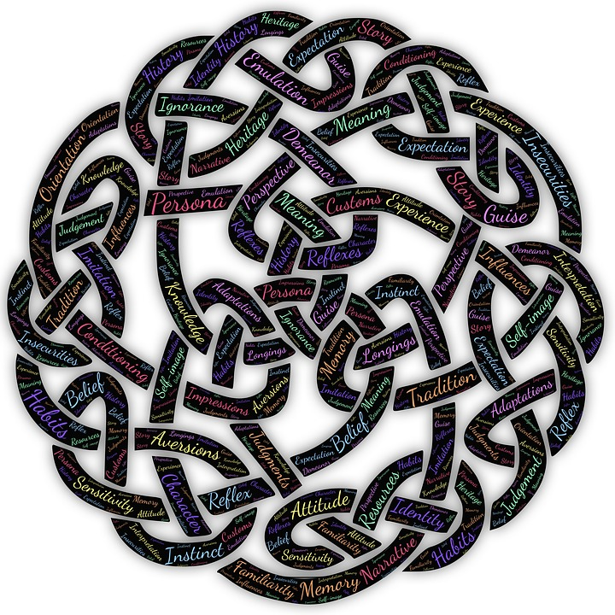
Perceptual capacity is a special sensitivity which helps you make (ethically) good decisions and ‘do the right thing’. It’s a bit like intuition but there are significant differences from it. It’s where one no longer needs to rely too heavily on rules and algorithms (which are usually difficult to apply anyway because the situation is often quite complex). In such circumstances, the GP with good perceptual capacity will deal with the situation well – relying on judgements that they themselves cannot always explain clearly and rationally, but they know are right (i.e. they have insight). In considering many such situations, the fact is that we often understand much more than we can explain, either to others or ourselves. Such tacit knowledge is of great importance in general practice.

However, it is NOT the same as intuition. Intuition is about instinct and knowing without an intellectual component, whilst perceptual capacity is very much about using the intellect but allowing it to be steered by what might be possible (imagination) and what is felt (emotional engagement).

Perceptual capacity is the ability to understand what a situation requires at an intellectual level, but also with imagination and the appropriate emotional engagement:

- having a good intellectual grasp of a situation (e.g. the clinical context)
+
- embracing your imagination to think a little more ‘freely’
+
- An appropriate degree of emotional engagement (feelings, circumstances etc.).

Without perceptual capacity, general practice becomes the unthinking application of rules, formulae, guidelines and contractual obligations. Is that how you want general practice to be? A set of rigid rules and guidelines? Not all patients and scenarios fit guidelines and protocols precisely – situations are often more complex than that. A GP’s perceptual capacity is central in assessing all elements of a clinical situation and finding a way forwards. QoF focuses on the management of diseases or populations rather than on the individual. It takes us away from the patient’s narrative and makes us see them as examples of diseases rather than people with concerns and in distress. Did you sign up to medicine to do this or to help our fellow people?

On its own, the clinical history and examination does not tell us what the right thing to do is. For that, one has to involve the patient, understand their perspective and circumstances. The patient’s narrative (amongst other non-clinical perspectives) is just as important as the clinical in ensuring that the right thing is done. We must look at both. Only then can we start using clinical evidence conscientiously, explicitly and judiciously (as Sackett suggested in the first place). Perceptual capacity helps us make good judgements; it is important that we assert its importance in GP training and in models of good general practice. Strengthening our perceptual capacity will help us do what we as GPs are (traditionally) meant to do – to listen to individual patients and respond thoughtfully, appropriately and sensitively – and therefore do the right thing.

So, how can trainees develop their perceptual capacity so that they ‘do the right thing’?
- GP trainees need to engage in education through reflecting on experience. This will help them develop their perceptual capacity and a sense for ‘moral seriousness’ (take seriously the business of ethics – moral argumentation and justification).
- GP trainees need to explore various dimensions of the clinical encounter and then synthesise them into a whole –the clinical bits, the narrative, the emotional engagement, the imagination and so on.

All of this has its roots in Nicomachean ethics. Nicomachean ethics was Aristotle’s best known work on ethics and it deals with how the highest good for humans and the highest aim of human practical thinking is happiness (please note that this is a gross simplification).

Aristotle is concerned with practical rather than theoretical wisdom and refers to an important sequence that needs to take place to achieve happiness:
Right actions (due to right teachings)

Right habits

Conscious and voluntary choice about continuing the right habits

Virtuous character

Eudaimonia (happiness)

The thing about the virtuous character is that there are both intellectual and moral components.
- Intellectual virtue starts and grows from teaching – which requires experience and time.
- Moral virtue is the result of habit (repeated action).

The development of perceptual capacity requires both intellectual virtue (the right teaching) and moral virtue (the right habits). Perceptual capacity is not something that you are born with. It is something that has to be developed through education, reflection and experience. This is what we must inspire in our trainees.

‘Perceptual capacity and the good GP: invisible, yet indispensable for quality of care’ by John Gillies and Mark Sheehan (Br J Gen Pract. 2005 December 1; 55(521): 974–977).

