Understanding feedback – basic principles
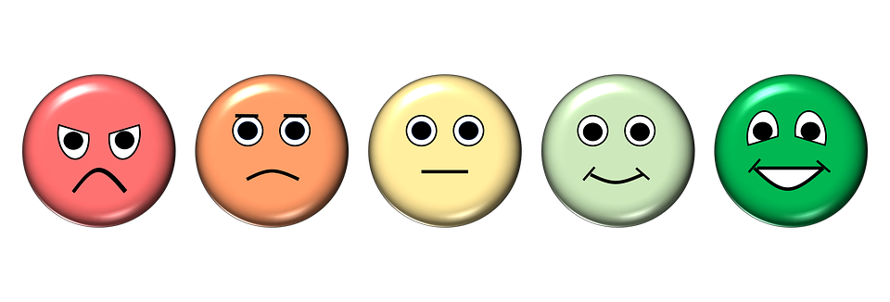
Feedback will form a prominent part of and will permeate throughout your time with us. Therefore, it’s important that you understand what feedback is about. Feedback is much more than marks and grades – it’s an essential part of your learning process. Feedback helps you to develop and become better than you already are. So, try and view feedback as being constructive, even if it appears critical of your performance at times.

Definition of feedback
Feedback is information about performance or behaviour which leads to action to affirm or develop performance or behaviour, i.e.
- To affirm what you do well
- To help you develop in areas you do less well.

How might you get feedback?
Feedback can come in a formal or informal way. Formal feedback is defined as, “a written piece that strictly adheres to rules, conventions, and ceremony, and is free of colloquial expressions.” Examples include COTs, CBDs, mini-CEXs, MSFs and PSQs. Formal feedback is important because it guarantees the flow of communication in an effortless, precise and timely way. By doing that it ensures that we stop regularly, reflect on our strengths and weakness, figure out where we are and help us decide where to go next. Informal feedback is as its name suggests is not so rigid in terms of rules and conventions and often happens when it is necessary rather than at regularly set times. Informal feedback is important because sometimes formal feedback can obstruct the free and uninterrupted flow of communication on your day to day work.

Who might give you feedback?
The obvious people who will give you feedback are your Trainer, Clinical Supervisor and Educational Supervisor. Informally, they’ll give you feedback on your day to day work. Formally, they’ll give you feedback on assessed work (like COTs, CBDs, mini-CEXs and so on).

But feedback can come from a variety of other sources too and you should take note when it happens. For instance, other staff in the practice or department may yield formal feedback in the way of Multi Source Feedback or some sort of 360 degree appraisal type thing. Informal feedback may come in the form of ‘off the cuff’ comments which are equally valuable in helping you develop. If an admin person says ‘late again I see’, you might find that a bit hurtful and it’s easy to get absorbed in that feeling and react back in an emotional way. But it’s the mature person that will reflect and realise that it’s saying something about your time management skills.

Your peers are another source of feedback. You may receive formal feedback on a presentation you did – perhaps through an evaluation sheet given out to them afterwards. Informal feedback might come from discussing cases or other areas of work (either on a 1-1 basis or in a group session).

Then there are patients. Informally, patients can make comments during your interaction with them like ‘I’m sorry to say doctor, but you’re in a bit of a grumpy mood’. Formally, they may give you feedback in the form of a Patient Satisfaction Questionnaire.

Most informal comments are not said to hurt you. Listen and take note. People are simply expressing how they find you. It’s up to you to decide whether you want to change your behaviour in order to alter the impression you evoke in others. Remember – that’s within your control.

Hopefully, when your trainer gives you feedback, it will…
- Be timed well – when you’re both feeling calm (and no acute life upsetting events)
- Be given enough time with full attention and no interruptions
- Involve mutual goodwill
- Make you feel that they aren’t your enemy
- Feel like they genuinely want to help you develop.

You trainer will ensure that your feedback is….
- Well balanced (i.e. a balance of positive and negative things)
- Specific - with clear facts and examples
- Descriptive (not evaluative) – based on what you did and what was observed, not on how you are as a person.
- Based on something YOU CAN change - and offers an idea of how to change.

