5 things all patients want

If we think about people and why they come in simple terms, it’s because something has disrupted their usual lives. They just want to come in, get diagnosed and fixed so that they can go back to normality. Roy Lilley summarises it nicely.
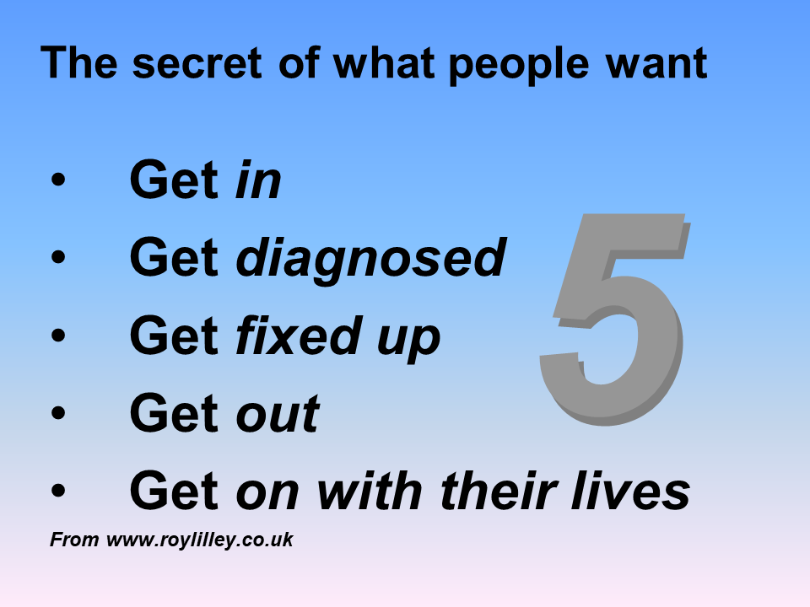 | 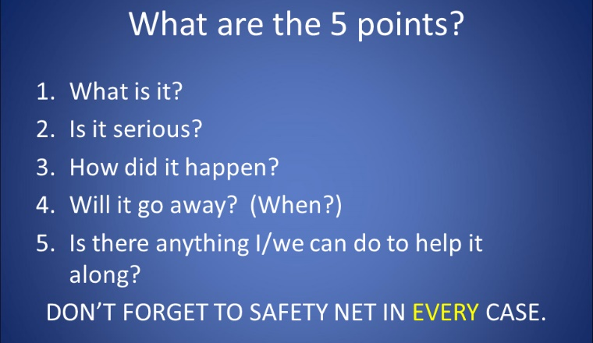

But things aren’t so difficult in the real world. As a doctor, sometimes you can quickly diagnose and fix people – but that’s pretty rare. The art of general practice is managing the complexity and uncertainty that usually accompanies medical problems. Therefore, it’s probably more helpful to think about the 5 things most patients want to know when they go to see a doctor. Using this framework can help settle a patient, even when you’re not sure about what is going on.

What is it?: “mmm… It’s a little difficult to tell what it is”
Is it serious? “but what I can tell you is that it isn’t serious and that’s the most important piece of information you need to know”
Will it go away?
“however, I do expect it should settle towards the end of next week since you’ve already had it for a week”
Is there anything I/we can do to help it along?
“I thinks it’s best to let nature just get rid of it”
How did it happen?
“It’s probably blah blah blah, but like I said before, the most important thing is that I don’t think it’s serious and it should settle”
Don’t forget to safety net in EVERY case
“but listen, if it hasn’t settled by next week or the rash gets worse or you look or feel worse, then please don’t hesitate to come back. Does that sound reasonable?”

