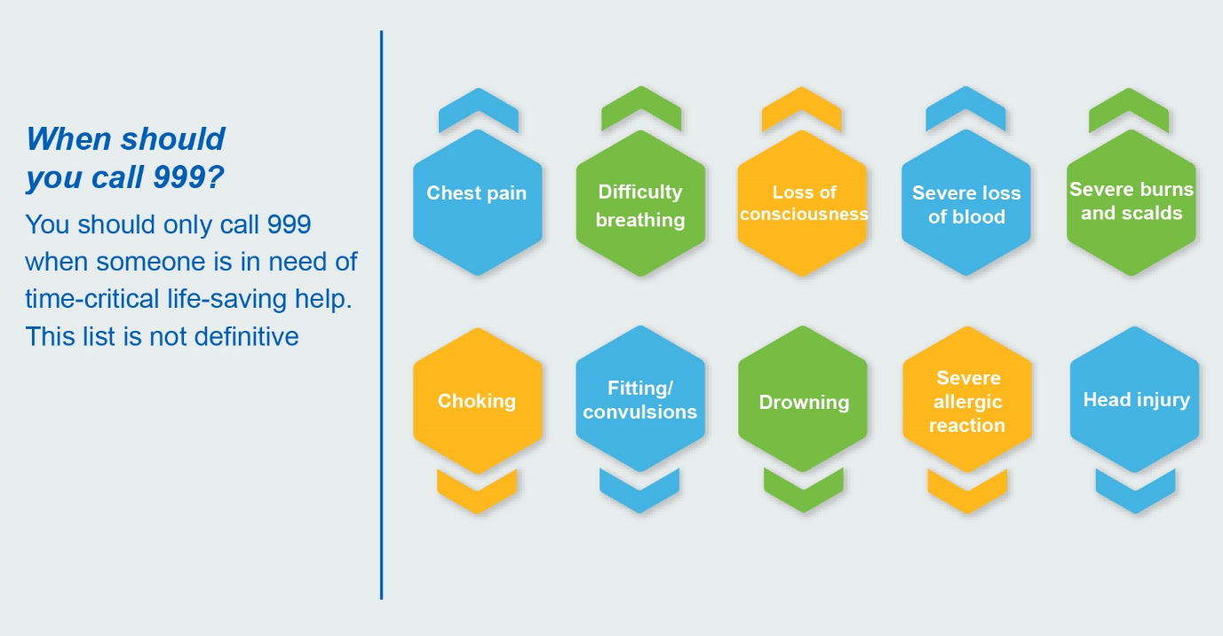

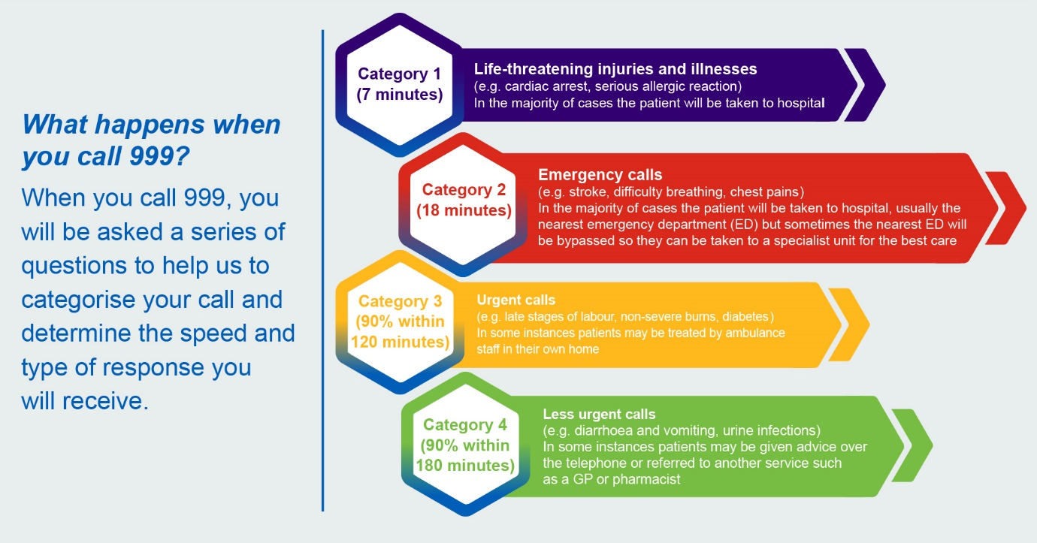

If you are a GP reading this document…
- Decide which category you require.

If you are a patient reading this document…
- Please think about whether you need an ambulance. In 2017, only 67% of patients who called 999 required hospital admission. So think!
- Of course, if you have a life-threatening condition or something MEDICALLY urgent like a stroke, chest pain or breathing problem - go ahead and call 999.
- If it something not urgent - think about talking to your local pharmacist, NHS 111 or GP.

