Hypoglycaemia

Adrenergic Symptoms | Neuroglycopenic Symptoms
- Tremor, Sweating, Paraesthesia  - Hunger & Nausea  - Palpitations  - Headache | - Drowsiness, Blurred Vision & Speech Difficulty  - Confusion, Coma, Loss of Consciousness  - Convulsions

Hypoglycaemia = Capillary Blood Glucose (CBG) < 4mmol/L

MILD: patient is awake, mostly compis mentis at home or in surgery:
15-20g of fast-acting carbohydrate is used to treat a hypoglycaemic episode if the patient is conscious and can self-treat.
- 5 large jelly babies
- 200ml smooth orange juice
- 150ml full sugar Coca Cola
- 5 or 6 dextrose tablets
- Note: Chocolate is not as good as the above. The fat slows down the release of sugar.
- More detailed notes on the second page

MODERATE: patient is confused or disorientated or aggressive but conscious & can swallow:
- GlucoGel® (2 x 25g tubes) or Rapilose® gel – squeezed into side of mouth (between teeth and gums). Massage cheeks gently from outside.
- More detailed notes on the second page

SEVERE: patient is unconscious or fitting
- Call 999
- Do not give any mouth glucose treatments
- Put in recovery position
- Give 1mg Glucagon injection s.c. or i.m.
- More detailed notes on the second page

More Detailed Algorithm for Hypoglycaemia

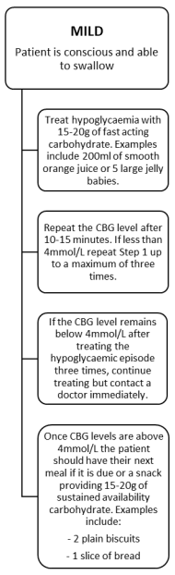 | 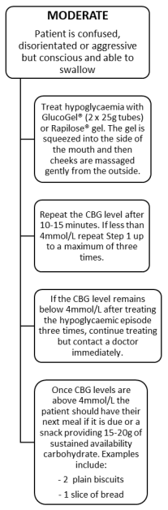 | 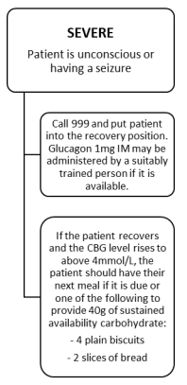

Treating Hypoglycaemia whilst driving

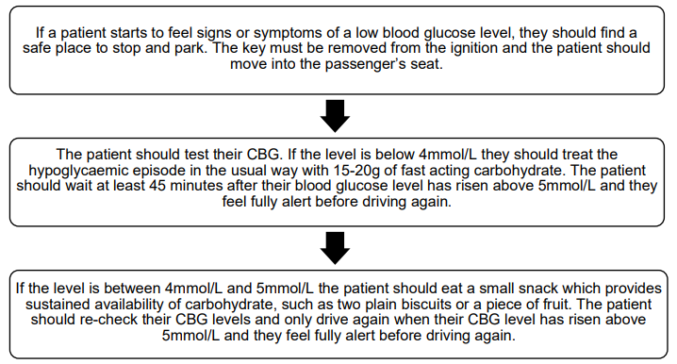

Notes
- Watch out for Lucozade. Since the introduction of The Soft Drinks Industry Levy in April 2018 many soft drinks companies changed the formulation of their products to reduce sugar content. As a result of this, 150ml of Lucozade® is no longer sufficient to treat hypoglycaemia. If patients choose to treat hypoglycaemia with Lucozade®, they will need to drink 170ml-230ml. (This figure is correct at the time of writing for Lucozade® Energy-Original. Patients should check the nutritional information on labels of hypoglycaemia treatment products to decipher what quantities would equate to 15-20g of carbohydrate.)

- When the patient has reached a CBG level of more than 4mmol/L they should take a snack providing sustained availability of 15-20 grams of carbohydrate (e.g. a sandwich, a cereal bar or 2 digestive biscuits) or the next meal (if it is due). This will prevent blood-glucose concentration from falling again.

- Flash glucose monitors or Continuous Glucose Monitors like the Freestyle Libre. They monitor interstitial blood glucose NOT capillary blood glucose levels (time lag). Glucose levels in the interstitial fluid lag behind glucose levels in your blood by up to 15 minutes. The lag time is longest if your blood glucose level is changing rapidly, after eating or if you are exercising. So… (1) Ask patient about their symptoms and (2) ask patients to test using their glucose blood strips.

