BRADFORD VTS TEACHING AIDS  Teaching aid for GP trainees & IMGs | UPDATED  June 2026
Helping Patients Stop Smoking
Behavioural interventions you can use in everyday GP consultations
◆ The big idea
You don’t need a long session to make a difference. A 30-second prompt plus an offer of help is one of the most powerful, lowest-cost things you can do in medicine.
Your job is not to win the argument in one visit — it is to plant the seed and hand over the map.

~30 sec  to deliver brief advice | ≈ 40%  higher odds of quitting  with counselling | No extra harm  behavioural support is safe

Why bother in a busy clinic?
- Smoking is the single biggest preventable cause of illness and early death in the UK. NICE NG209
- Stopping smoking at any age reverses much of the damage — the body starts to recover within days.
- Brief, opportunistic advice from a clinician reliably increases quit attempts — and it costs almost nothing. NCSCT; Cochrane 2021
Your core tool: the 3 A’s
Almost everything you do for smoking fits into three simple steps — known as Very Brief Advice (VBA). Memorise these three words and you have the whole model:
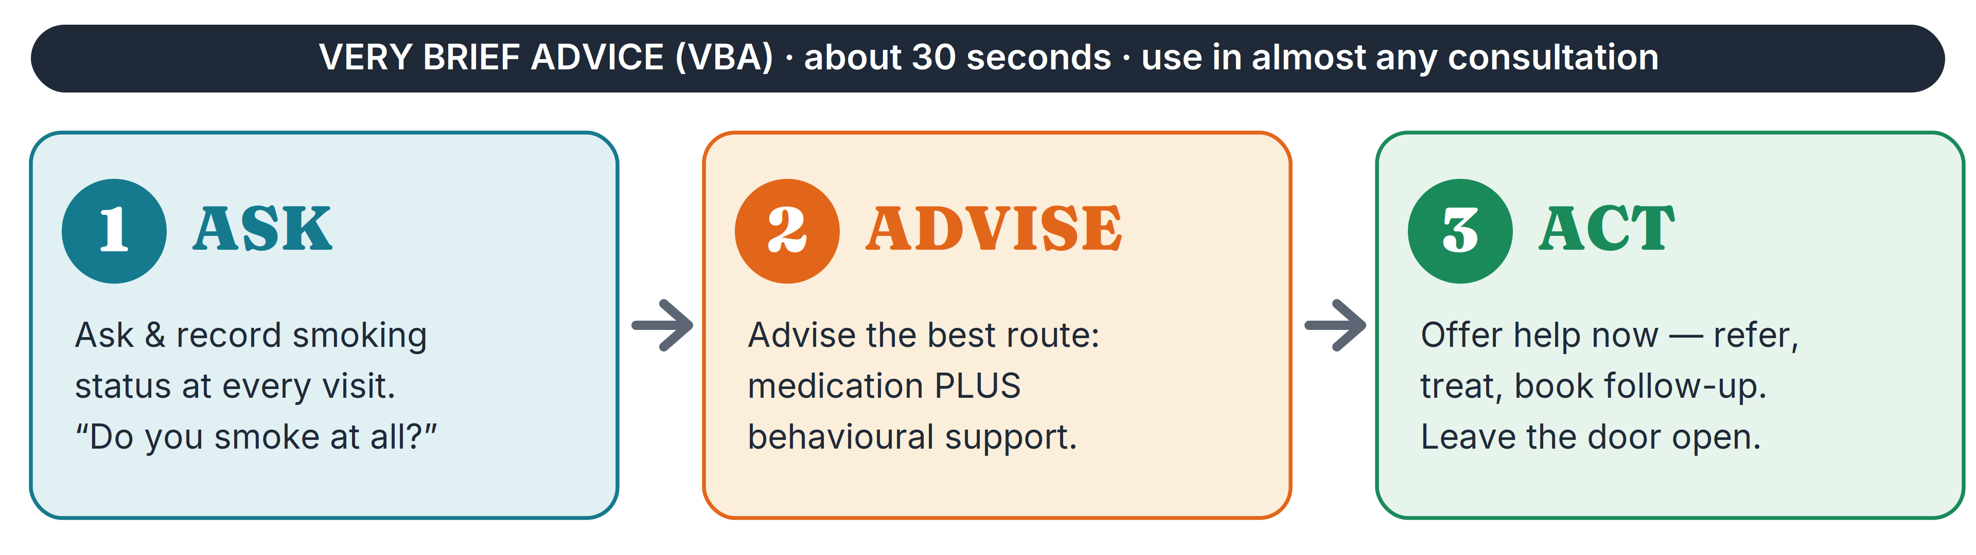
The 3 A’s — Ask, Advise, Act. A 30-second routine you can repeat in almost any consultation.
The 3 A’s in practice
1 · ASK — and record it
Ask every patient about tobacco, and record the answer. You must ask at every suitable opportunity, not just when smoking is the reason for the visit.
Try: “Do you smoke at all?” or “Have you used any tobacco in the last year?”
NICE NG209 rec 1.11.1 & 1.11.6

2 · ADVISE — the best route, not a lecture
Don’t nag or judge. Calmly advise the best way to quit: stopping in one go, using medication plus behavioural support together.
Say something like: “The best way to stop is with a combination of treatment and support — and I can set that up for you today.”
NICE NG209 rec 1.11.2, 1.12.6 & 1.12.8

3 · ACT — offer help today
Make an offer of help to everyone who smokes — don’t wait for them to ask.
Refer to your local stop-smoking support, start or arrange medication, and book a follow-up. If they decline, leave the offer open and ask again next time.
NICE NG209 rec 1.12.1 & 1.12.6; NCSCT VBA+

▲ What’s changed from older teaching
Old habit: assess how “ready” or “motivated” the patient is before offering help.
Now: offer help to everyone. Simply offering assistance triggers more quit attempts than advising people to stop. Do not make help conditional on the patient seeming motivated.

What actually works — the evidence
A large Cochrane review pooled 312 trials in over 250,000 people. Here is what it found, sorted by how strong the evidence is: Cochrane 2021, CD013229
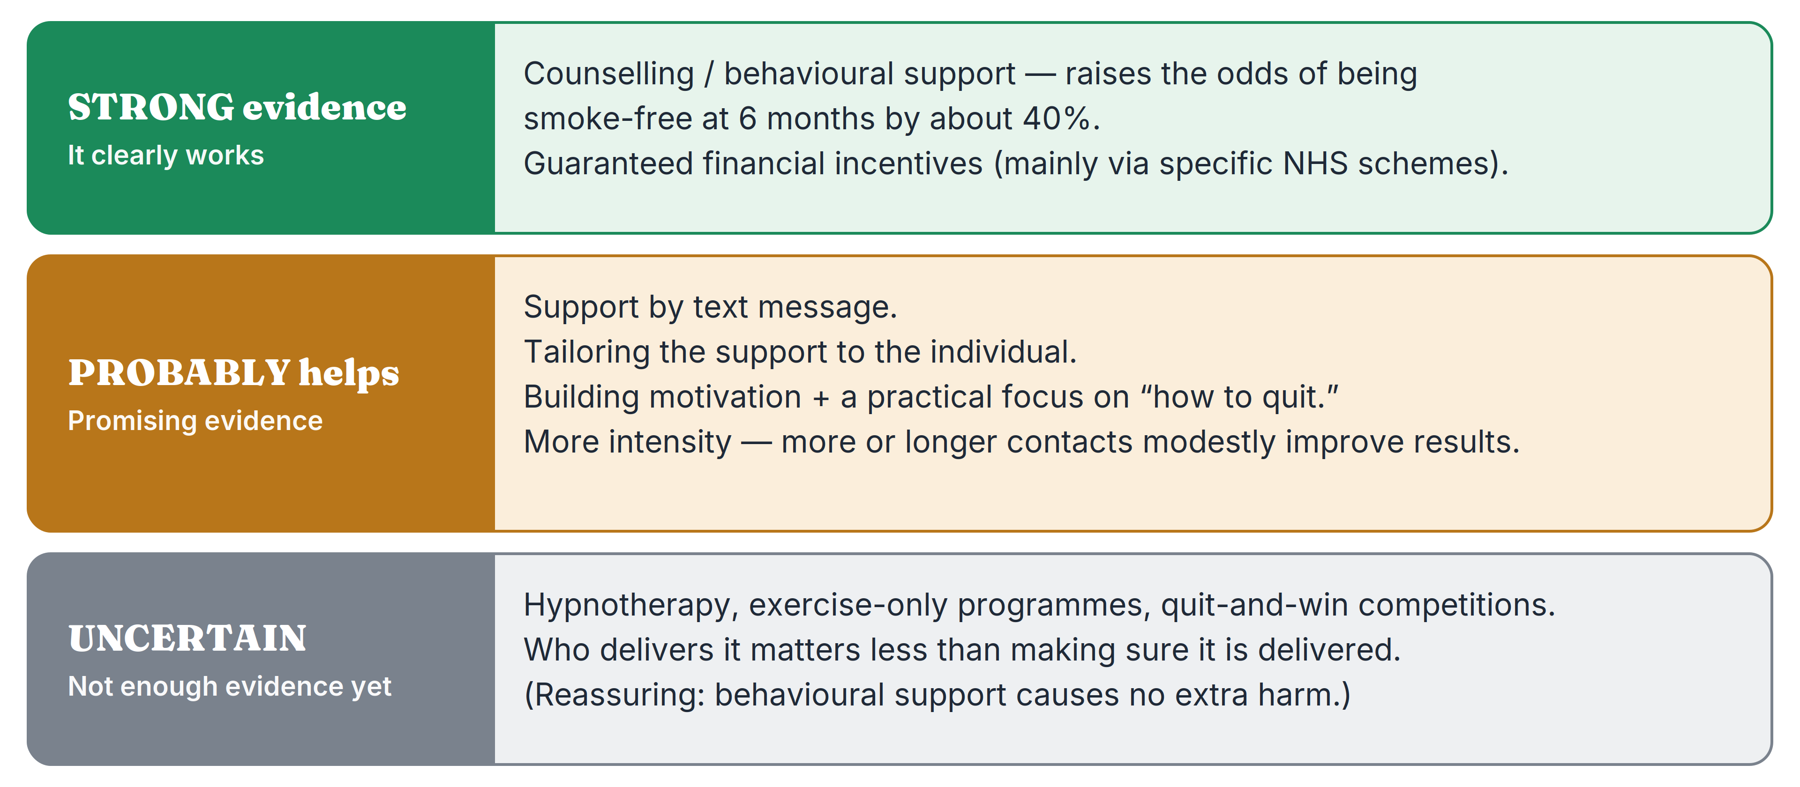
Strength of evidence for different types of behavioural support (Hartmann-Boyce et al., Cochrane 2021).
◎ The headline you can quote
Counselling and behavioural support clearly work: they raise the odds of being smoke-free at six months by about 40%, with no increase in harm.
Support helps whether or not the person also takes medication. Combining the two is the most effective approach — so never withhold medication just to “try support first.”
Why combine support with medication
Think of quitting as a vehicle with two engines. Each does a different job; together they pull much harder than either alone.
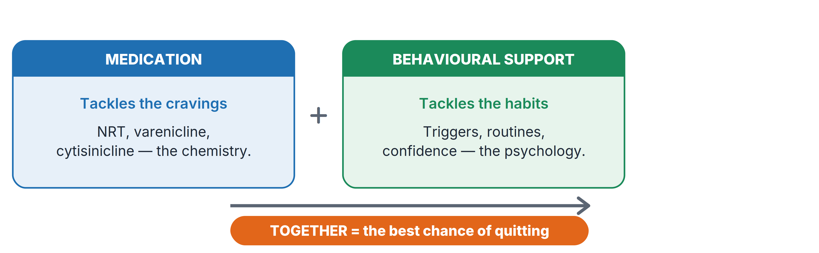
Licensed medicines NICE lists include combination NRT (short- and long-acting together), varenicline, cytisinicline, and bupropion; nicotine-containing e-cigarettes are also effective. For every choice, dose and contraindication, follow the BNF and NICE NG209 — do not prescribe from memory. NICE NG209 rec 1.12.2 & 1.12.8; BNF
▲ Safety — a few absolutes
Do NOT prescribe cytisinicline, varenicline or bupropion to anyone under 18. NICE NG209 rec 1.12.4
Do NOT offer cytisinicline to people aged 66 or over. rec 1.12.5
In pregnancy the rules differ: offer behavioural support, and follow the NICE NG209 pregnancy section and the BNF before any prescribing.
Make it stick: intensity & follow-up
More contact = better results
The more support a person gets — more sessions, longer sessions, a longer programme — the better their chances. So always book a follow-up rather than leaving it as a one-off.
Cheap add-ons that probably help: text-message support and tailoring advice to the individual. Cochrane 2021
When the patient isn’t ready
Some patients won’t want to stop today. Don’t push — keep the door open and do these four things:
- Get a quick sense of dependence: how many a day, and how soon after waking they have the first cigarette.
- Make sure they understand that stopping cuts their risk of serious illness.
- Offer a harm-reduction step — cutting down, often helped by nicotine replacement — as a bridge towards stopping.
- Leave the offer of help open, record it, and ask again next time. NICE NG209 rec 1.11.5

Quick guide: do and don’t
DO  - Ask and record smoking status at every visit.  - Offer help proactively to everyone who smokes.  - Combine behavioural support with medication.  - Book a follow-up — more contact works better.  - Refer to your local stop-smoking service. | DON’T  - Don’t lecture, judge or shame the patient.  - Don’t wait for the patient to raise it first.  - Don’t make help conditional on “being ready.”  - Don’t assume light smokers don’t need help.  - Don’t rely on willpower alone — offer treatment.

The 30-second recap
ASK every patient if they smoke — and record it.
ADVISE the best route: medication plus behavioural support.
ACT now — refer, treat, and book a follow-up.
Every contact counts. You are planting seeds — each prompt brings the next quit attempt closer.
Sources used
- NICE NG209 — Tobacco: preventing uptake, promoting quitting and treating dependence (2021, updated 2025).
- Hartmann-Boyce J, et al. Behavioural interventions for smoking cessation: an overview and network meta-analysis. Cochrane Database Syst Rev 2021, CD013229.
- NCSCT — Very Brief Advice on smoking (VBA+), 2021.
- BNF — for all drug doses, choices and contraindications.

◆ Disclaimer
This document is provided exclusively for educational and training purposes as a teaching aid. It does not constitute formal clinical guidance. Clinicians must independently verify all medical information, prescribing guidance, procedural protocols and legal requirements against current national guidance, local policies and the relevant regulatory bodies before applying it in practice.

