BRADFORD VTS TEACHING AIDS
Substance misuse — tutorial plan for GP trainers
GP Trainer Resource · Bradford VTS · May 2026

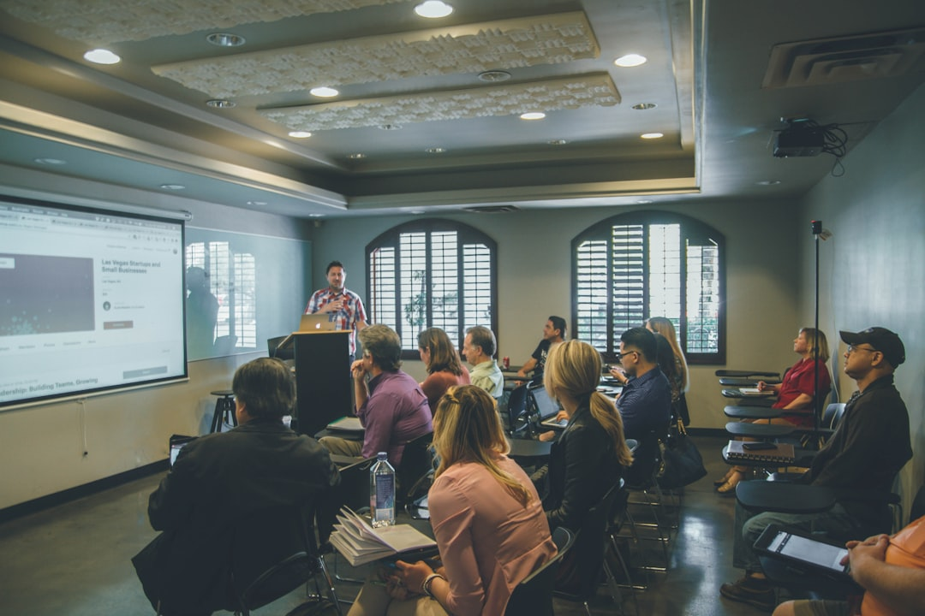
Figure 1. Small-group teaching and facilitation are central to safe, reflective GP training conversations about substance misuse.

This tutorial plan updates the original Bradford VTS teaching notes into a practical, IMG-friendly session guide for GP trainers. It uses current UK guidance and keeps the focus on safe assessment, harm reduction, safeguarding, collaborative care, and clear referral pathways.

Session overview
- Recommended duration: 60–75 minutes
- Audience: GP trainers teaching GP registrars or mixed primary care learners
- Teaching style: interactive tutorial using cases, discussion, and brief knowledge checks
- Core framing: non-judgemental, trauma-informed, person-centred, and safety-focused

Aims
- To help GP trainers run a structured tutorial on recognising, assessing, and managing substance misuse in primary care.
- To support trainees to balance patient-centred care with safeguarding, prescribing safety, and multidisciplinary working.

Learning objectives
- Describe what general practice can contribute to the care of people with substance misuse problems.
- Carry out a focused assessment covering substances used, dependence, physical health, mental health, risk, and social context.
- Differentiate between brief intervention, harm-reduction advice, supported withdrawal, opioid substitution treatment, and referral for specialist input.
- Recognise red flags requiring urgent same-day assessment, safeguarding action, or emergency referral.
- Discuss how to work with local drug treatment services / DAAT, mental health teams, maternity services, and safeguarding services.
- Reflect on personal attitudes, stigma, and communication skills when consulting with people who use drugs or alcohol.
AKT tip: Know the broad management categories: brief advice for lower-risk use, structured support for dependence, urgent escalation for overdose/withdrawal risk, and referral for specialist opioid or alcohol treatment pathways.

SCA tip: In simulated consultations, show empathy, ask permission before exploring substance use, quantify use clearly, check risk and safeguarding, and agree one realistic next step.

Why this topic matters
Substance misuse is common in UK practice and often overlaps with chronic disease, pain, mental illness, domestic abuse, homelessness, and safeguarding concerns.
In England, around 280,000 adults enter community drug and alcohol treatment each year, and the UK records more than 5,000 drug-poisoning deaths annually, underlining the need for safe, early intervention [1][2].

Suggested session plan
Timing | Section | Facilitation notes and learning activities | Suggested discussion questions
0–10 min | Opening and ground rules | Set a respectful tone. Invite trainees to name why this topic can feel difficult. Clarify that the session is about practical GP work, not specialist addiction medicine only. Agree confidentiality limits and remind the group to avoid stigmatising language. | What makes substance misuse consultations challenging in routine general practice? What language helps patients feel safe enough to be honest?
10–20 min | What GPs can offer | Use the original notes to explore access to general medical care, continuity, preventive care, prescribing safety, brief intervention, and coordination with local drug treatment services / DAAT. Emphasise that GPs should work within competence and local pathways rather than running unsupported prescribing schemes. | Which parts of substance misuse care are realistically provided well in general practice, and which need shared care or referral?
20–35 min | Assessment in three passes | Teach a first-pass assessment of motivation, current use, withdrawal/dependence, overdose risk, and immediate safety; a second pass covering physical and mental health, BBV risk, pregnancy, pain medicines, and prescribed drugs; and a third pass covering housing, finance, legal issues, family support, trauma, children, and safeguarding. | What questions help you separate current intoxication, dependence, and longer-term psychosocial need? Which red flags would change your management today?
35–50 min | Case-based management planning | Work through brief cases: experimental cannabis use, recreational stimulant use, stable opioid dependence, chaotic polydrug use, and dual diagnosis. For each case, ask trainees to define goals, immediate safety steps, whether prescribing is appropriate, and who else should be involved. | How would your plan differ for a patient asking for help to stop versus one seeking replacement prescriptions or crisis support?
50–60 min | Monitoring and follow-up | Discuss review intervals, urine drug testing limits, naloxone, BBV testing, contraception/sexual health, sick note issues, medication safety, and relapse planning. Stress negotiated care plans, documentation, and continuity. | When is urine drug testing useful, and when can it damage trust or add little clinical value?
60–75 min | Reflection and close | Return to attitudes, boundaries, team safety, and trainer modelling. End with key take-home messages and agreed actions for the trainee’s next substance misuse consultation. | How do your own assumptions about addiction influence your consulting style and decision-making?

Core teaching content for the trainer

1. What general practice can offer
- Accessible first-contact care for physical, mental, and preventive health needs.
- Continuity and relationship-based care, which can be therapeutic in its own right.
- Brief advice, motivational conversations, opportunistic intervention, and relapse support.
- Safer prescribing review, including dependence-forming medicines such as opioids, benzodiazepines, gabapentinoids, and z-drugs.
- Assessment and referral to local drug treatment services / DAAT or alcohol services when structured treatment is needed.
Facilitation note: Ask the trainee to compare an ideal GP role with the limits of actual local service capacity and GP competence.
Suggested discussion questions:
- How can continuity with one clinician reduce harm even when abstinence is not yet realistic?
- What are the risks of prescribing outside an agreed local pathway or without adequate monitoring?
AKT tip: Remember that maintenance treatment for opioid dependence is usually specialist-led or shared-care based. The exam often tests safe referral, risk assessment, and prescribing boundaries rather than brand-name regimens.

2. Assessment framework
- Start with the patient’s reason for attending today: what has prompted help-seeking now?
- Clarify each substance used: what, how much, how often, route, duration, last use, and past withdrawal symptoms.
- Ask specifically about alcohol, opioids, benzodiazepines, cocaine/crack, cannabis, amphetamines, synthetic cannabinoids, ketamine, nitrous oxide, and prescribed or over-the-counter medicines.
- Assess risk: overdose history, injecting, sharing equipment, seizures, delirium tremens history, suicidal ideation, self-neglect, exploitation, domestic abuse, and safeguarding concerns involving children or vulnerable adults.
- Review physical and mental health: liver disease, respiratory disease, infection, BBV risk, pregnancy, psychosis, depression, anxiety, PTSD, ADHD, and chronic pain.
- Explore social context: housing, debt, employment, legal problems, immigration stressors, trauma, family support, and caring responsibilities.
SCA tip: Examiners reward structure. Signpost: “I’d like to ask about what you are using, how it affects your health, and any immediate safety concerns, then we can decide the best support.”

Suggested discussion questions:
- Which features suggest dependence rather than occasional use?
- How would you assess capacity and reliability of history if the patient appears intoxicated?

3. Management options in current UK practice
- Use brief intervention and motivational interviewing for lower-risk or early problematic use.
- For alcohol dependence or high-risk drinking, assess withdrawal risk carefully; severe dependence, seizures, delirium tremens history, unstable mental or physical health, or poor social support may need urgent specialist or hospital assessment rather than community detox.
- For opioid dependence, do not start unsafe ad hoc prescribing. Follow local pathways and seek specialist advice or urgent referral if opioid substitution treatment is being considered.
- Offer harm reduction: overdose advice, naloxone access where available, safer injecting advice, BBV testing, vaccination where appropriate, contraception and sexual health support, and smoking cessation.
- Review prescribed dependence-forming medication and avoid abrupt discontinuation without a clear plan, especially where withdrawal or illicit substitution is likely.
- Document shared decisions, risk, safeguarding, and the follow-up plan clearly.
Facilitation note: Link management to the original “first wave / second wave / third wave” structure so trainees see how assessment drives action.
Suggested discussion questions:
- When is same-day referral safer than trying to contain the issue in routine primary care?
- What harm-reduction advice should be routine even if the patient is not ready to stop?
AKT tip: Be alert to alcohol withdrawal red flags: previous seizures, delirium tremens, confusion, unstable comorbidity, or lack of support. These usually push management away from routine outpatient detox.

4. Interpreting common patient patterns
- Experimental use: avoid overreaction, assess wider risk, and use honest education.
- Recreational use: focus on safer use, mental health impact, driving/work risks, and escalation warning signs.
- Stable dependence: explore readiness to change, support networks, and realistic referral or shared-care options.
- Chaotic dependence or polydrug use: expect complexity, prioritise safety, and involve multiple agencies early.
- Dual diagnosis: integrated planning is essential; do not assume mental health symptoms are purely substance-induced or vice versa.
Suggested discussion questions:
- How should the consultation differ between an experimental cannabis user and a chaotic opioid-and-benzodiazepine user?
- What practical steps can a GP take when both mental illness and substance misuse are active problems?
SCA tip: A safe consultation often scores better than a “clever” one. Clarify risk, negotiate a plan, provide safety-netting, and arrange follow-up instead of overpromising specialist treatment from general practice.

5. Urine drug testing: when it helps and when it does not
- Urine testing may support assessment if the history is unclear, if legal or occupational reports require objective information, or within agreed specialist/shared-care protocols.
- It should not replace a good clinical assessment.
- Poorly explained testing can undermine trust, and results can be hard to interpret because detection windows vary between substances.
Suggested discussion questions:
- What are the clinical and relational downsides of routine urine testing in general practice?
- How would you explain the limits of test results to a trainee or patient?

6. Professional attitudes, boundaries, and team safety
- Encourage trainees to notice feelings such as frustration, rescue fantasies, fear, or therapeutic pessimism.
- Promote non-stigmatising language: “person with opioid dependence” is better than “addict”.
- Set clear boundaries around prescribing, communication, aggression, and missed appointments.
- Ensure staff know local procedures for lone working, panic alarms, and responding to threatening behaviour.
Suggested discussion questions:
- Which clinician attitudes can unintentionally increase shame or disengagement?
- How can practices support staff confidence and safety without becoming punitive?

Key current clinical updates for trainers
NICE and current UK guidance continue to support harm reduction, trauma-informed care, BBV prevention, and coordinated multidisciplinary management.
Naloxone access, overdose prevention advice, and attention to polydrug use remain important because deaths often involve multiple substances, including opioids, benzodiazepines, gabapentinoids, or alcohol [2][3].
Nitrous oxide misuse, synthetic drugs, and misuse of prescribed medicines should now be part of routine questioning in younger adults and mixed-use presentations.
Safeguarding should be proactive: ask about children in the household, pregnancy, coercion, exploitation, and domestic abuse.

Suggested closing summary for the trainer
- General practice is often the first place where harmful substance use becomes visible.
- A structured assessment, realistic management plan, and clear follow-up usually matter more than trying to solve everything in one consultation.
- Safe prescribing boundaries, safeguarding, and collaborative work with local drug treatment services / DAAT are central to good care.
- Respectful language and curiosity improve engagement and outcomes.

References
[1] Office for Health Improvement and Disparities. Adult substance misuse treatment statistics 2022 to 2023: report. https://www.gov.uk/government/statistics/substance-misuse-treatment-for-adults-statistics-2022-to-2023
[2] Office for National Statistics. Deaths related to drug poisoning in England and Wales: 2023 registrations. https://www.ons.gov.uk/peoplepopulationandcommunity/birthsdeathsandmarriages/deaths/bulletins/deathsrelatedtodrugpoisoninginenglandandwales/2023registrations
[3] NICE. Overview | Drug misuse prevention: targeted interventions | Guidance. https://www.nice.org.uk/guidance/ng64
Important: Always double check this advice and drug doses with the latest NICE/BNF guidance. This document is for educational purposes only.

