Pure Tone Audiometry (PTA)

By Abby Milchard MSc
Clinical Scientist
Audiology Department
Royal South Hants Hospital
Souithampton

Measuring Hearing Loss using PTA

The audiogram is the chart on which hearing ability is recorded and shows the threshold hearing level (in dB HL) against the frequency (in Hz). There are 4 audiometric descriptors to describe hearing loss: mild (20-40 dB), moderate (41-70 dB), severe (71-95 dB) and profound (>95 dB). These are based on the average of the pure-tone hearing threshold levels at 250, 500, 1000, 2000 and 4000 Hz. Averages do not imply any particular configuration of loss and do not exclude additional terms e.g. high-frequency loss. Although hearing levels of better than 20 dB HL are within the normal range, they do not necessarily imply normal hearing as there may be additional factors involved.
(The banana shaped section is where speech sounds are heard during normal one to one conversation).

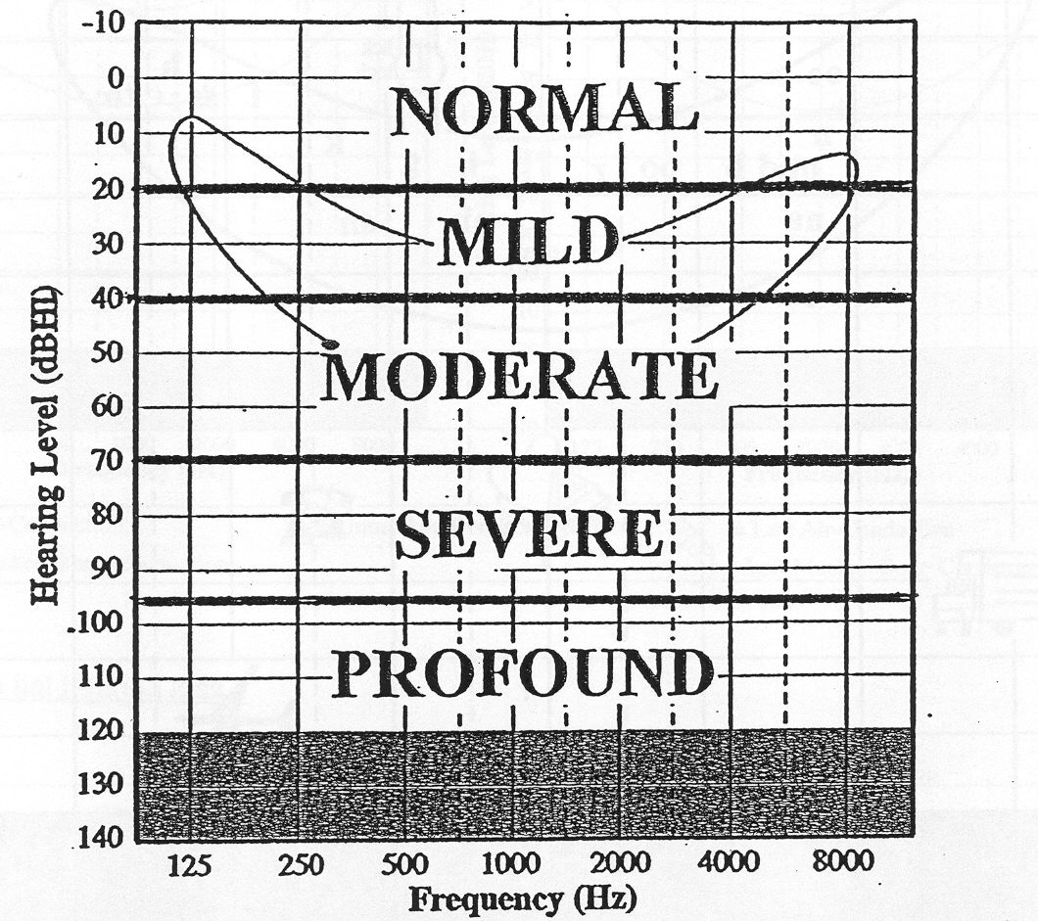

Air conduction (AC) testing is the testing of hearing through headphones, where sound is delivered into the external auditory meatus and travels through the middle ear and inner ear before travelling along the auditory nerve to the brain. Air conduction results tell us essentially what levels a person can hear sounds in their environment. Bone conduction (BC) testing is the testing of hearing by bone vibration, which in effect allows sound to bypass the middle ear and travel straight to the inner ear before travelling up to the brain. This enables a clinician to determine whether a hearing loss is due to an abnormality in the middle ear, inner ear or both e.g. if thresholds are significantly better using bone conduction testing than air conduction testing, this suggests a middle ear abnormality.

A hearing test should always begin with otoscopy to look for wax and any abnormalities in the ear. If there is occluding wax, this can artificially raise (make worse) the thresholds at high frequencies for air conduction and artificially lower (improve) the thresholds at low frequencies for bone conduction. Therefore this should always be removed prior to testing where possible.

Symbols: Right ear air conduction: O
Left ear air conduction: X

Examples Using Air Conduction

Examples of various types of hearing loss follow.

- Normal hearing

- Severe flat hearing loss

- Moderate sloping high frequency hearing loss

- Left corner audiogram

Bone Conduction

Definition

The transmission of sound to the inner ear primarily by means of mechanical vibration of the cranial bones.

Bone Conduction Testing

In man, there is no physiological useful purpose for this system and the ossicular chain is balanced to diminish bone conduction to reduce body noises. The ear is approximately 60 dB less sensitive to airborne sound via bone conduction than air conduction. However, BC can be useful in estimating the integrity of the sensorineural system and the difference between AC and BC thresholds for the same ear is known as the air-bone gap. The air-bone gap gives the degree of conductive loss.

Interpretation

BC thresholds are used as a test of cochlear integrity. For example, if the BC thresholds are 20 dB HL or less then there is no sensorineural loss and if they are greater than 20 dB HL, then there is a sensorineural hearing loss present.

BC thresholds can be used to evaluate a hearing loss. The example shown below fro the right ear shows the AC and BC matching which shows there is no conductive element to the hearing loss. The example on the left ear shows masked (see later for explanation of masking) bone conduction thresholds better than the air conduction thresholds, which shows a conductive element to the hearing loss. The gap magnitude of the air-bone gap indicates the degree of conductive hearing loss.

These applications rest on the assumption that BC results are a measure of cochlear function. This is not true. BC results can be affected by the status of the external and middle ear due to the mechanisms of transmission of bone conducted sound. In one situation, this can be useful in diagnosing a problem. In the presence of ossicular fixation (usually due to a condition called otosclerosis), the bone around the stapes footplate overgrows. This leads to an apparent reduction in bone conduction threshold at 2 kHz as this is near the resonant frequency of the ossicular chain. The apparent sensorineural loss caused by a conductive problem is called a Carhart notch.

Masking

If both ears have similar thresholds, cross-hearing is not a problem. However, problems arise when the non-test ear has much better thresholds than the test ear; the cross-heard portion of the sound may become audible to the non-test ear before it becomes audible to the test ear. The response of the patient would then reflect the sensitivity of the non-test cochlea rather then the test ear and these are called shadow responses. It is bad practice to rely on the patient reporting which ear they are hearing the tone in, as they often cannot give this information accurately. Masking is the method used to establish the true responses from the test ear. The idea of masking is to raise the threshold of the non-test ear so that we can be sure that the results obtained are correct for the ear being tested. This may be achieved by introducing a masking noise into the non-test ear of the appropriate intensity to prevent it from detecting the test signals. To predict cross hearing, we assume minimum interaural attenuations i.e. 40dB for AC and 0 dB for BC.

Air conduction

We predict whether cross hearing for air conducted sound has occurred by looking to see if there is a difference of 40 dB or more between the air conduction thresholds of the worse hearing ear and the air or bone conduction thresholds of the better hearing ear. This is because the level of the tone in the poorer ear at that frequency may have been so loud as to have crossed over via bone conduction and have been heard by the better ear. Therefore, the real threshold for the poorer ear at that frequency may actually be worse than appears at first.

Masking is required at all 6 frequencies 250-8000 Hz, with the right ear as test ear, as the presentations in the right ear at these frequencies could have been cross-heard by the left ear.

Masking is required at 500, 1000, 2000 and 4000 Hz,with the left ear as test ear, as the presentations in the left ear at these frequencies may have been cross-heard by the right ear. If there is significant change, then masking will be required at 250 and 8000 Hz also.

Bone conduction

We predict whether cross hearing for bone conducted sound has occurred by looking to see if there is a difference of 15 dB or more (i.e. if there is a significant conductive or mixed loss) between the air conduction thresholds (of either ear) and the not masked bone conduction.

Masking is required at 500 and 1000 Hz as the bone conduction presentations at these frequencies on the right side may have been cross-heard by the left side. We are therefore unsure if the loss in the right ear is conducive or sensorineural.

Rules of Masking

Masking is commonly applied in 3 rules, based on the theory of interaural attenuation as previously explained. Rules do simplify work and getting to grips with audiometry when you are learning. But, there are downsides:

- There is a tendency to get so fixed on applying the rules that you fail to grasp the concept of cross hearing and why you are masking
- The rules do over generalise and there are times when they fail to encompass all examples
- This in turn can lead to unnecessary masking or not masking in situations where it might be appropriate
- The rules do not take into account all the evidence for interaural attenuation – especially for bone conduction

Masking Rule 1

Masking will be needed at any frequency where the difference between the left and right not-masked air conduction thresholds is 40 dB or more (55dB or more if using insert earphones).

I.e. Difference between right and left AC (not-masked) > 40 dB (or 55dB with inserts)

For example:
In this case we know that the cochlear hearing of the right ear is normal and better than that recorded in the left ear by 40 dB or more at every frequency except 250 Hz. After masking, if the thresholds are in fact shown to be worse than what was first recorded, this is denoted by shading in the original thresholds and recording the new thresholds underneath. If a point on the audiogram is masked but does not change, it is denoted by shading in the bottom half of the symbol.

Masking Rule 2

Masking will be needed at any frequency where the not-masked bone conduction threshold is better than the air conduction threshold (on either ear) by 10 dB or more.

I.e. Difference between not-masked BC and AC is > 10 dB
(This is the BSA Recommended Procedure but the former ISVR Protocol stated >15 dB and this value is commonly used across the country)

For example:

In this case, the not-masked BC thresholds may belong to the better hearing ear on the right side. Therefore, we cannot be sure if the hearing loss on the left side is conductive, sensorineural or mixed. Hence masking must be carried out to determine the bone-conducted thresholds of the left ear. Although the interaural attenuation may be as low as 0 dB, it is not necessary to mask unless there is an air-bone gap of 15 dB or greater. This is because, unless there is an air-bone gap of this size, the gap is not considered to be significant and the hearing loss is said to be sensorineural.

Another example:
If the bone conduction threshold with masking remains the same, or only increases by 5 or 10dB, it is possible that the not-masked BC results were from the ear with the worse air conductions threshold, and it may be necessary to test the better ear while applying masking to the worse ear. This will establish the true bone conduction for the ear with the better air conduction.

It is still good practise to use an earplug in the test ear at 4000 Hz when masking for bone conduction.

Although this rule may frequently indicate the need for masking, there will be occasions where this is not warranted, depending on the purpose of the investigation. The rule is also assuming interaural attenuation of 0dB at each frequency. While this can, on occasion, save time doing unnecessary masking, it does mean that conductive losses can be missed (see lecture for examples). Remember that current data suggests that the IA for BC can be up to 20 dB.

Masking Rule 3

Masking will be needed additionally where Rule 1 has not been applied, but where the bone conduction threshold of the better ear is better by 40 dB or more (or 55 dB if using insert earphones) than the not-masked air conduction threshold attributed to the worse ear.

I.e. Difference between the not-masked BC and worse not-masked AC > 40 dB (or 55dB with inserts)

The reason for this is in fact similar to Rule 1. In Rule 1, the worse ear was masked in case the tone delivered to that ear had been picked up by the better hearing cochlea on the better hearing ear. In the example that follows, the right ear has a conductive loss and hence a normal working cochlea and it is possible that the tone delivered to the left ear was so loud as to have been cross-heard by the better hearing cochlea on the right side, even though there is a hearing loss in that ear.

For example:
If Rule 3 applies at the frequencies where bone conduction is tested, masking should also be considered at the frequencies not tested by bone conduction, as the principle will likely apply at those frequencies as well.

Rule 3 can over-generalise and a knowledge of cross hearing is required to establish whether it is appropriate to mask.

Suspicious Audiograms

The following are apparently finished audiograms that are extremely unlikely given the principles we have already discussed in audiometry.

This audiogram has not been masked and yet there is more than 80 dB difference between the ears. It would be expected that cross-hearing should have occurred, resulting in better not-masked AC thresholds than are suggested here. This is likely to be the case of a non-organic hearing loss.
This audiogram suggests a conductive loss on the right side, which exceeds the maximum interaural attenuation for most people. Also it is extremely likely that there could be a purely conductive loss of more than 70 dB as, with the absence of a middle ear, hearing thresholds would still be approximately 70 dB.

This audiogram shows not-masked bone conduction much worse than the best air conduction thresholds. While there may be up to 20 dB interaural attenuation, this exceeds this and is a likely indicator of a non-organic hearing loss.

