FIT testing: reducing unnecessary colonoscopies June 2022

There has been new guidance by BSG and ACPGBI in June 2022. The aim is to able to spare patients unnecessary colonoscopies, release capacity in 2WW lower GI pathway, and ensure the most urgent symptomatic patients are seen more quickly.
Lower GI Cancer FastTrack referrals should be accompanied by a FIT result,
with the result recorded in the twenty-one days leading up to the referral
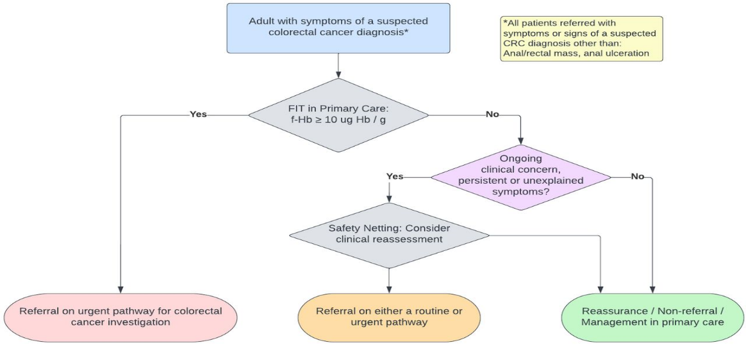

It recommends:
All adults with symptoms of a suspected colorectal cancer diagnosis, including those with rectal bleeding, should be offered a FIT test in primary care, except those with an
- anal/rectal mass or
- anal/rectal ulceration.

Patients who have persistent/recurrent anorectal bleeding BUT whose FIT is fHb <10μg Hb/g refer for flexi-sigmoidoscopy but this does not need to be on the Lower GI FDS pathway.

The risk of ColoRectal Carcinoma (CRC) with normal FIT, normal examination, and normalFBC is <0.1%

Read full guidance Faecal immunochemical testing (FIT) in patients with signs or symptoms of suspected colorectal cancer (CRC): a joint guideline from the Association of Coloproctology of Great Britain and Ireland (ACPGBI) and the British Society of Gastroenterology (BSG) | Gut (bmj.com)
Current 2WW Referral Criteria
1. Patients over 40 years:
- Unexplained weight loss with Abdominal pain
- Lower abdo mass
- Rectal mass
- Rectal bleeding and one of the following:
  - Unexplained change in Bowel Habit
  - Unexplained iron deficiency anaemia

2. Patients over 50 years (in addition to 1):
- Unexplained Rectal bleeding
- Positive FIT (see below for when to consider testing) * BFD ONLY

3. Patients over 60 years (in addition to 1 & 2)
- Unexplained change in bowel habit

Consider testing for occult blood in faeces to assess in adults without rectal bleeding who:
- Aged >50yrs with unexplained, abdominal pain or weight loss, or
- Aged <60 with changes in bowel habit or iron-deficiency anaemia**, or
- Aged >60yrs and have anaemia even in absence of Iron deficiency

