BRADFORD VTS TEACHING AIDS
Date: July 2026
MENTAL HEALTH · CONSULTATION SKILLS
CBT for GPs
Simple cognitive behavioural techniques for the 10-minute GP consultation

ABOUT THIS TEACHING AID
Satwant Singh looks at the benefits of cognitive behavioural therapy and explains how you can use some simple techniques with patients during routine consultations.
Healthcare professionals who have been trained to use cognitive behavioural therapy techniques feel more skilled when working with patients with mild to moderate depression and anxiety — and, in my experience, patients benefit too.

WHERE CBT SITS TODAY
Cognitive behavioural therapy is a short-term, structured psychotherapy. It remains one of the core NICE-recommended psychological treatment options for depression (NICE NG222, 2022) — offered in guided self-help, group and individual formats alongside options such as behavioural activation and interpersonal psychotherapy — and it is a first-line psychological treatment for most anxiety disorders.

1 | What is cognitive behavioural therapy?

As the word “cognitive” implies, the therapy deals with our thoughts and how they affect the way we feel and behave.
For example, imagine that you notice a heartsink patient on your morning surgery list. Ask yourself: “What thoughts are running through my head, and how are these making me feel and behave?”
Figure 1 demonstrates how our thoughts affect the way we feel and behave, and the link between thoughts, feelings, and behaviour.
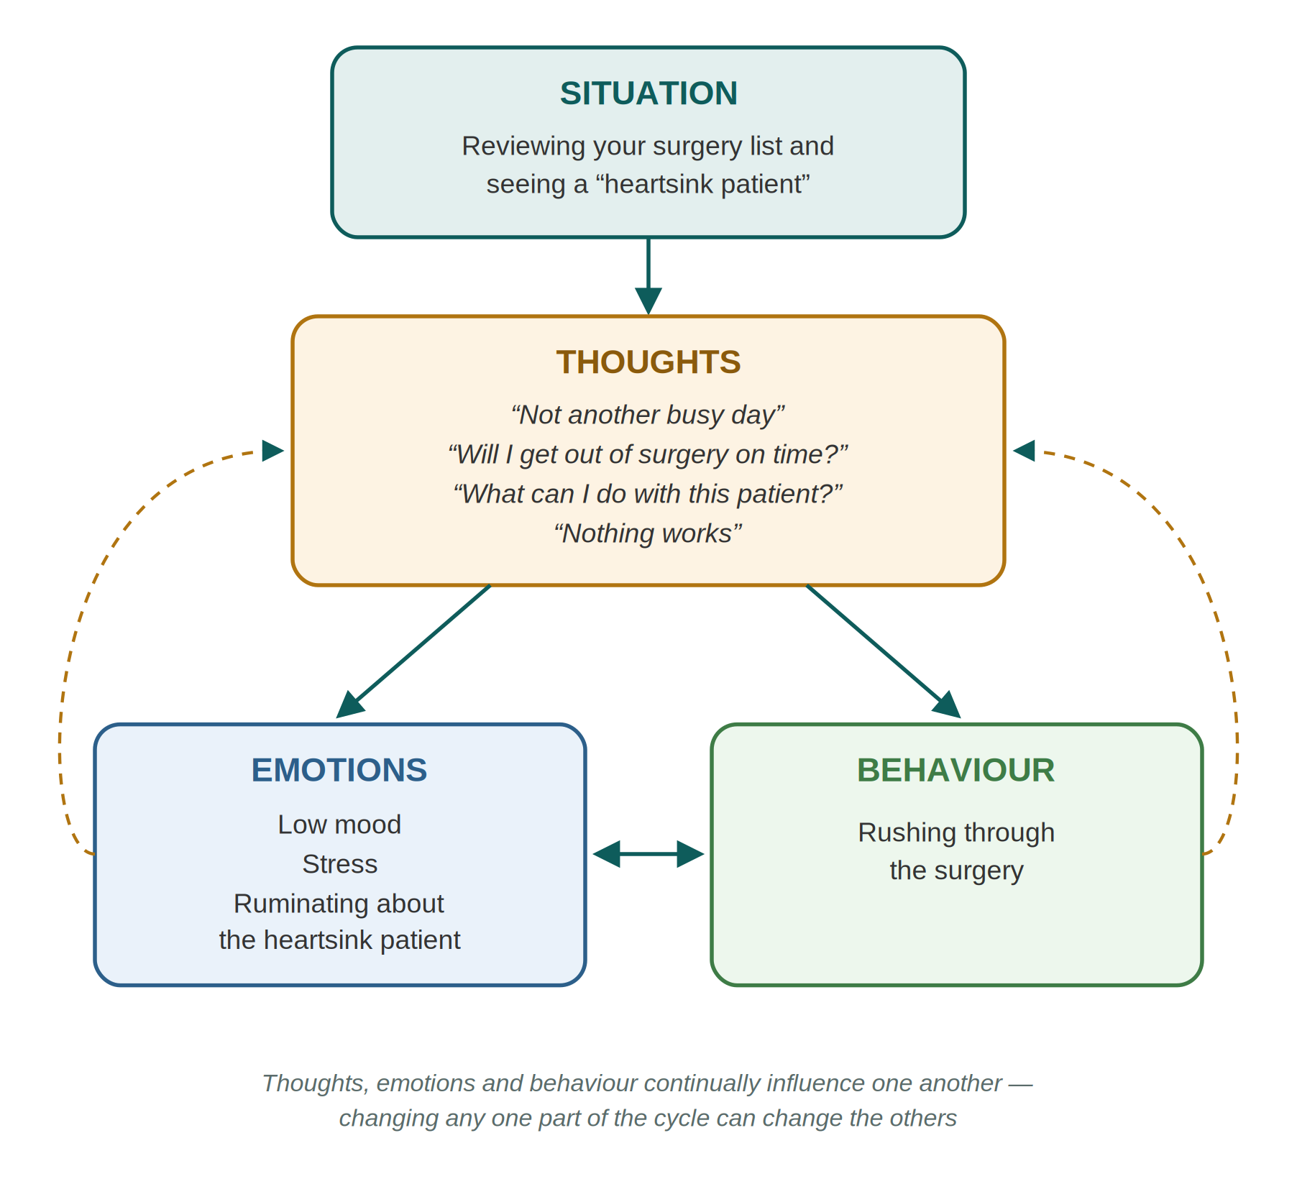
Figure 1. The cognitive model — the link between a situation, our thoughts, feelings and behaviour
The theory behind cognitive behavioural therapy is that we interpret information according to our beliefs and assumptions. These beliefs and assumptions are formed from our experiences in life; our core beliefs come from our early childhood experiences.
People often misinterpret information, however, and this leads to negative emotions. People misinterpret information because of their thinking styles, often known as “thinking errors” or “thought distortions” (Table 1).

Table 1. Types and examples of thinking errors
Type of thinking error | Explanation | Example
Black and white thinking | Seeing things in extremes | “I did not make the patient better, therefore I am no good”
Labelling | Giving yourself a label | “I am a failure”
Emotional reasoning | Using your feelings as evidence | “I don’t feel I am capable of doing anything”
Mind reading | “Knowing” what others are thinking | “They must not like me”
Fortune telling | “Knowing” how things are going to turn out | “I am not going to apply for the job because I know I won’t get it”
Catastrophising | Thinking of the worst-case scenario | “I am going to fail”
Demands | Musts and shoulds | “I must be able to make him better”
Blame / personalising | Personalising things to yourself | “If I were there, this would not have happened”
Overgeneralising | When one thing goes wrong, everything goes wrong | “It always happens to me”
Mental filtering / selective attention | Only looking at evidence that fits with the way you feel | “I always get told off” (disqualifying the times you have been praised for good work)

In cognitive behavioural therapy, the therapist and patient work together to understand the patient’s problem and identify patterns of thinking and behaviour that drive their difficulties. Treatment continues between sessions with homework assignments. The homework includes:
- Monitoring thoughts
- Challenging distorted thinking
- Identifying underlying assumptions
- Testing out specific beliefs

THE END GOAL
Patients also learn how to become their own therapist and deal with problems as they arise — the skills last well beyond the course of treatment.

2 | Who is suitable?

The patient must be able to engage with the therapy. In other words, the patient needs to understand the link between their thoughts and the way they feel. A simple way of assessing this is to ask the patient what thoughts they have and how these thoughts make them feel. For example:
CONSULTATION IN PRACTICE — testing whether a patient can make the thought–feeling link
Healthcare professional | You were saying that you are feeling down?
Patient | Yes, for the last week.
Healthcare professional | What thoughts do you get when you feel down?
Patient | I am no good, nothing is working out right.
Healthcare professional | How do those thoughts make you feel?
Patient | I feel even more down.

THE SUITABILITY TEST IN ONE LINE
If a patient can name a thought and describe how it makes them feel, they can usually engage with CBT-style work.

3 | Accessing CBT Services

NHS Talking Therapies. In England, the main route to NICE-recommended CBT for anxiety and depression is now the NHS Talking Therapies for anxiety and depression programme (formerly IAPT). Patients aged 18 and over (16+ in some areas) can self-refer directly — no GP letter is needed — or be referred by any primary care professional. Services offer guided self-help, group work and individual CBT, delivered in person, by phone, by video or through supported digital programmes.
Accredited therapists. The British Association for Behavioural and Cognitive Psychotherapies (BABCP) maintains the CBT Register UK & Ireland — accredited by the Professional Standards Authority — of accredited therapists who provide cognitive behavioural therapy both on the NHS and privately (babcp.com). You could direct your patient to this register, particularly if they are considering private therapy.
Patients can also use self-help manuals to understand the concept of the therapy, but many patients will still need the professional support of a therapist to help them with difficult areas.
Digital CBT. Digitally enabled (online and app-based) CBT has matured considerably. NICE now recommends guided self-help — including digitally enabled therapies delivered with practitioner support through NHS Talking Therapies — as a first-choice option for most people with less severe depression, and has conditionally recommended a range of digital CBT programmes for depression and anxiety disorders while further evidence is generated.
PRACTICAL POINTS FOR THE CONSULTATION
• Signpost self-referral: patients can find their local service via nhs.uk (“find NHS Talking Therapies”).
• Waiting lists are common — the simple techniques in this teaching aid are ideal to use while patients wait.
• For eating disorders, bipolar disorder, personality disorder, psychosis or drug/alcohol problems, refer to the appropriate specialist service rather than Talking Therapies.

4 | Techniques you can use in your consultations

Cognitive behavioural therapy is widely available through psychology services and NHS Talking Therapies, but there may be a waiting list. It can be useful to use these early intervention techniques with your patient while they are waiting for therapy.
Here are some simple cognitive behavioural therapy techniques that you can use in consultations with any patient, whether or not they have mental health problems.

Socratic dialogue
This is a simple way of questioning that allows the patient to elaborate and participate fully. Example questions are:
- How did it affect you?
- What did you do to deal with it?
- Was it helpful?
- How might your spouse or partner deal with this?
- What do you do when you feel like this?

These questions help you find out as much information as possible and have a better understanding of what the patient means.

Recognising thinking errors
By spotting patients’ thinking errors (or thought distortions) (see Table 1), you can explore with patients how they are distorting their thinking. For example:
CONSULTATION IN PRACTICE — gently naming a thinking error
Patient | I felt such a failure as a mother when I couldn’t buy my son the shoes he wanted.
Healthcare professional | Do you think you might be seeing things in the extreme?

Disputing the negative thoughts and thinking errors
This technique can help patients look at other ways they could view a situation. The healthcare professional could ask their patient:
- Would you say that if a mother can’t buy her children what they want, that makes her a failure?
- Is buying things for your children the only thing that makes you a good mother?
- What are the key things that make a good mother?
- What are the good things that you are doing for your children?
- What would your friends think makes a good mother?

Scheduling activities
Simple techniques that help patients plan their activities can be valuable, especially for patients with depression. Not only do they start doing more, but the feeling of doing something despite having depression empowers them.
A useful technique is to find out from your patients what they enjoy doing, and then encourage them to alternate this with a task that they have to do. For example:
CONSULTATION IN PRACTICE — pairing a chore with a reward
Healthcare professional | What do you enjoy doing?
Patient | Having a cup of tea.
Healthcare professional | Would it be possible for you to do some washing up, and when you complete it, have a cup of tea?

Figure 2 shows how patients can use a schedule to help plan their time.
Figure 2. Activity schedule
Time | Mon | Tue | Wed | Thu | Fri | Sat | Sun
09.00–10.00
10.00–11.00 | Do the washing up
11.00–12.00 | Have a break and a cup of tea
12.00–13.00

Shared understanding
If you and your patient share your understanding of their problem and of the treatment options, patients can be more likely to complete their treatment. They will also learn more about their mental health. Begin by finding out what the patient understands about their condition. For example:
CONSULTATION IN PRACTICE — building a shared formulation
Healthcare professional | How would you make sense of the problem that you have come to see me about?
Patient | My fear of getting a panic attack has made me avoid going out of the house.
Healthcare professional | We can see how your fear of having a panic attack has stopped you from going out, and this has gradually got worse over the last few months.

Putting it into practice
You can use these techniques in a 10-minute consultation. It’s worth first trying them out on yourself when you’re in situations where you feel uncomfortable:
- Jot down your thoughts
- Identify the thinking errors
- Then try taking a different perspective and ask yourself: “What would I say to my colleague if my colleague said this to me?” “What would my colleague say to me?”

IF YOU FIND YOURSELF STUCK
You may find you’re unable to use these techniques. If so, it might be useful to ask yourself:
• What is stopping me from using these techniques?
• What do I need to enable me to use cognitive behavioural therapy skills in my consultations?

5 | Evidence

At the time this article was written, one randomised controlled trial had looked at training GPs to use cognitive behavioural therapy, although GPs were given only brief training. There was no improvement in patients’ depression in the intervention group (King et al, BMJ 2002).
The author’s conclusion — that a new training model was needed, with more support and supervision of healthcare professionals while they develop their skills in cognitive behavioural therapy — has largely been borne out. Structured training, supervision and stepped-care delivery are now built into the NHS Talking Therapies programme, and CBT itself has a strong evidence base and remains a NICE-recommended first-line psychological treatment for depression and most anxiety disorders (NICE NG222, 2022).
THE HONEST TAKE-HOME
Brief CBT training does not turn a GP into a therapist — and it doesn’t need to. The aim of this teaching aid is to borrow simple, safe CBT-informed techniques to enrich your consultations, while referring patients who need formal therapy to trained, supervised therapists.

6 | Resources

Mind
This mental health charity publishes clear online information for patients about cognitive behavioural therapy — what it is, what happens in sessions and how to access it. Website: mind.org.uk
British Association for Behavioural and Cognitive Psychotherapies (BABCP)
The lead organisation for CBT in the UK. It publishes public information about common mental health problems and how they can be treated with cognitive behavioural therapy, and hosts the CBT Register UK & Ireland for finding an accredited therapist. Website: babcp.com
NHS Talking Therapies
Free, confidential NICE-recommended talking therapies for anxiety and depression, with self-referral in every service in England. Patients can find their local service via nhs.uk.

Self help material
- Burns D. The Feeling Good Handbook. Harmondsworth: Penguin, 1989.
- Gilbert P. Overcoming Depression. London: Robinson, 1997.
- Kennerley H. Overcoming Anxiety. London: Robinson, 1997.
- Greenberger D, Padesky CA. Mind Over Mood. New York: Guilford Press, 1995.
- Williams C. Overcoming Depression: A Five Areas Approach. London: Arnold, 2001.

TIP
Several of these titles (and their updated editions) feature on the Reading Well “Books on Prescription” scheme and are stocked by most public libraries in England.

Further reading
- Crockett P. Please can you inform me of the various routes into counselling? What are the different types of counselling? BMJ Career Focus 2004;329:42-c.
- Enright SJ. Fortnightly review: Cognitive behavioural therapy — clinical applications. BMJ 1997;314:1811.
- Jones P, Singh S, Aquino P. Cognitive behavioural therapy in practice. BMJ 2003;326(Suppl):s181–s182.
- Holmes J, Neighbour R, Tarrier N, Hinshelwood RD, Bolsover N. All you need is cognitive behaviour therapy? BMJ 2002;324:288–94.
- Hawton K, Salkovskis PM, Kirk J, Clark DM. Cognitive Behaviour Therapy for Psychological Problems. Oxford: Oxford University Press, 1989.
- Wills F, Sanders D. Cognitive Therapy: Transforming the Image. London: Sage, 1997.
- Scott J, Palmer S, Paykel E, Teasdale J, Hayhurst H. Use of cognitive therapy for relapse prevention in chronic depression. Br J Psychiatry 2003;182:221–7.

References (from the original article)
- Department of Health. Treatment Choices for Psychological Therapies and Counselling. London: DoH, 2001.
- Scott J. Cognitive therapy as an adjunct to medication in bipolar disorder. Br J Psychiatry 2001;178:164–8.
- Turkington D, Kingdon D, Turner T. Effectiveness of brief cognitive behavioural therapy intervention in the treatment of schizophrenia. Br J Psychiatry 2002;180:523–7.
- Kaltenthaler E, Parry G, Beverley C. Computerised cognitive behavioural therapy: a systematic review. Behav Cogn Psychother 2004;32:31–55.
- King M, Davidson O, Taylor F, et al. Effectiveness of teaching general practitioners skills in brief cognitive behaviour therapy to treat patients with depression: randomised controlled trial. BMJ 2002;324:947.

Competing interests: None declared.

7 | A Teaching Case – Mr Ahmad

Review these questions and answers to help you reflect on the issues discussed in this module.
CASE — MR AHMAD
Consider Mr Ahmad, a 35-year-old bank official. He comes to see you because he feels tired and can’t sleep well. During the consultation he is tearful. He says he is a failure and everything he does goes wrong. He says he can’t enjoy anything and finds it a chore to do any activities. He has no suicidal thoughts.

Would it be useful to use cognitive behavioural therapy techniques in this consultation?
From the information given he appears to be suitable. He is able to articulate how he is feeling and the thoughts he is experiencing, and he has approached you for help. Some useful questions you could ask Mr Ahmad are:
- How do the thoughts you are having make you feel?
- How would you like things to be different?
- Have you any thoughts that might help you feel differently?
What are some of the key questions you would ask Mr Ahmad to explore what is happening to him?
- How long have you been feeling like this?
- Has anything happened recently at work or at home?
- What is your sleep pattern like?
- When you lie awake at night, what have you been doing?
- What thoughts do you have while lying awake?
- What are your energy levels like?
- What are you doing to cope with the way you are feeling?

These Socratic questions will allow Mr Ahmad to elaborate further, enabling you to understand better what is happening to him. They might also identify a triggering event, such as stress at work.
How would you develop a shared understanding of the patient’s problems?
You could illustrate this by using the cognitive model below:
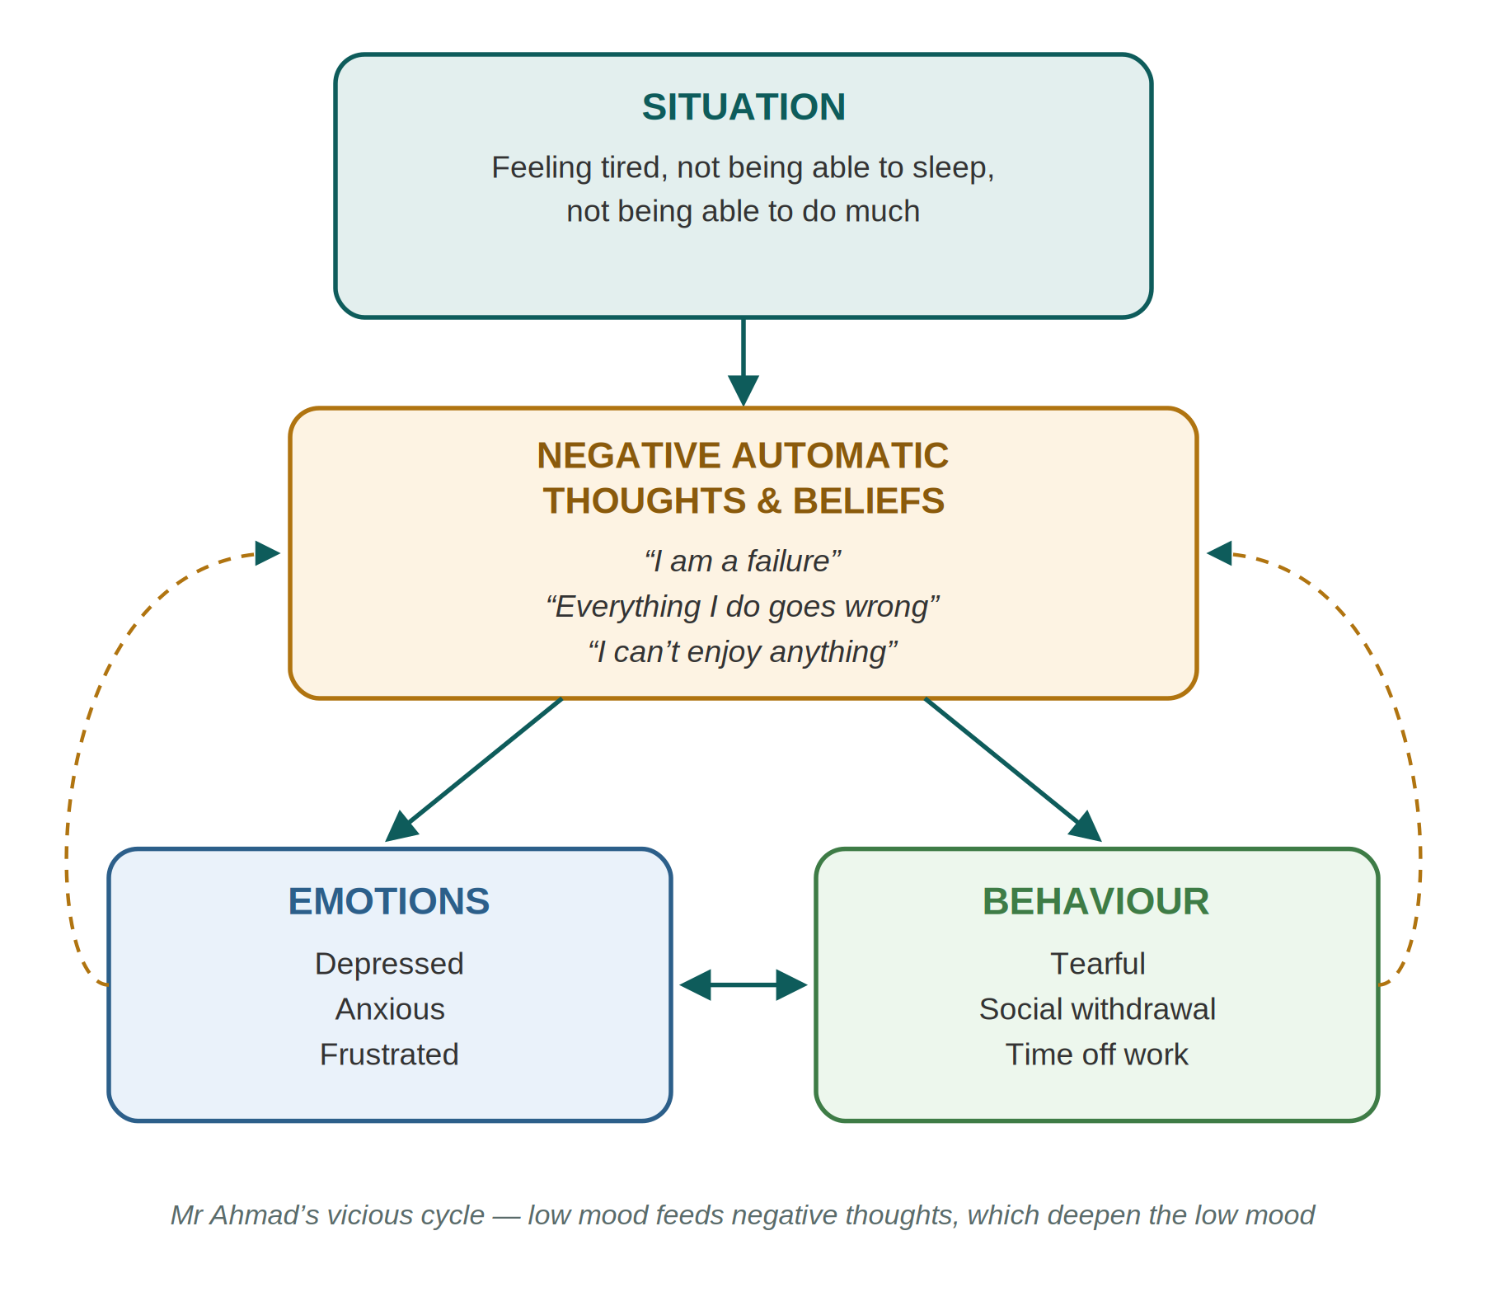
Figure 3. A shared formulation for Mr Ahmad using the cognitive model
What thinking errors is Mr Ahmad expressing and how would you help him recognise them?
Use Table 1 (reproduced below) as a guide to identify the thinking errors. You can use the table with your patient in the consultation, helping him to recognise his thinking patterns.
Table 1 (revisited). Types and examples of thinking errors
Type of thinking error | Explanation | Example
Black and white thinking | Seeing things in extremes | “I did not make the patient better, therefore I am no good”
Labelling | Giving yourself a label | “I am a failure”
Emotional reasoning | Using your feelings as evidence | “I don’t feel I am capable of doing anything”
Mind reading | “Knowing” what others are thinking | “They must not like me”
Fortune telling | “Knowing” how things are going to turn out | “I am not going to apply for the job because I know I won’t get it”
Catastrophising | Thinking of the worst-case scenario | “I am going to fail”
Demands | Musts and shoulds | “I must be able to make him better”
Blame / personalising | Personalising things to yourself | “If I were there, this would not have happened”
Overgeneralising | When one thing goes wrong, everything goes wrong | “It always happens to me”
Mental filtering / selective attention | Only looking at evidence that fits with the way you feel | “I always get told off” (disqualifying the times you have been praised for good work)

For example, when Mr Ahmad says, “I am a failure and everything I do goes wrong”, there is clearly an element of:
- Black and white thinking — he is seeing things in the extreme
- Labelling — “I am a failure”
- Mental filtering — not recognising what he has done well and focusing instead on the negatives, which are consistent with the way he is feeling
- Overgeneralising — “everything I do goes wrong”
- Emotional reasoning — he is going by feelings rather than facts
What questions might you ask him to dispute his thinking errors and negative thoughts?
- If your best friend was going through something similar to what you have been experiencing, would you say that he was a failure?
- Has everything you have done in the last week gone wrong?
- What things have you done, regardless of whether you did them well or not?
- What does failure mean?
- What evidence do you have to support the idea that you are a failure? Make a list.
- What evidence do you have to show that you are not a failure? Make a list.
- Looking at both these lists, would you say that you are a failure? Review both lists and come up with a balanced view. For example, you might say: “I am good at some things and not so good at certain things, but that does not make me a failure.”
How could you schedule activities with him?
Ask Mr Ahmad to keep a record of all his activities over the next week. This will then help him to structure his time.
Identify with him his main chores and his main pleasurable activities. Plan his day by alternating some light chores and pleasurable activities. It’s important to assess his level of depression and plan accordingly — if you plan too many activities he may not be able to do them all, and this will perpetuate his feeling of being a failure.
In follow-up consultations, go through his activity schedule. As his mood improves he can increase the number of activities he plans.
SAFETY FIRST — A MODERN REMINDER
For any patient presenting like Mr Ahmad, complete a full depression assessment in line with NICE NG222: explore severity, duration and functional impact, ask directly about suicidal ideation, plans and self-harm at presentation and at follow-up, screen for psychotic symptoms and comorbid anxiety or substance use, and consider physical causes of tiredness (e.g. FBC, TFTs, HbA1c where clinically indicated). Agree a clear safety-net and follow-up plan.

DISCLAIMER
This document is provided exclusively for educational and training purposes as a teaching aid. It does not constitute formal clinical guidance. Clinicians must independently verify all medical information, prescribing guidance, procedural protocols, and legal requirements against current national guidance, local policies, and relevant regulatory bodies before applying in practice.

