BRADFORD VTS TEACHING AIDS

Date: July 2026

DUAL DIAGNOSES
What To Do
A practical guide for GPs and GP trainees when more than one mental health problem walks through the door
WHY THIS MATTERS
Mental health problems rarely arrive one at a time. Depression, anxiety, alcohol and drug problems, and persistent physical symptoms cluster together — and the order in which you tackle them changes the outcome. This teaching aid sets out a simple, guideline-based sequence for deciding what to treat first, what to do when a disorder is clearly identified, and what to do when symptoms fall short of a formal diagnosis.

A NOTE ON TERMINOLOGY — “DUAL DIAGNOSIS” HAS TWO MEANINGS
- In everyday clinical use (and in this handout), it means a patient with more than one coexisting mental health problem — e.g. depression plus an anxiety disorder, or low mood plus alcohol misuse.
- In UK policy and NICE guidance (NICE NG58 and CG120), “dual diagnosis” has a narrower meaning: coexisting severe mental illness (usually psychosis) and substance misuse. Section 4 covers what GPs need to know about this group.

1 | If there is more than one disorder present

When disorders coexist, treat them in a deliberate order rather than all at once. Current NICE guidance supports the following sequence:
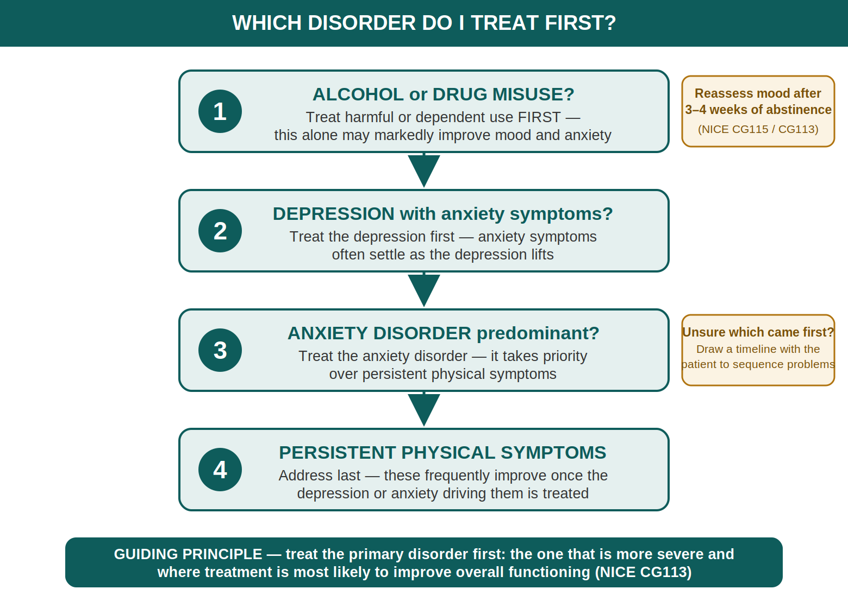
- Best to treat an alcohol (or drug) problem first if present. Treating harmful or dependent drinking first may in itself lead to significant improvement in depression and anxiety. If low mood or anxiety persists after 3–4 weeks of abstinence, assess and treat it in line with the relevant NICE guideline (NICE CG115; CG113).
- If low mood is present, treatment for depression usually takes priority over anxiety symptoms or persistent (unexplained) physical symptoms — anxiety symptoms often settle as the depression lifts (NICE NG222). But note the nuance: where the picture is of a primary anxiety disorder with secondary depressive symptoms, NICE advises treating the anxiety disorder first (NG222; CG113).
- If anxiety symptoms are present, treatment for anxiety takes priority over persistent (unexplained) physical symptoms. These physical symptoms increase in the presence of depression or anxiety — and frequently improve once the underlying mood or anxiety disorder is treated.
- Unsure which disorder is “primary”? Draw up a timeline with the patient of when each problem began. The disorder that came first, or the one that is more severe and most likely to improve overall functioning if treated, is usually the one to target first (NICE CG113).

2 | If patient has an identified disorder

- See the relevant guideline to help determine the treatment plan* — for most conditions seen in primary care this means NICE (e.g. NG222 for depression, CG113 for generalised anxiety and panic disorder, CG115 for alcohol-use disorders) or the matching NICE Clinical Knowledge Summary (CKS) topic.
- Use good-quality patient information to help explain the disorder — reliable, free sources include the NHS website (nhs.uk/mental-health), the Royal College of Psychiatrists’ patient information leaflets (rcpsych.ac.uk), and Mind (mind.org.uk). Explaining the diagnosis well improves engagement and adherence.
- Provide self-help resources and explain how they should be used — written leaflets, guided self-help workbooks, and NICE-recommended digital options. Patients in England can also self-refer directly to NHS Talking Therapies for anxiety and depression, without needing a GP referral.
- Set up follow-up visit(s) to review treatment — arrange a definite review (not “come back if it doesn’t settle”), especially in the early weeks after starting an antidepressant, and always sooner in anyone under 25 or where there is any risk of self-harm.
REMEMBER
The consultation itself is a treatment. Naming the problem, normalising it, and offering a plan and a review date reduces distress even before any prescription or referral takes effect.

3 | If patient appears to have subthreshold disorder(s)

(Positive responses to many questions, but not enough to fulfil the diagnostic criteria for a disorder.)
- Medication may not be necessary — for subthreshold or mild symptoms, NICE advises against routinely offering antidepressants as first-line treatment; active monitoring, guided self-help, and low-intensity psychological interventions come first (NG222).
- Use the “advice and support to patient and family” approach — explain the symptoms, offer written or online information, and involve family or carers where the patient agrees. Address sleep, alcohol, exercise and stressors: these often drive subthreshold symptoms.
- Use good-quality patient information to help explain the symptoms — the same trusted sources as above (NHS website, RCPsych, Mind) work well for patients who don’t meet diagnostic criteria but are struggling.
- Indicate that you are available for consultation should the need arise — explicit safety-netting matters. Subthreshold symptoms can progress: tell the patient what deterioration would look like and when to come back, and consider a planned review rather than leaving the door only passively open.
* Please use the accompanying handout titled “Diagnostic Checklist for Mental Health Problems”.

4 | Beyond the basics — what else every GP should know

The bullets above cover the common scenario of overlapping depression, anxiety, alcohol misuse and physical symptoms. The points below cover the areas GPs most often miss — including the group NICE formally calls “dual diagnosis”: severe mental illness with coexisting substance misuse.
“NO WRONG DOOR” — DON’T LET PATIENTS FALL BETWEEN SERVICES
- NICE NG58 is explicit: people must not be excluded from mental health services because of substance misuse, nor from substance misuse services because of mental illness. Historically this group was bounced between both — with the worst outcomes of all.
- For patients with severe mental illness and substance misuse, mental health services should take the lead for assessment and care planning (NG58). If a referral is refused on the grounds of “they need to sort the drink/drugs first”, it is reasonable to push back and cite this guidance.
- Intoxication at presentation is not a reason to refuse assessment of mental state and risk — arrange review when sober rather than closing the episode.

DON’T MISS — RISK IS SUBSTANTIALLY HIGHER IN THIS GROUP
- Suicide: of people in contact with mental health services in England who died by suicide between 2010 and 2020, 47% had a problem with alcohol and 38% with drugs (National Confidential Inquiry into Suicide and Safety in Mental Health). Always ask about substance use when assessing suicidal ideation — and always ask about suicidal ideation in substance misuse.
- Physical health: people with coexisting severe mental illness and substance misuse die 15–20 years earlier than the general population, largely from preventable cardiovascular and respiratory disease. Ensure they receive the annual SMI physical health check, and actively offer smoking cessation.
- Safeguarding: think about dependent children, vulnerable adults in the household, and domestic abuse — substance misuse and mental illness together raise the threshold of concern (NG58/CG120 both highlight safeguarding).

PRESCRIBING PEARLS IN COMORBIDITY
- Ask about cocaine before starting an SSRI — NICE CG113 specifically flags the drug–drug interaction, and the need to avoid combining multiple serotonergic drugs. Follow MHRA safety advice on citalopram (dose-dependent QT prolongation).
- Alcohol + antidepressants: an antidepressant started while someone is drinking dependently is unlikely to work well — another reason the alcohol comes first. In dependent drinkers, warn against abrupt unsupervised cessation (risk of withdrawal seizures) and refer to community alcohol services for planned, assisted withdrawal.
- Benzodiazepines: avoid initiating for anxiety in patients with current or past substance misuse except as part of a supervised alcohol detoxification regimen.
- Verify all doses against the BNF or NICE CKS at the point of prescribing — this teaching aid deliberately contains no drug doses.

WHERE TO SEND PEOPLE — QUICK REFERENCE
- NHS Talking Therapies (England): self-referral for depression and anxiety disorders — no GP letter needed.
- Community drug & alcohol services: usually self-referral or GP referral; commissioned locally (in Bradford: New Vision Bradford).
- Community mental health team: for severe mental illness with substance misuse — mental health services lead the care (NG58); substance use is not grounds for rejection.
- Crisis: NHS 111 (option 2 for mental health), local crisis team, or emergency services if immediate risk. Samaritans 116 123 for the patient’s own use.

The 5-minute dual diagnosis check — a consultation aide-mémoire
ASK / DO | WHY / HOW
Screen for alcohol & drugs | In every mental health presentation — use AUDIT-C for alcohol; ask directly (and non-judgementally) about drugs, including cocaine, cannabis and prescribed-drug misuse.
Screen for mood & anxiety | In every substance misuse presentation — the comorbidity runs both ways; most people in drug and alcohol treatment have a psychiatric disorder.
Sequence the problems | Timeline with the patient: which came first? Which is worst now? Treat the primary disorder first.
Assess risk explicitly | Suicidal ideation, self-harm, risk to others, safeguarding of children and vulnerable adults.
Agree one plan | One problem treated first, in writing if helpful, with a named review date — not three referrals fired off simultaneously.
Safety-net & follow up | Explain what deterioration looks like; book the review rather than waiting for re-presentation; check the SMI register / annual physical health check where relevant.

A | Appendix — clinical updates made to this edition & sources

This teaching aid is a redesign of a legacy Bradford VTS handout. The original section order, titles and advice have been preserved. The following updates were made for clinical currency — all verified against the sources listed on 5 July 2026:
CHANGE MADE | SOURCE / RATIONALE
“Treat alcohol first” retained, with the 3–4 week abstinence reassessment rule added and extended to drug misuse. | NICE CG115 (Alcohol-use disorders); NICE CG113 rec 1.2.8 (harmful/dependent substance misuse treated first in GAD).
“Depression before anxiety” retained but nuanced: where a primary anxiety disorder has comorbid depressive symptoms, consider treating the anxiety disorder first; treat the primary (more severe) disorder first. | NICE NG222 (Depression in adults, 2022) rec 1.2.13; NICE CG113 rec 1.2.7.
“Unexplained somatic complaints” updated to “persistent (unexplained) physical symptoms”. | Current preferred UK terminology; the original clinical point (they increase with depression/anxiety) is retained unchanged.
“Interactive summary cards” (from the 2000 WHO Guide to Mental Health in Primary Care, on which this handout was based) replaced with current patient-information sources. | The WHO Guide and its summary cards are no longer published or in use. Replacements: NHS website, RCPsych patient information, Mind.
Self-help expanded to include NHS Talking Therapies self-referral. | NHS Talking Therapies for anxiety and depression (national NHS England programme; self-referral available).
Subthreshold section: added that antidepressants are not routinely first-line for subthreshold/mild symptoms. | NICE NG222 recs 1.5 (less severe depression: do not routinely offer antidepressants first-line).
New Section 4 added at the Programme Director’s request: no-wrong-door principle, risk data, prescribing cautions, checklist and signposting. | NICE NG58 & CG120; NCISH data cited in the DHSC Co-occurring Mental Health and Substance Use Delivery Framework (GOV.UK, 2025); NICE CG113 (SSRI/cocaine, MHRA citalopram).

KEY SOURCES
- NICE NG222 — Depression in adults: treatment and management (2022)
- NICE CG113 — Generalised anxiety disorder and panic disorder in adults (updated 2020)
- NICE CG115 — Alcohol-use disorders: harmful drinking and alcohol dependence
- NICE NG58 & CG120 — Coexisting severe mental illness and substance misuse
- DHSC — Co-occurring mental health and substance use delivery framework (GOV.UK, 2025), citing NCISH data
- NICE CKS — Depression; Generalised anxiety disorder; Alcohol — problem drinking

DISCLAIMER
This document is provided exclusively for educational and training purposes as a teaching aid. It does not constitute formal clinical guidance. Clinicians must independently verify all medical information, prescribing guidance, procedural protocols, and legal requirements against current national guidance, local policies, and relevant regulatory bodies before applying in practice.

