A GUIDE TO
JOINT INJECTION
TECHNIQUES

BRADFORD VTS TEACHING AIDS May 2026 · Updated to NICE NG226, NICE CKS & BNF

Guidance  NICE · BNF · RCGP | Updated  May 2025 | Audience  GPs · Minor Surgery

DISCLAIMER
This is an educational resource for qualified UK primary care clinicians.
It does not replace individual clinical judgement, formal training, or local protocols.
Always verify prescribing decisions against the current BNF and NICE guidance.
Practitioners must hold appropriate competence before performing any injection procedure.

Adapted from Canoso JJ — Rheumatology 2nd Ed. (Klippel & Dieppe). Updated for UK practice.

Contents

1 | Introduction
2 | Indications for Aspiration & Injection
3 | Synovial Fluid Analysis
4 | Contraindications
5 | Equipment & Procedure
6 | Corticosteroid Principles & Complications
7 | The Wrist & Hand  MCP · PIP · Trigger Finger · De Quervain's · Carpal Tunnel · CMC · Wrist · Ganglia
8 | The Elbow  Elbow Joint · Olecranon Bursa · Tennis Elbow
9 | The Shoulder  Glenohumeral · Subacromial Bursa · AC Joint · Bicipital Groove
10 | The Hip  Hip Joint · Greater Trochanteric Pain · Iliopsoas Bursa
11 | The Knee  Knee Joint · Baker's Cyst · Anserine Bursitis
12 | The Ankle & Foot  Ankle · Subtalar · Posterior Tibialis · Retrocalcaneal · Plantar Fascia · MTP · Morton's Neuroma
13 | The Spine  Interspinous Ligaments
14 | Summary Safety Reference  Red Flags · Frequency Limits · Quick Dose Reference
15 | References & Guidance Sources

Introduction

Joint and soft tissue injections are a valuable skill in UK primary care. They are used both to diagnose musculoskeletal conditions and to deliver targeted anti-inflammatory treatment.
This guide covers the principles, safety requirements, technique, and specific anatomical protocols needed for competent, safe practice.
The fundamental principles for entering a joint and for injecting periarticular structures are broadly similar. Both rely on accurate anatomical knowledge, rigorous aseptic technique, appropriate patient selection, and clear aftercare instruction.
NICE NG226 (2022) — KEY POINTS
NICE NG226 (2022) recommends intra-articular corticosteroid injections for osteoarthritis when other pharmacological treatments are ineffective or unsuitable — or to support therapeutic exercise.
Patients must be advised that these injections provide short-term relief only — typically 2 to 10 weeks.
Hyaluronic acid (viscosupplementation) injections must NOT be offered for OA. NICE explicitly recommends against this.

Indications for Aspiration & Injection

When to Aspirate

Synovial fluid analysis is the most reliable tool for distinguishing inflammatory from non-inflammatory joint disease. You must aspirate whenever infection, crystal arthropathy, or haemarthrosis is suspected.
⚠ PATIENT SAFETY — NEVER ASSUME
Never assume the nature of an effusion without analysis.
Missed septic arthritis occurs when fluid is not sent for microscopy, culture, and crystal analysis.
Crystal synovitis and septic arthritis CAN coexist. A positive crystal result does not exclude infection.

Aspirate — Indications | Inject — Indications
🔴 Mandatory: suspected septic arthritis | ✔ OA — when exercise and analgesics are insufficient
🟡 Strongly advised: crystal arthropathy (gout/pseudogout) or haemarthrosis | ✔ Inflammatory arthritis (RA, PsA, spondyloarthropathy)
🔵 Differentiate inflammatory from non-inflammatory arthritis | ✔ Crystal-induced synovitis — to relieve acute inflammation
🔵 Relieve tense, painful effusions | ✔ Periarticular: tendinopathy, bursitis, de Quervain's, trigger finger, CTS
🔵 Remove blood or pus from a joint | ✔ Adhesive capsulitis (frozen shoulder) — in the painful phase
🔵 Facilitate imaging (arthrography)

Synovial Fluid Analysis

Every aspirated sample must be sent for all three of the following investigations:
- 1. Total and differential white cell count
- 2. Gram stain and culture — include chocolate agar if gonococcal infection is suspected
- 3. Polarised light microscopy for urate (gout) and pyrophosphate (pseudogout) crystals

Feature | Normal | Osteoarthritis | Inflammatory (RA etc.) | Septic Arthritis
Appearance | Clear | Clear | Opaque / cloudy | Opaque / turbid
Volume (ml) | 0–1 | 1–10 | 5–50 | 5–50
Viscosity | High | High | Low | Low
WBC / mm³ | <200 | 200–10,000 | 5,000–75,000 | >50,000
% PMN cells | <25% | <50% | >50% | >75%

KEY LEARNING POINT
WBC > 50,000/mm³ with > 75% PMN cells strongly suggests septic arthritis.
Treat as infectious until proven otherwise. Refer urgently.

Contraindications

Absolute Contraindications

🚫 ABSOLUTE CONTRAINDICATION — DO NOT PROCEED
Suspected or confirmed septic arthritis — You MUST aspirate to diagnose. You must NOT inject corticosteroid until infection is excluded.
Overlying skin infection, cellulitis, or infected wound at the injection site.
Suspected bacteraemia or systemic sepsis.
Known hypersensitivity to the intended corticosteroid or local anaesthetic.
Prosthetic joint — You must NOT inject in primary care. Refer to orthopaedics under full aseptic theatre conditions.
Absence of informed consent.

Relative Contraindications — Proceed with Caution

The following require careful individual risk–benefit assessment:

Anticoagulation | Peripheral joint injections are low bleeding risk. Evidence does not support routine anticoagulation cessation. Check INR for warfarin patients. Document your risk assessment.
Thrombocytopenia / bleeding diathesis | Increased haemorrhagic risk. Seek haematology advice if uncertain.
Diabetes mellitus | Significant transient rise in blood glucose. Warn the patient before the procedure. Advise glucose monitoring for at least one week post-injection. Peritendinous injections may cause elevations lasting 5–21 days.
Poorly controlled hypertension | Corticosteroids can transiently raise blood pressure.
Immunosuppression (including biologics) | Higher infection risk. Proceed only if clearly indicated and documented.
Pregnancy / breastfeeding | Not considered harmful, but document shared decision-making.
Failed previous injections | Lack of prior response is a relative contraindication. Reassess the diagnosis before repeating.

🚫 PROCEDURES THAT MUST NEVER BE PERFORMED IN PRIMARY CARE
The following procedures are outside the scope of primary care minor surgery
and must NOT be attempted regardless of clinician experience:

▸ Sacroiliac joint injection — risk of spinal cord injury, deep pelvic
haematoma; requires CT/fluoroscopic guidance
▸ Facet joint injection — requires imaging guidance; spinal cord risk
▸ Epidural steroid injection — requires specialist anaesthetic environment
▸ Hip joint aspiration — femoral neurovascular bundle risk; imaging essential
▸ Iliopsoas bursa injection — deep pelvic; femoral nerve injury risk
▸ Retrocalcaneal bursa injection — Achilles tendon rupture risk; ultrasound required
▸ Bicipital tendon injection — biceps tendon rupture risk; ultrasound required

For all of the above: refer to the appropriate specialist service.

Equipment & Procedure

Required Equipment

Item | Specification
Skin preparation | Chlorhexidine 2% in 70% isopropyl alcohol (preferred). Allow to dry fully before needle insertion.
Gloves | Non-sterile minimum; sterile gloves preferred for joint aspiration.
Needles — LA | 25–27 gauge for skin infiltration.
Needles — large joints | 21–22 gauge (knees, shoulders, ankles, hips).
Needles — small joints | 23–25 gauge (wrists, MCPs, PIPs, MTPs).
Syringes — injection | 2–5 ml for corticosteroid ± local anaesthetic.
Syringes — aspiration | 10–50 ml. Use 18 gauge needle for thick or purulent fluid.
Specimen containers | EDTA tube (cell count) · plain tube (biochemistry) · sterile pot (culture).
Dressing | Simple adhesive plaster post-procedure.

Step-by-Step Technique

1. Obtain informed consent. Explain the procedure, risks, and benefits. Document consent.
2. Position the patient supine or recumbent. For shoulder procedures, always seat the patient with armrests and an assistant present.
3. Identify landmarks by palpation before cleaning the skin. Mark the needle entry point with a thumbnail imprint or sterile pen.
4. Clean the skin thoroughly with chlorhexidine 2% in alcohol. Allow it to dry completely.
5. Local anaesthetic is optional for small joints and tendon sheaths. For larger joints or anxious patients, infiltrate to the joint capsule with 1% lidocaine (without adrenaline). Many experienced practitioners prefer a single swift needle thrust — it is less painful than LA infiltration.
6. Insert the needle with a confident single thrust. A "give" or "pop" indicates entry into the joint space. Never inject against resistance.
7. Aspirate before injecting. For intra-articular injections, confirm placement by aspirating fluid. For periarticular injections, confirm easy flow with local anaesthetic first.
8. When changing from aspiration to injection syringe, hold the needle firmly with forceps to prevent displacement.
9. Withdraw the needle swiftly. Apply firm pressure for at least 2 minutes. Cover with a plaster.

⚠ CAUTION
Never inject against unexpected resistance — the needle tip is likely in tendon tissue.
Do not inject directly into tendon substance — this is a primary cause of tendon rupture.
Do not reuse needles or syringes. Maintain strict no-touch technique throughout.

Aftercare

- Rest the injected joint for 24–48 hours. This minimises leakage and optimises anti-inflammatory response.
- Warn all patients: post-injection flare occurs in ~5% of cases — transient pain and swelling 4–24 hours post-injection, caused by corticosteroid crystal synovitis (not infection). Resolves within 48 hours.
- Warn all patients: facial flushing affects up to 40% — transient, harmless, but alarming if unexpected.
- Warn diabetic patients to monitor blood glucose for at least one week post-injection.
- Provide written aftercare information including when to return urgently.

🔴 SAFETY-NETTING — ADVISE ALL PATIENTS
Advise patients to return urgently if: pain and swelling increase after 48 hours, systemic symptoms develop (fever, rigors), or the skin becomes red, hot, and fluctuant.
These features must be investigated urgently for iatrogenic septic arthritis.

Corticosteroid Injections — Principles

Mechanism

Corticosteroids reduce local inflammation by suppressing the synovial lining and reducing inflammatory mediator release. Crystalline long-acting preparations are deposited in the target tissue, taken up by synovial cells, and slowly released. A small proportion enters the systemic circulation — systemic effects are real and must be anticipated.

Choice of Corticosteroid in UK Practice

Preparation | Brand | Typical Use | Key Consideration
Methylprednisolone acetate | Depo-Medrone® | Periarticular, tendon sheaths, bursae, small–medium joints | Preferred for superficial injections — lower risk of skin atrophy
Triamcinolone acetonide | Kenalog® | Large intra-articular (glenohumeral, knee) | More potent, longer-acting. Avoid for superficial or peritendinous use
Hydrocortisone acetate | — | Superficial small joints, trigger finger | Short-acting, lower systemic effect

DRUG SELECTION — IMPORTANT
Use methylprednisolone acetate (not triamcinolone) for all periarticular and soft tissue injections.
De Quervain's tenosynovitis and olecranon bursa injections: triamcinolone carries high risk of skin atrophy and disfiguring hypopigmentation.
If triamcinolone hexacetonide (Lederspan®) is used, choose the lower end of the dose range — it is approximately twice as potent as acetonide.

Dosing Principles

All doses in this guide are expressed as methylprednisolone acetate equivalents (40 mg/ml). When triamcinolone acetonide is used, choose the lower figure from the range given.

Complications — Consent Points

Most complications are rare when technique is correct. All of the following must be discussed with the patient before proceeding:

Complication | Details & Management
Post-injection flare (5%) | Pain worsens 4–24 hours post-injection. Caused by crystal-induced synovitis. Resolves within 48 hours. If symptoms persist or systemic features develop, re-aspirate urgently to exclude infection.
Facial flushing (up to 40%) | Transient corticosteroid pulse. Harmless but alarming. Warn all patients beforehand.
Blood glucose elevation | Particularly significant in diabetes. Can persist 5–21 days with peritendinous injections. Advise glucose monitoring for at least one week.
Skin atrophy / hypopigmentation | Especially with superficial injections and triamcinolone. More common in elderly patients and in people with darker skin tones — can be disfiguring. Resolves over months to 2 years.
Tendon rupture | Results from intratendinous injection. You must NOT inject into tendon tissue. Never inject against resistance. Athletes with multiple Achilles infiltrations are at high risk.
Infection (1 in 15,000–50,000) | Extremely rare but potentially catastrophic. Strict aseptic technique is mandatory. Higher risk in immunocompromised patients.
Corticosteroid arthropathy | Repeated intra-articular injections can cause Charcot-like destructive arthropathy. Limit to 3–4 per year. Never inject without reassessment.
Adrenal suppression | Serial infiltrations can cause transient HPA axis suppression. Relevant in patients on systemic steroids.

The Wrist & Hand

Finger & Metacarpophalangeal (MCP) Joints
Indications | Rheumatoid arthritis, psoriatic arthritis, active Bouchard's nodes.
Needle | 25–27 gauge
Dose | 10–15 mg methylprednisolone acetate
Approach | Dorsolateral, digit in semiflexion. Enter from the dorsolateral aspect. Produces circumferential distension. Multiple joints may be injected per session.
Precautions | Do not overdistend. Fluid can back up — apply firm pressure with sterile gauze for 5 minutes post-procedure.
Complications | Joint hyperlaxity; capsular calcification (frequent but inconsequential).
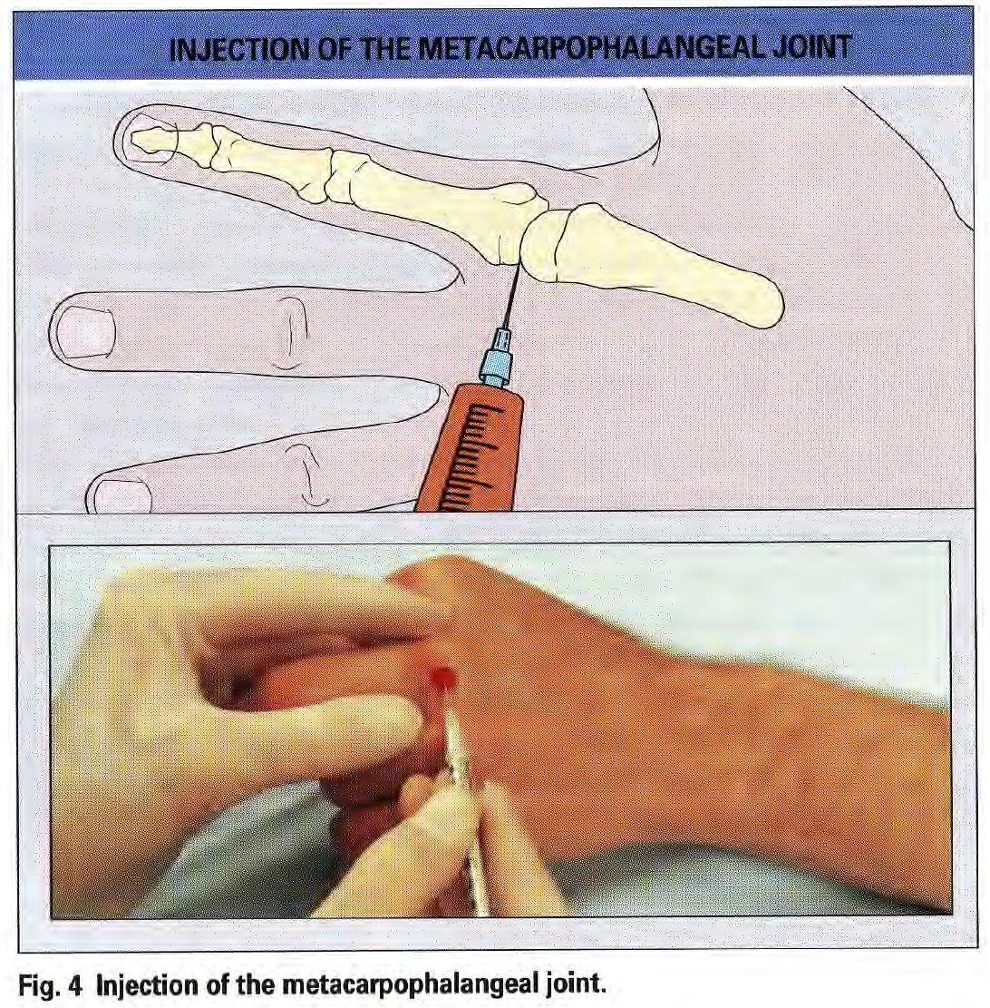
▸ Fig. 4 Injection of the metacarpophalangeal joint

CLINICAL NOTE
In RA, multiple joints may be injected in the same session. Use the minimum effective dose per joint.

Proximal Interphalangeal (PIP) Joints
Indications | Rheumatoid arthritis, psoriatic arthritis, active Bouchard's nodes.
Needle | 25–27 gauge
Dose | 10–15 mg methylprednisolone acetate
Approach | Dorsolateral, digit in semiflexion. Enter between the collateral ligament and extensor hood.
Precautions | Use minimal volume. Apply post-procedure compression for 5 minutes.
Complications | As for MCP joints.
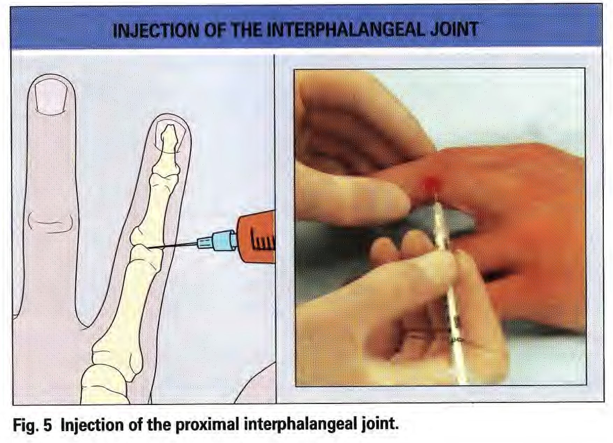
▸ Fig. 5 Injection of the proximal interphalangeal joint

Flexor Tendon Sheaths (Trigger Finger)
Indications | Trigger finger (stenosing flexor tenosynovitis); flexor tenosynovitis in RA or psoriatic arthritis.
Needle | 25–27 gauge or 23 gauge butterfly
Dose | 15–20 mg methylprednisolone + 1–2 ml 1% lidocaine
Approach | Palmar approach. Entry: just distal to palmar crease (thumb); proximal palmar crease (index); distal palmar crease (long, ring, little fingers). Needle at 45° distal inclination.
Confirming placement | Reciprocal needle movement on passive finger flexion = tendon engagement. Withdraw 1 mm and recheck. Easy flow = correct sheath placement.
Precautions | You must NOT inject into the tendon. If resistance is felt, reposition.
Repeat injections | Up to 3 injections, at least 3 weeks apart.
Complications | Superficial fat atrophy (asymptomatic). Tendon rupture and infection are rare with correct technique.
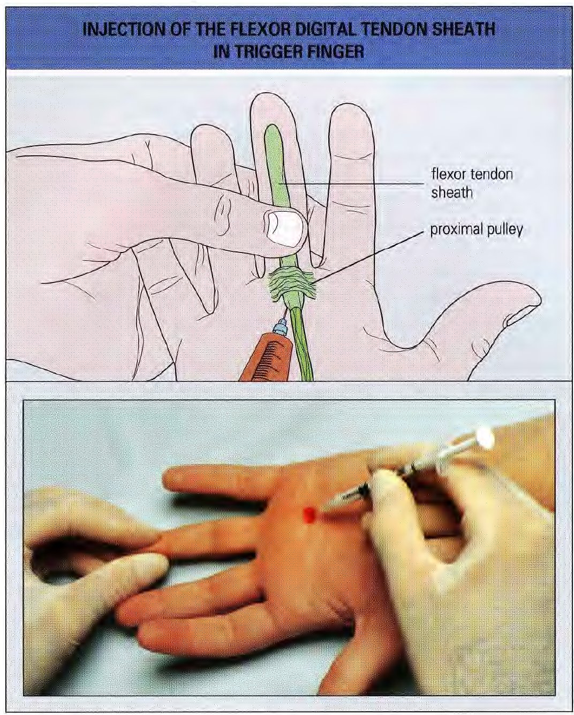
▸ Fig. 6 Injection of the flexor digital tendon sheath — trigger finger

CLINICAL NOTE
Refer for surgical release (A1 pulley division) if symptoms recur after 2–3 injections, or if there is a fixed flexion deformity.

De Quervain's Tenosynovitis
Indications | Inflammation of the common sheath of APL and EPB. Highly responsive to corticosteroid injection (~80% success rate).
Needle | 25 gauge
Dose | 20–30 mg methylprednisolone acetate (NOT triamcinolone — risk of skin atrophy at this superficial site)
Approach | Aim towards the radial styloid (deep to the sheath). Insert into the sheath, withdraw 1 mm, inject. Successful injection distends the sheath distally to the metacarpal base.
Precautions | Inject within the sheath only. Do not infiltrate a grossly thickened sheath without considering mycobacterial infection.
Complications | Skin hypopigmentation is common — especially in darker skin tones. Warn patients beforehand. Skin atrophy (particularly in elderly patients).

⚠ CAUTION
~80% injection response rate. Refer to hand surgery if symptoms persist after 2 injections.

Carpal Tunnel Syndrome (CTS)
Indications | Mild-to-moderate CTS confirmed clinically. Do not inject if thenar wasting is present or nerve conduction shows axonal loss — refer for surgical assessment.
Needle | 22–25 gauge or 23 gauge butterfly
Dose | 20–40 mg methylprednisolone (without lidocaine preferred for accuracy — or + 1 ml lidocaine)
Approach | Just distal to the distal wrist flexor crease, medial to palmaris longus (PL) tendon. If PL absent (~25% of people), use the midline. Insert to 1 cm depth at 45° distal and 45° lateral inclination.
Confirming placement | Paraesthesiae in median nerve distribution = nerve engagement — reposition immediately. Needle movement with passive finger flexion = tendon — withdraw 1 mm.
Aftercare | Night wrist splint in neutral position reduces carpal tunnel pressure — provide via physiotherapy or OT.
Complications | Transient worsening of paraesthesiae. Median nerve damage from direct injection is rare but serious.
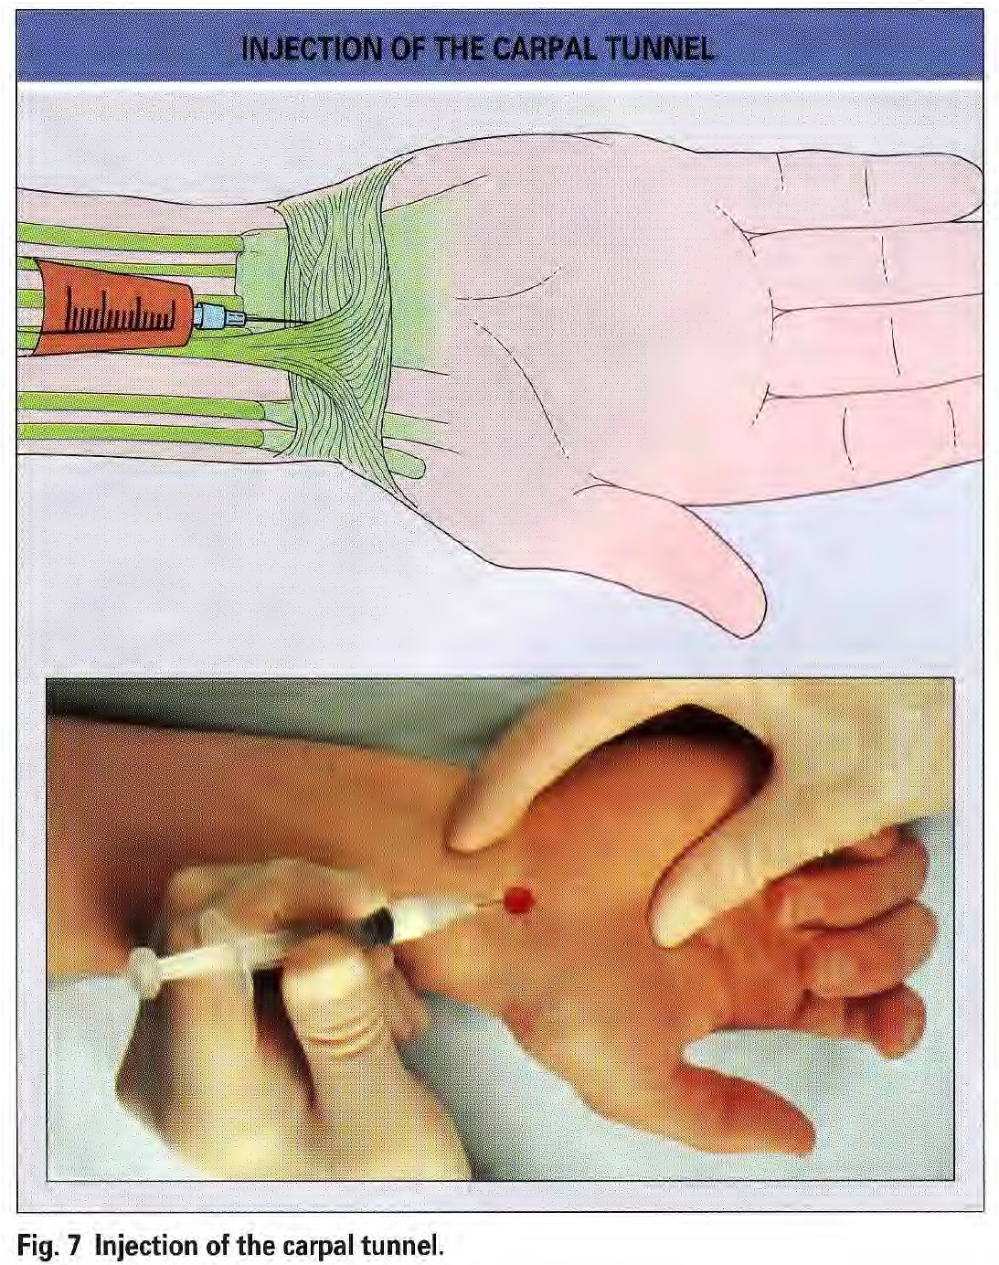
▸ Fig. 7 Injection of the carpal tunnel

CLINICAL NOTE
Refer for carpal tunnel decompression if: symptoms are severe, there is thenar wasting, nerve conduction shows axonal loss, or symptoms recur promptly after 2 injections.

First Carpometacarpal (CMC) Joint
Indications | Painful OA at the base of the thumb ("square hand" with grating and tenderness at the prominence).
Needle | 23–25 gauge
Dose | 15–30 mg methylprednisolone
Approach | Within the anatomical snuffbox. Flex the thumb across the palm. Enter between APL/EPB anteriorly and EPL posteriorly.
Precautions | The radial artery encircles this joint and its course varies. Aspirate before injecting.
Complications | None, if the radial artery is avoided.

Wrist Joint
Indications | Acute arthritis (gout, pseudogout, septic arthritis); RA, other inflammatory synovitides, OA.
Needle | 23 gauge (injection); 18–20 gauge (aspiration of thick fluid)
Dose | 30–40 mg methylprednisolone. Attempt aspiration first.
Approach | Dorsal approach. Slightly palmar-flex the wrist. Enter just distal to Lister's tubercle, just ulnar to EPL tendon.
Precautions | No significant neurovascular structures at this entry point.
Complications | None.
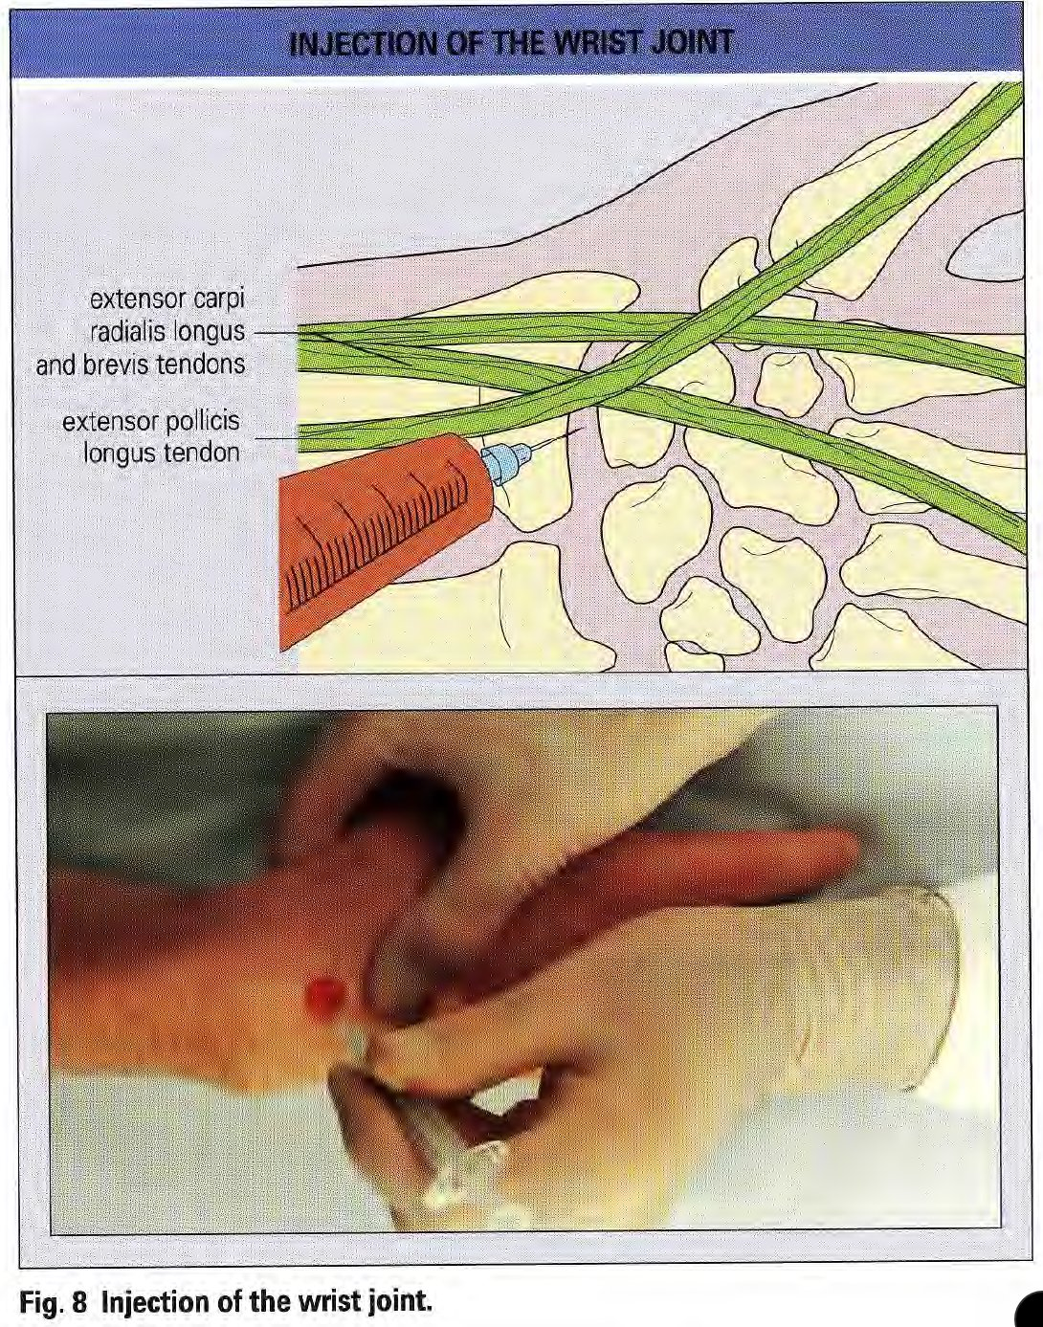
▸ Fig. 8 Injection of the wrist joint

Ganglia
Indications | Symptomatic dorsal wrist ganglia. Injection combined with aspiration is effective.
Needle | 18–20 gauge (ganglia fluid is very viscous — finer needles will block)
Dose | 15–20 mg methylprednisolone after aspiration
Approach | Aim to the centre. Aspirate viscous translucent fluid completely. If fluid is not translucent, send for culture and crystal analysis.
Precautions | Exclude radial artery aneurysm (pulsatile). Ganglia > 3 cm or within the carpal tunnel should be referred for surgical excision.
Complications | None.

CLINICAL NOTE
Natural resolution occurs in up to 50% of cases. Discuss watchful waiting as the first option.

The Elbow Region

Elbow Joint
Indications | Aspiration for acute arthritis. Injection for RA, psoriatic arthritis.
Needle | 22 gauge (injection); 18–20 gauge (aspiration)
Dose | 30–40 mg methylprednisolone. Attempt aspiration first.
Position | Elbow flexed to 90° for all approaches.
Posterior approach | Palpate the midline depression between the two halves of the triceps tendon. Insert the needle perpendicularly into the olecranon fossa.
Inferolateral approach | Palpate the midpoint between the olecranon tip and lateral epicondyle. Insert perpendicularly, aiming at the joint centre.
Lateral approach | Enter the radiocapitellar joint from the lateral side, just proximal to the radial head. Pass tangentially between the two bones.
Precautions | No significant neurovascular structures at any of these entry points.
Complications | None.
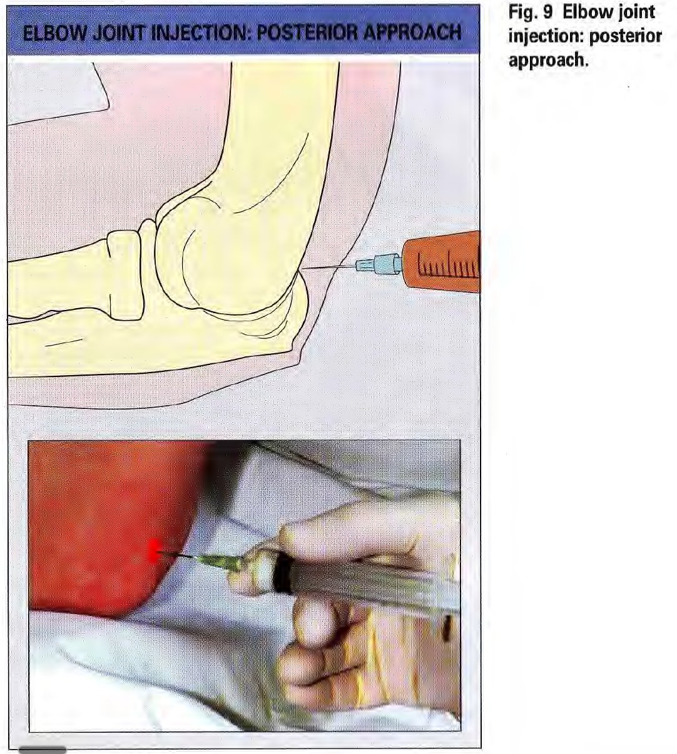
▸ Fig. 9 Elbow — posterior approach
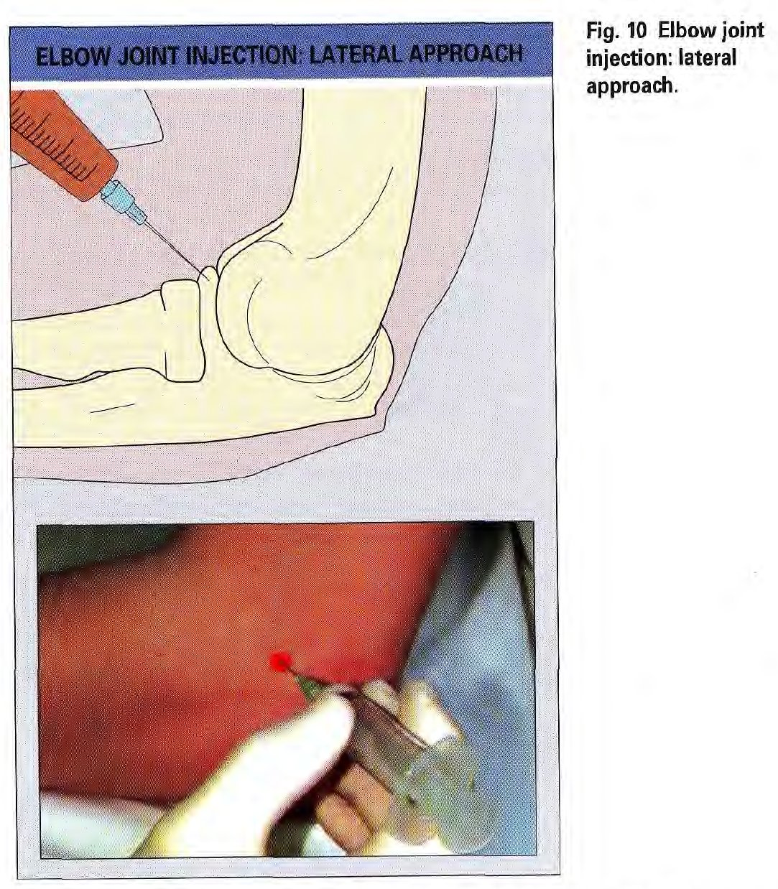
▸ Fig. 10 Elbow — lateral approach

Olecranon Bursa
Indications | Diagnosis of bursitis (exclude infection). Treatment of aseptic bursitis refractory to conservative management. A negative bursal fluid culture is required before injecting.
Needle | 22 gauge
Dose | 20 mg methylprednisolone acetate. Aspirate first.
Approach | Lateral, through normal skin, aiming at the bursa centre. Avoid the bursal apex — the skin is maximally stretched there and can create a chronic sinus.
Precautions | Do NOT enter medially — risk of ulnar nerve injury. Avoid injecting through inflamed or infected skin.
Complications | Skin atrophy, chronic pressure pain, septic bursitis (particularly with triamcinolone).

CLINICAL NOTE
Conservative management first: avoid leaning on the elbow for 3 months. Use methylprednisolone acetate only — triamcinolone hexacetonide has a higher complication rate in the olecranon bursa.

Tennis Elbow (Lateral Epicondylitis)

⚠ TENNIS ELBOW — IMPORTANT CHANGE IN GUIDANCE
Repeated corticosteroid injections for lateral epicondylitis (tennis elbow) are now strongly discouraged.
High-quality evidence shows 12-month outcomes are WORSE than with physiotherapy or watchful waiting.
First-line treatment is exercise-based physiotherapy. Injection should only be considered once, after an adequate physiotherapy trial.
Source: NICE CKS — Tennis Elbow (updated 2024).

Indications | Only consider after a minimum 6-week trial of exercise-based physiotherapy and analgesia has failed. This procedure is now DISCOURAGED as routine practice.
Needle | 22 gauge
Dose | 10–20 mg methylprednisolone
Approach | At the point of maximum tenderness over the common extensor origin. Pass needle to periosteal contact. Infiltrate 2–3 ml lidocaine first — failure to abolish pain on resisted wrist dorsiflexion means wrong site. The corticosteroid is infiltrated deeply at the tenoperiosteal junction.
Precautions | Do not inject superficially. Superficial injection increases risk of skin atrophy and hypopigmentation.
Complications | Transient worsening of pain in ~40% of cases. Repeated injections cause chronic pain.
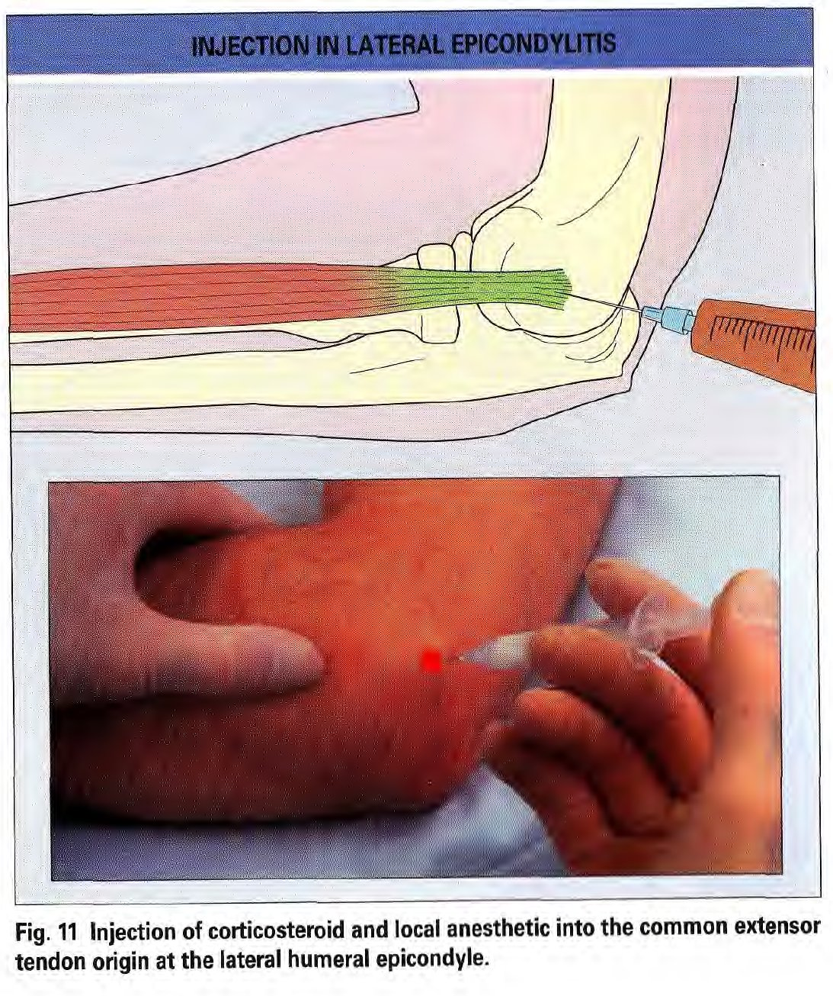
▸ Fig. 11 Injection at the lateral humeral epicondyle — tennis elbow

⚠ CAUTION
High-quality evidence shows 12-month outcomes after corticosteroid injection are WORSE than with physiotherapy or watchful waiting.
Lack of improvement with lidocaine infiltration should prompt reassessment — consider posterior interosseous nerve compression or cervical radiculopathy.

CLINICAL NOTE
NICE CKS (2024): First-line treatment is exercise (eccentric loading, physiotherapy). Corticosteroid injection may impair long-term recovery. Over 90% of patients recover without injection.

The Shoulder Region

Glenohumeral Joint
Indications | Aspiration for acute arthritis. Injection for RA, spondyloarthropathy, adhesive capsulitis (frozen shoulder — particularly the pain-predominant phase), OA.
Needle | 22 gauge (injection); 20 gauge or larger (aspiration)
Dose | 40–60 mg methylprednisolone or 40 mg triamcinolone acetonide. Attempt aspiration first.
Patient position | Seated with armrest support. An assistant must be present. Warn about vasovagal syncope. If any fainting history, use posterior approach only.
Posterior approach (preferred) | Palpate the posterior acromion margin. Insert 1 cm below and 1 cm medial to its posterior corner. Direct anteriorly and medially towards the coracoid process until bone contact at the articular space.
Anterior approach | Patient seated, arm at side, elbow 90°, forearm in sagittal plane. Enter 1 cm distal and 1 cm lateral to the coracoid process. Inject lidocaine incrementally. Once bone is touched, gently internally rotate the forearm to advance the needle into the joint.
Precautions | The posterior approach avoids major neurovascular structures. Anterior misplacement risks the axillary vessels and brachial plexus.
Complications | Vasovagal syncope. Always have an assistant and safe seating.
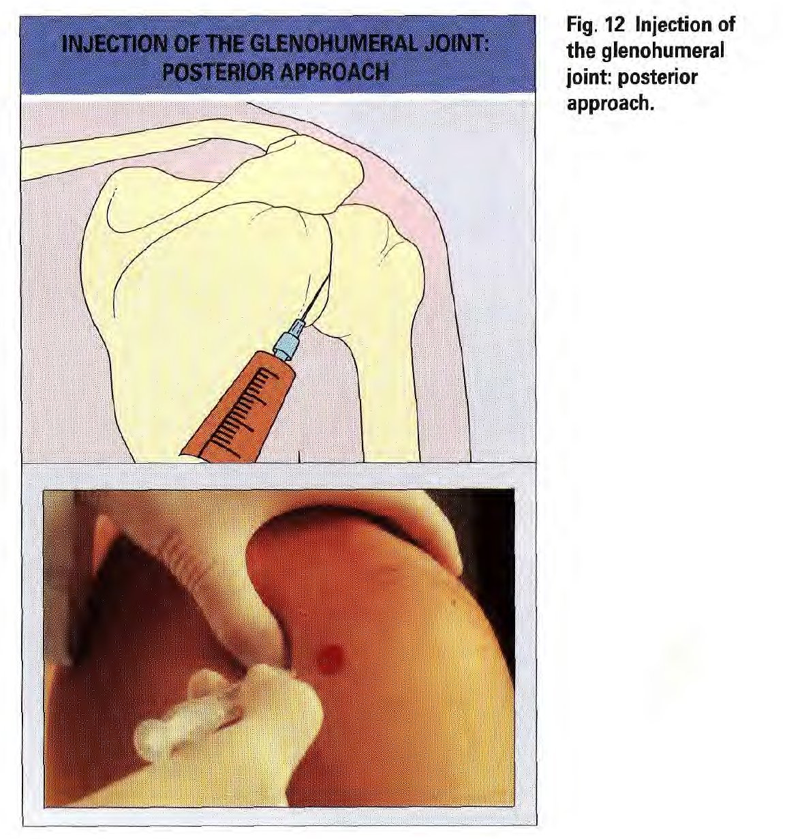
▸ Fig. 12 Glenohumeral joint — posterior approach
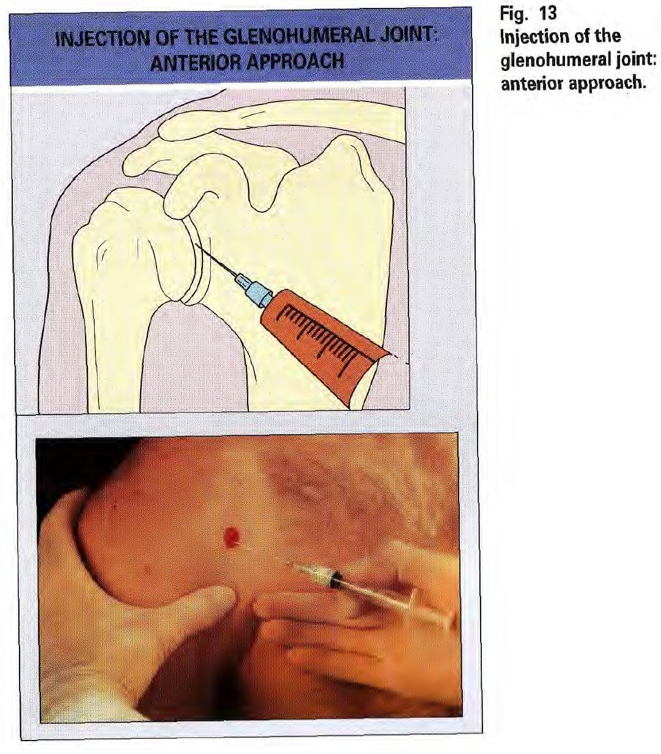
▸ Fig. 13 Glenohumeral joint — anterior approach

CLINICAL NOTE
A dry tap in acute glenohumeral arthritis is common. If aspiration is essential for diagnosis, repeat under ultrasound or fluoroscopic guidance.
In frozen shoulder, the contracted capsule makes injection technically difficult. Ultrasound guidance significantly improves accuracy.

Subacromial Bursa
Indications | Subacromial impingement syndrome; calcific tendinitis of the rotator cuff.
Needle | 22–25 gauge
Dose | 30–40 mg methylprednisolone
Patient position | Seated with armrest. Assistant present. Watch for fainting.
Posterolateral approach | Ask the patient to relax the shoulder. Direct the needle anteromedially under the acromion. Easy flow of injectate confirms bursal location.
Anterior approach | Infiltrate lidocaine first. Direct the needle posteriorly, flush with the inferior acromion surface, 1 cm lateral to the AC joint. Once the coracoacromial ligament is crossed, resistance drops. Easy flow confirms bursal placement.
Complications | None significant.
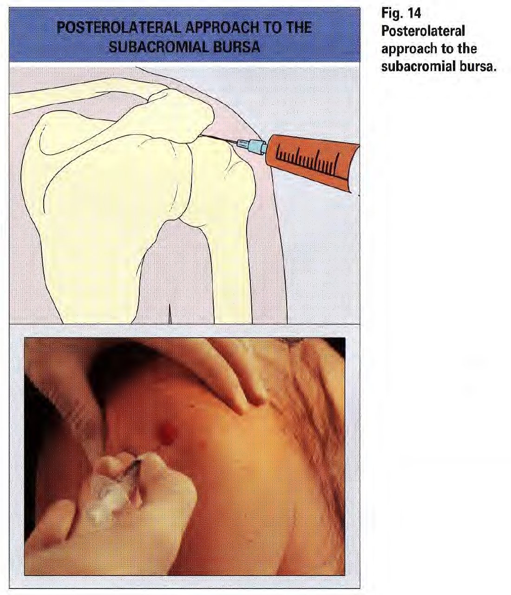
▸ Fig. 14 Subacromial bursa — posterolateral approach
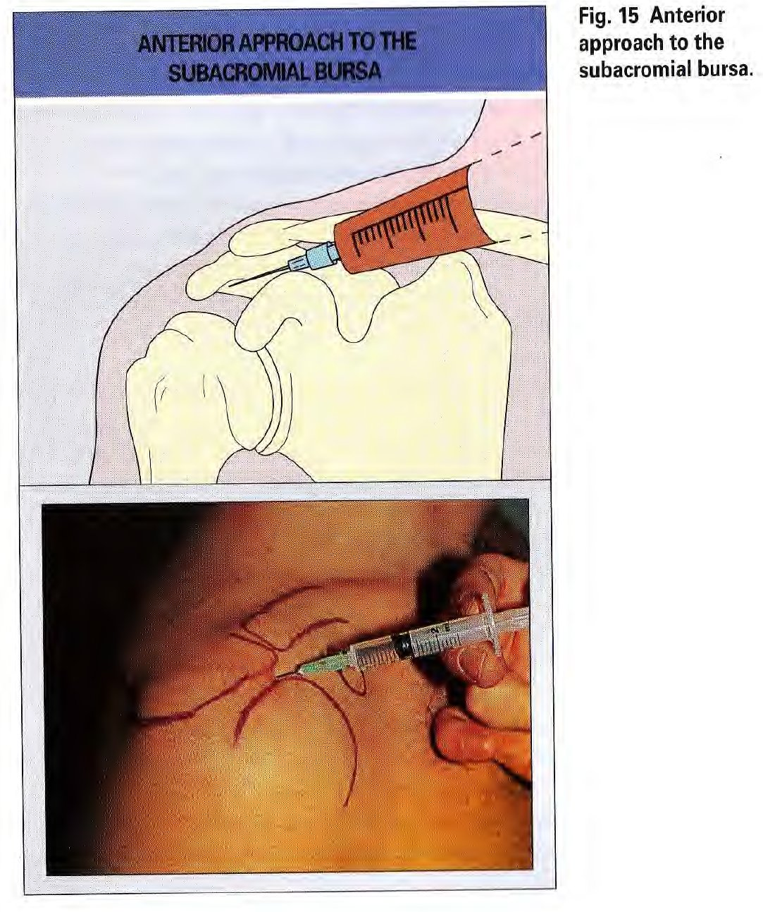
▸ Fig. 15 Subacromial bursa — anterior approach

CLINICAL NOTE
Only ~50% of landmark-guided subacromial injections accurately enter the bursal sac — yet clinical outcomes are often still good.
Consider referral for ultrasound-guided injection when landmark-guided attempts have failed or the patient is obese.

Acromioclavicular (AC) Joint
Indications | Acute arthritis; OA, RA, spondyloarthropathy.
Needle | 23 gauge butterfly or 22 gauge
Dose | 10–20 mg methylprednisolone. Aspirate first.
Approach | Aim perpendicular to the articular cleft. Advance 0.5 cm. Aspirate, then inject to distend the joint.
Precautions | The AC joint is narrow with a partial meniscus — technically demanding. Exclude septic AC arthritis in IV drug users and patients with recent subclavian catheters.
Complications | None, if sepsis excluded.

Bicipital Tendinitis
🚫 NOT RECOMMENDED IN PRIMARY CARE — SPECIALIST REFERRAL REQUIRED
Bicipital tendon / bicipital groove injection is NO LONGER RECOMMENDED as a primary care procedure.

WHY:
▸ Direct or peritendinous corticosteroid injection near the biceps tendon carries a high and documented risk of biceps tendon rupture.
▸ The biceps tendon is frequently structurally compromised by the underlying subacromial impingement that causes most bicipital pain. Any injection at this site significantly increases the risk of tendon failure.
▸ The NHS PGD for corticosteroid injection (2023) lists direct tendon injection as an absolute contraindication.
▸ Blind peritendinous placement cannot be reliably confirmed without ultrasound.

WHAT TO DO INSTEAD:
▸ Most bicipital pain is caused by subacromial impingement — treat with subacromial bursa injection (the correct and safer primary care procedure).
▸ If true bicipital tenosynovitis is confirmed on imaging, refer for ultrasound-guided peritendinous injection under specialist MSK or radiology supervision.
▸ Do NOT attempt this procedure blindly in primary care.

The Hip Region

Hip Joint
🚫 NOT PERFORMED IN PRIMARY CARE — SPECIALIST REFERRAL REQUIRED
Hip joint aspiration must NOT be performed in primary care.

WHY: The hip joint lies deep to the femoral neurovascular bundle. Blind needle insertion risks injuring the femoral artery, femoral vein, or femoral nerve — with potentially life-threatening or permanently disabling consequences.

Current UK standards mandate real-time imaging guidance (fluoroscopy, ultrasound, or CT) to confirm intra-articular needle placement before any aspiration or injection. This is a specialist orthopaedic and radiology procedure.

WHAT TO DO: Refer urgently to orthopaedics or radiology for image-guided hip aspiration. Do not attempt this procedure blindly or without imaging control.

Greater Trochanteric Pain Syndrome (GTPS)
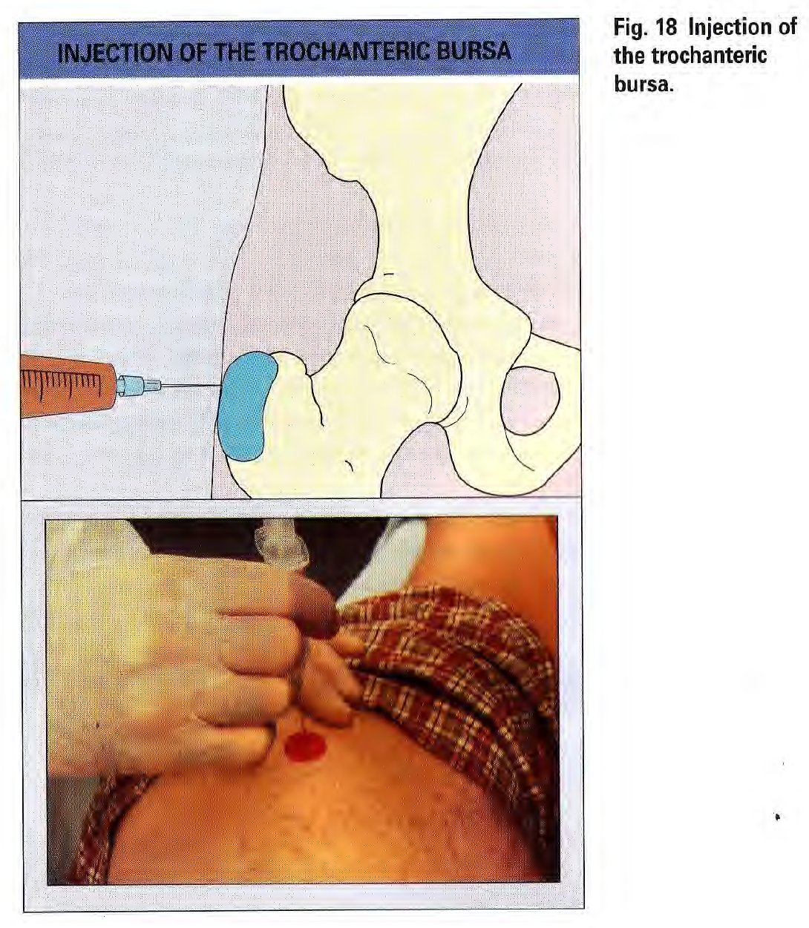
Note | Formerly called "trochanteric bursitis". This condition is enthesopathy at the gluteus medius and minimus insertion — not true bursitis.
Indications | Refractory GTPS after physiotherapy and analgesia have been tried.
Needle | 22 gauge, 1.5 inch. Spinal needle in obese patients.
Dose | 30–40 mg methylprednisolone + 3 ml 1% lidocaine
Position | Patient on opposite side.
Approach | Palpate the greater trochanter distally to proximally. The point of maximal tenderness is usually at the posterior corner. Insert vertically to periosteal contact. Step 1: Infiltrate lidocaine radially over a 3 cm cone (half on bone, half in adjacent soft tissue). Step 2: If pain is relieved, inject the corticosteroid and lidocaine mixture into the same area.
Precautions | Ensure needle length is sufficient to reach the bone in obese patients.
Complications | None.
▸ Fig. 18 Injection of the trochanteric bursa

CLINICAL NOTE
Address the underlying cause: gait abnormality, leg length discrepancy, hip OA, lumbosacral dysfunction.
NICE CKS: Injection is an adjunct to physiotherapy — not a stand-alone treatment. Physiotherapy is required for sustained benefit.

Iliopsoas Bursa
🚫 NOT PERFORMED IN PRIMARY CARE — SPECIALIST REFERRAL REQUIRED
Iliopsoas bursa injection must NOT be performed in primary care.

WHY: The iliopsoas bursa is a deep pelvic structure immediately adjacent to the femoral nerve and femoral vessels. Blind injection carries an unacceptable risk of neurovascular injury. The procedure requires contrast medium to confirm intrabursal placement, which mandates fluoroscopic or ultrasound guidance in a specialist setting.

WHAT TO DO: Refer to MSK radiology or rheumatology for image-guided injection. This procedure is not within the scope of primary care minor surgery.

The Knee Region

Knee Joint
Indications | Aspiration for any joint effusion (mandatory if septic arthritis suspected). Injection for RA, spondyloarthropathy, OA, crystal-induced synovitis.
Needle | 22 gauge (injection); 18–20 gauge (aspiration — use larger gauge for thick fluid or large effusion)
Dose | 40–60 mg methylprednisolone. Always attempt aspiration before injection.
Approach | Medial approach preferred (the lateral patellofemoral cleft is narrower; the capsule is tougher laterally). Position needle at patellar midpoint, between upper and lower poles, directed posterolaterally beneath the patella.
Precautions | In RA patients, always send aspirated fluid for culture before injecting corticosteroid. Do not inject an acutely inflamed joint until culture results are available.
Complications | None with correct aseptic technique.
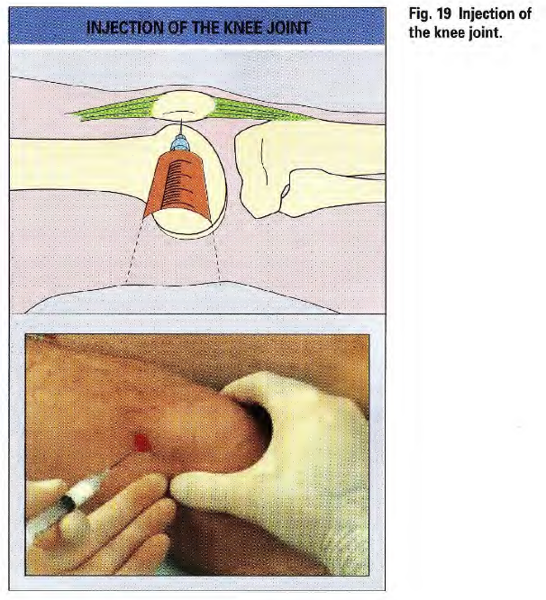
▸ Fig. 19 Injection of the knee joint

CLINICAL NOTE
NICE NG226: Intra-articular corticosteroid injection for knee OA provides short-term benefit only (2–10 weeks). Inform patients before proceeding.
Corticosteroid crystals persist in joints for weeks to months — documented injection dates prevent misdiagnosis of gout or pseudogout on later aspiration.

Baker's Cyst (Popliteal Cyst)
Key principle | Do NOT aspirate or inject a Baker's cyst directly. It is a secondary phenomenon — caused by excess synovial fluid produced in the knee joint.
Treatment | Treat the underlying knee disorder (RA, OA, meniscal pathology). The cyst resolves when the underlying cause is controlled.

Anserine Bursitis
Indications | Anserine bursitis syndrome: medial knee pain, anteromedial tibial tenderness — typically in obese patients with knee OA or genu valgum.
Needle | 22 gauge
Dose | 20–30 mg methylprednisolone + 2–3 ml 1% lidocaine
Approach | Knee in semiflexion — follow the medial thigh border to the tibial flare; mark maximum tenderness. Extend the knee fully. Insert perpendicularly to tibial periosteal contact. Infiltrate a 3 cm diameter area.
Precautions | Paraesthesiae extending down the medial leg indicate saphenous nerve engagement — reposition immediately.
Complications | None.

CLINICAL NOTE
Anserine bursitis almost always recurs unless the underlying cause is addressed. Initiate intensive quadriceps strengthening immediately. Address: obesity, genu valgum, patellofemoral OA.

The Ankle & Foot

Ankle Joint (Tibiotalar)
Indications | Aspiration for any effusion (particularly suspected septic or crystal arthritis). Injection for RA, spondyloarthropathy, OA.
Needle | 22 gauge (injection); 20 gauge (aspiration)
Dose | 40–60 mg methylprednisolone. Attempt aspiration first.
Approach | Patient supine. Flex and extend the foot to identify the tibiotalar cleft. Insert the needle vertically, medial to the anterior tibialis tendon.
Precautions | Avoid the dorsalis pedis artery — palpate it before inserting the needle.
Complications | None.
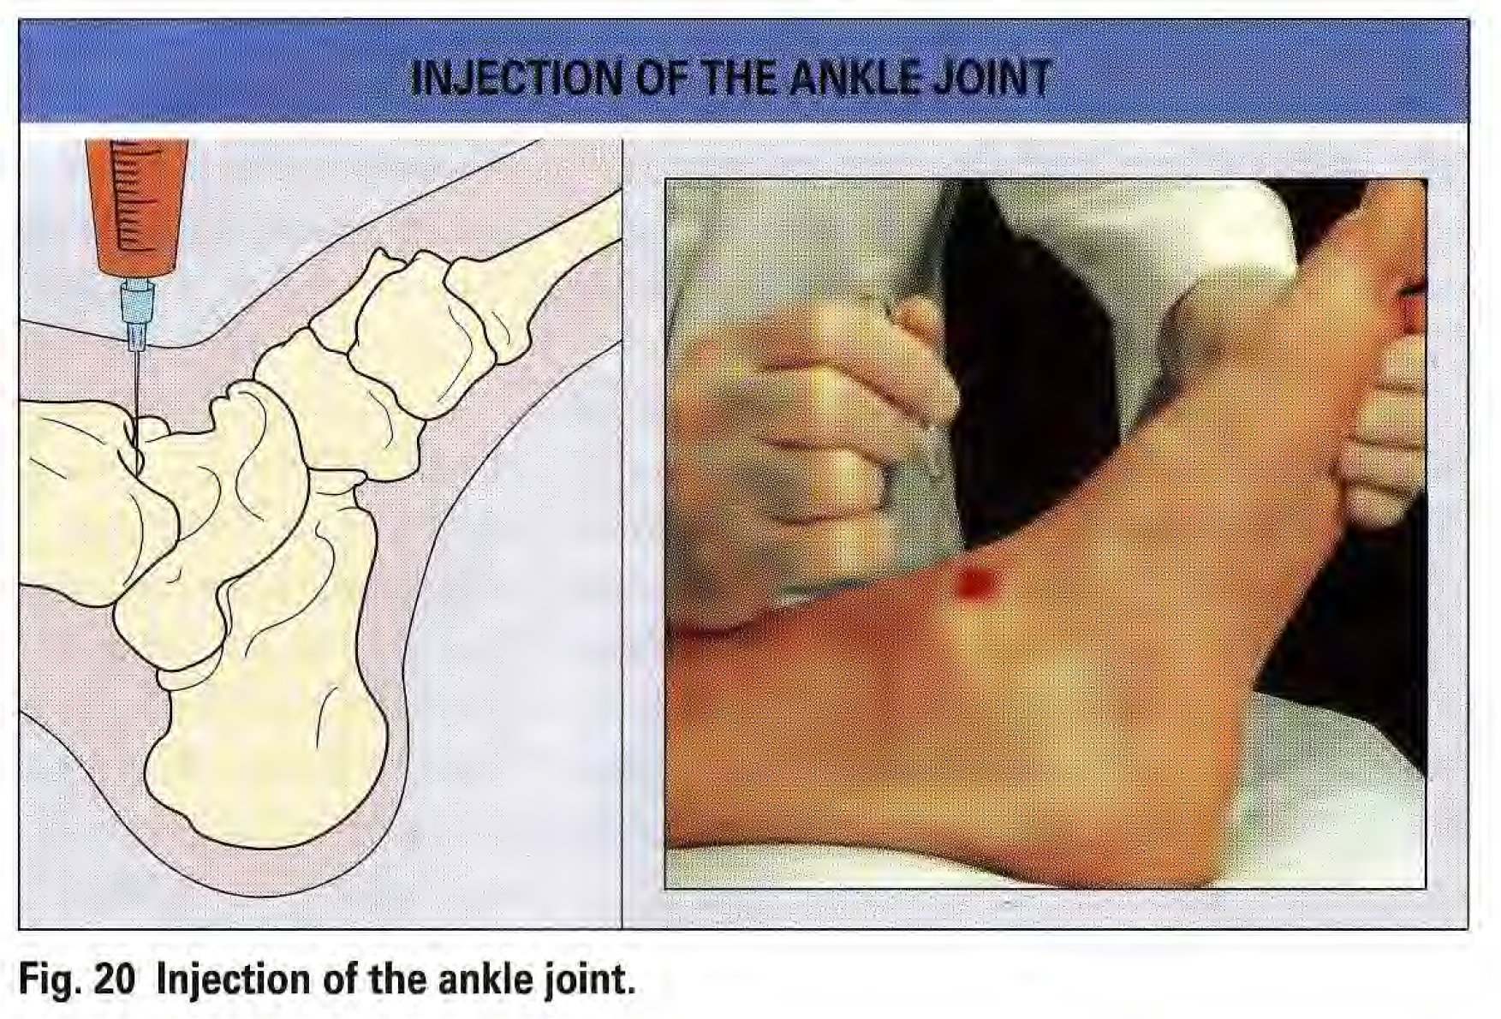
▸ Fig. 20 Injection of the ankle joint

Subtalar Joint
Indications | Aspiration or injection for RA, spondyloarthropathy, OA.
Needle | 22 gauge
Dose | 20–30 mg methylprednisolone. Attempt aspiration first.
Approach | Gently invert and evert the foot to identify the sinus tarsi (soft cleft anterior to lateral malleolus). Insert perpendicularly towards the tip of the medial malleolus. Aspiration of fluid confirms intra-articular placement. Inject under low pressure.
Precautions | None significant.
Complications | None.
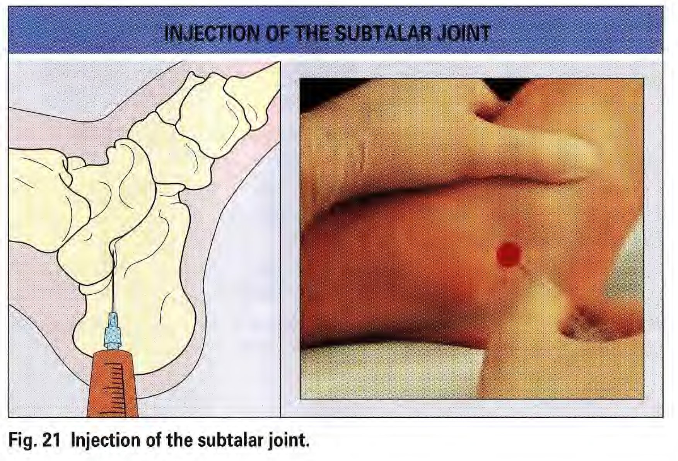
▸ Fig. 21 Injection of the subtalar joint

Posterior Tibialis Tendon Sheath
Indications | Posterior tibialis tenosynovitis in RA or spondyloarthropathy; tarsal tunnel syndrome.
Needle | 22 gauge
Dose | 20–30 mg methylprednisolone
Approach | Patient supine, injected leg resting on the contralateral knee. Insert perpendicularly, 3 finger breadths proximal to the medial malleolus tip, flush with the posterior tibial surface, to ~1.5 cm depth. Inject under low pressure.
Precautions | Aspirate first to exclude posterior tibial artery puncture. Plantar paraesthesiae = posterior tibial nerve — reposition immediately. Confirm free flow to avoid intratendinous injection.
Complications | Spontaneous posterior tibialis tendon rupture is a risk in RA — intratendinous injection markedly increases this.

CLINICAL NOTE
This procedure should only be performed by practitioners with thorough knowledge of posterior ankle anatomy. Consider referral for ultrasound-guided injection.

Retrocalcaneal Bursa
🚫 NOT RECOMMENDED FOR BLIND INJECTION — ULTRASOUND GUIDANCE MANDATORY
Blind retrocalcaneal bursa injection must NOT be performed in primary care.

WHY — ANATOMICAL DANGER:
▸ The retrocalcaneal bursa is separated from the Achilles tendon by a fibrocartilaginous layer only 200 microns thick.
▸ Cadaveric studies show that even ultrasound-guided injections regularly cause extravasation of injectate INTO the Achilles tendon and surrounding adipose tissue.
▸ The NHS PGD for corticosteroid injection (2023) explicitly classifies the Achilles tendon as an avascular area and lists it as a CONTRAINDICATION for corticosteroid injection.
▸ Blind injection risks direct intratendinous corticosteroid deposition, which dramatically weakens tendon collagen and causes spontaneous tendon RUPTURE.

WHAT TO DO:
▸ Refer to an MSK ultrasound-guided injection service (radiology or rheumatology).
▸ Even with ultrasound guidance this injection is technically challenging and controversial. Ensure the specialist is aware of the rupture risk.
▸ First-line management is physiotherapy with eccentric loading exercises.

Plantar Fascia Attachment
Indications | Refractory plantar fasciitis in spondyloarthropathies. Only if symptoms are severe and conservative management has failed for ≥ 3 months.
Needle | 22 gauge
Dose | 20–30 mg methylprednisolone + 2 ml 1% lidocaine
Approach | Medial approach, needle parallel to the plantar skin, 2 cm deep to the plantar surface. Aim towards the medial plantar tubercle of the calcaneus. Rubbery resistance = fascial location. Inject deep and superficial to the fascia.
Precautions | Requires thorough knowledge of plantar anatomy.
Complications | Repeated injections cause permanent plantar fat pad atrophy and pressure pain. Maximum 2 injections.

CLINICAL NOTE
Limit to a maximum of 2 injections. Fat pad atrophy is permanent and disabling. Refer for physiotherapy, orthotics, or specialist review if injection fails.

Metatarsophalangeal (MTP) Joints
Indications | Aspiration for gout diagnosis (first MTP). Injection for hallux rigidus, RA, spondyloarthropathy.
Needle | 22–23 gauge
Dose | 10–20 mg methylprednisolone. Attempt aspiration first.
Approach | Dorsal, lateral or medial to the extensor tendon. Slight passive plantar flexion opens the joint.
Precautions | None.
Complications | None.
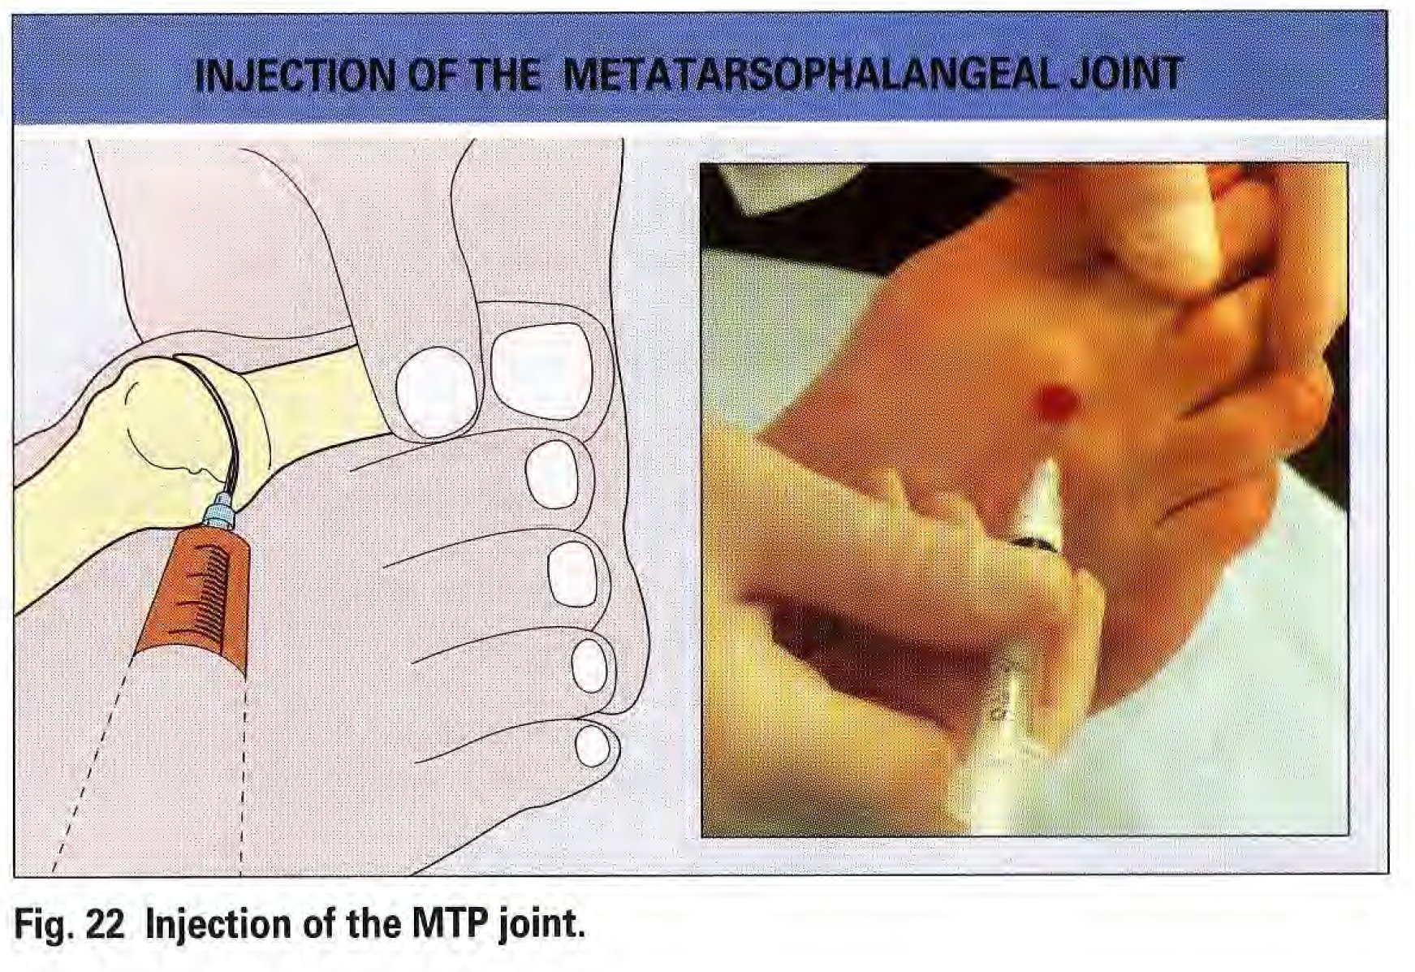
▸ Fig. 22 Injection of the metatarsophalangeal (MTP) joint

Morton's Neuroma
Indications | Confirmed Morton's neuroma causing significant forefoot pain, refractory to footwear advice, padding, and orthotics.
Needle | 22 gauge
Dose | 20–30 mg methylprednisolone + 1 ml 1% lidocaine. Do NOT use high volumes.
Approach | Dorsal approach between the metatarsal heads. Advance plantarly ~2 cm through the tough intermetatarsal ligament (firm resistance then give). Inject under low pressure.
Precautions | Requires precise anatomical knowledge. Refer if uncertain.
Complications | None expected. Maximum 2 reinjections, 2–3 weeks apart.

Trigger Points (Myofascial Pain)
Indications | Active myofascial trigger points — a palpable nodule that consistently reproduces the patient's pain on pressure.
Needle | 22 gauge
Injectate | 3–5 ml of 1% lidocaine or 0.25% bupivacaine. Do NOT use corticosteroid.
Approach | Insert at the trigger point or nodule centre. Infiltrate radially throughout the indurated area (fan technique).
Precautions | None.
Complications | None.

CLINICAL NOTE
Dry needling (without injectate) is an alternative technique with comparable evidence. Both approaches are appropriate in primary care.

The Spine — Interspinous Ligament

Interspinous ligament injections are occasionally used in reactive arthritis and ankylosing spondylitis with enthesopathy. This is not a routine primary care minor surgery procedure.

Interspinous Ligaments
Indications | Reactive arthritis or ankylosing spondylitis with interspinous ligament enthesopathy — where other treatments have failed.
Needle | 22 gauge
Dose | 15–20 mg methylprednisolone
Approach | Posteroanterior, at the midline between adjacent spinous processes. Infiltrate the ligament and its attachments. Multiple levels may be treated in one session.
Depth limit | Do NOT infiltrate deeper than 1.5 cm — this is the minimum safe distance from the dural sac.
Complications | None with correct depth control.

CLINICAL NOTE
Do not infiltrate beyond 1.5 cm. The dural sac lies deep to this level. Inadvertent dural puncture requires urgent management.

🚫 DO NOT PERFORM IN PRIMARY CARE — SPECIALIST PROCEDURES ONLY
Sacroiliac joint injection, facet joint injection, and epidural steroid injection must NEVER be performed in primary care.

WHY:
▸ These are deep spinal and pelvic procedures with potentially catastrophic complication profiles: epidural haematoma, spinal cord injury, arachnoiditis,dural puncture, systemic infection, and permanent neurological injury.
▸ They require real-time fluoroscopic or CT imaging guidance to confirm needle placement. Blind injection is absolutely contraindicated by all specialist society guidelines.
▸ These procedures fall entirely within the scope of interventional radiology, pain medicine, and spinal anaesthetics — not primary care minor surgery.

WHAT TO DO: Refer to a specialist pain clinic, spinal anaesthetics service, or interventional radiology. Do not attempt these procedures under any circumstances.

Summary Safety Reference

Red Flags — Do Not Inject; Refer Urgently

🔴 URGENT — DO NOT INJECT
Hot, swollen, acutely painful joint with systemic features (fever, rigors, raised CRP/WBC) — MUST aspirate; send for urgent MC&S. Do NOT inject corticosteroid until infection excluded.
Post-injection joint with increasing pain and swelling after 48 hours, or new systemic symptoms — suspect iatrogenic septic arthritis. Urgent re-aspiration, blood cultures, same-day emergency referral.
Any prosthetic joint — do NOT aspirate or inject in primary care. Refer to orthopaedics.
Progressive neurological symptoms, motor weakness, or bilateral limb symptoms — urgent referral before any injection.
Suspected malignancy as a cause of swelling — urgent 2-week wait referral.

Maximum Injection Frequency — UK Consensus

Joint / Structure | Recommended Maximum | Rationale
Any single joint | 3–4 per year maximum | Corticosteroid arthropathy risk with repeated use
Knee (OA) | 3 per year — balance benefit vs risk | NICE NG226: short-term benefit only (2–10 weeks)
Plantar fascia | 2 total | Fat pad atrophy is permanent
Carpal tunnel | 2–3 before surgical referral | Refer after 2 injections if symptoms recur
Trigger finger | 3 before surgical referral | Refer for A1 pulley release if still symptomatic
Tennis elbow | 1 injection maximum | Evidence: worse outcomes at 12 months

Drug & Dose Quick Reference

Joint / Structure | Needle | Dose (methylprednisolone) | Notes
Finger / MCP / PIP | 25–27g | 10–15 mg
Flexor tendon sheath | 25–27g | 15–20 mg + 1–2 ml lidocaine | Max 3 injections
De Quervain's | 25g | 20–30 mg | Methylprednisolone only
Carpal tunnel | 22–25g | 20–40 mg | Refer after 2 injections
First CMC joint | 23–25g | 15–30 mg
Wrist joint | 23g | 30–40 mg
Elbow joint | 22g | 30–40 mg
Olecranon bursa | 22g | 20 mg | Methylprednisolone only
Tennis elbow | 22g | 10–20 mg | Max 1 injection
Glenohumeral joint | 22g | 40–60 mg | Seated; assistant essential
Subacromial bursa | 22–25g | 30–40 mg | Seated; assistant essential
AC joint | 23g | 10–20 mg
Trochanteric bursa (GTPS) | 22g 1.5" | 30–40 mg + 3 ml lidocaine | Spinal needle if obese
Knee joint | 22g | 40–60 mg | NICE NG226
Anserine bursa | 22g | 20–30 mg + 2–3 ml lidocaine
Ankle joint | 22g | 40–60 mg
Subtalar joint | 22g | 20–30 mg
Plantar fascia | 22g | 20–30 mg + 2 ml lidocaine | Max 2 injections
MTP joint | 22–23g | 10–20 mg
Morton's neuroma | 22g | 20–30 mg + 1 ml lidocaine | Max 2 reinjections
Trigger points | 22g | Lidocaine 3–5 ml only | NO corticosteroid

References & Guidance Sources

This guide has been updated against the following primary sources. Always check for the most current version before clinical use.

1. NICE NG226 (2022). Osteoarthritis in over 16s: diagnosis and management. nice.org.uk/guidance/ng226
2. NICE CKS. Tennis elbow (updated 2024). cks.nice.org.uk/topics/tennis-elbow
3. NICE CKS. Carpal tunnel syndrome. cks.nice.org.uk/topics/carpal-tunnel-syndrome
4. NICE CKS. Trigger finger. cks.nice.org.uk/topics/trigger-finger
5. NICE CKS. Shoulder pain (updated 2023). cks.nice.org.uk
6. BNF. Corticosteroids — local injections. bnf.nice.org.uk
7. Canoso JJ. Joint injection techniques. In: Klippel JH, Dieppe PA (eds). Rheumatology 2nd Ed. Mosby-Wolfe, 1999.
8. Coombes BK, Bisset L, Vicenzino B. Effect of corticosteroid injection, physiotherapy, or both on clinical outcomes in lateral epicondylalgia. JAMA 2013; 309(5): 461–469.
9. Bisset L et al. Mobilisation with movement and exercise, corticosteroid injection, or wait and see for tennis elbow. BMJ 2006; 333: 939.
10. Marshall S, Tardif G, Ashworth N. Local corticosteroid injection for carpal tunnel syndrome. Cochrane Database Syst Rev 2007; (2): CD001554.
11. Peters-Veluthamaningal C et al. Corticosteroid injection for trigger finger in adults. Cochrane Database Syst Rev 2009; (1): CD005617.
12. Hirsch G, Kitas G, Klocke R. Intra-articular corticosteroid injection in anticoagulated patients. Rheumatology 2012; 51(10): 1731–1738.
13. Aleem AW et al. Blood glucose levels in diabetic patients following corticosteroid injections. Arch Bone Jt Surg 2017; 5(5): 315–321.
14. Smith CB et al. Corticosteroid injections for frozen shoulder: a global survey. Musculoskeletal Care 2025.
15. RCGP. GP curriculum: musculoskeletal health. rcgp.org.uk

Document updated May 2026
Updated for UK primary care under NICE NG226, NICE CKS & BNF

