BRADFORD VTS TEACHING AIDS | UPDATED  June 2026

MUSCULOSKELETAL · QUICK-REFERENCE CARD
Back Pain — Diagnostic Triage – The 6 patterns
Six patterns, one quick sort — what to recognise and what to do. For GP trainees and IMGs.
! How to read this card
These features warn you — they do not, on their own, dictate referral. Never act on a single red flag in isolation; weigh the whole picture. First exclude a problem coming from elsewhere, then sort the spine into simple backache, nerve-root pain, or possible serious pathology.

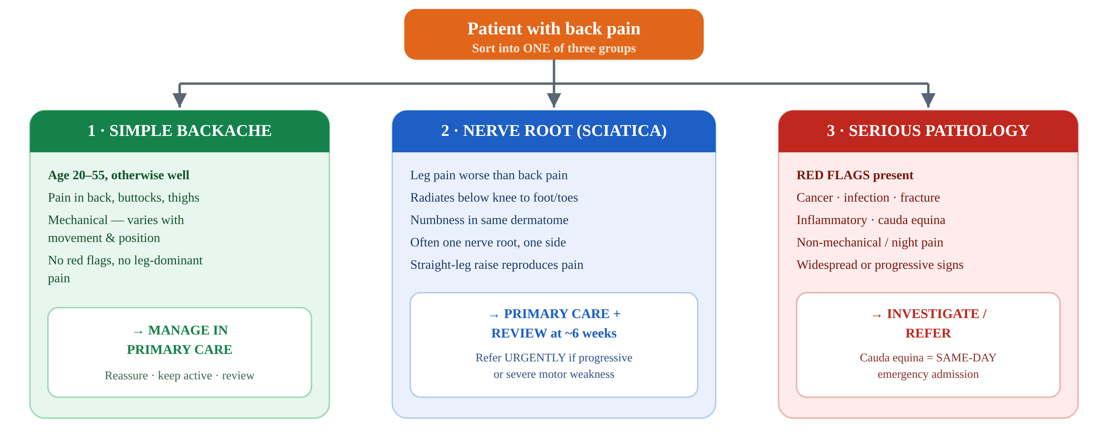

✓ | The six patterns |  |  | Recognise · Act
Pattern |  | Recognise — warning features | Act
Simple backache |  | - Age 20–55, otherwise well  - Pain in lumbosacral region, buttocks and thighs  - Mechanical — varies with activity and posture  - No red flags, no leg-dominant pain | Manage in primary care — reassure, keep active, NSAID first-line, no routine imaging, review.
Nerve-root pain (sciatica) |  | - Unilateral leg pain worse than back pain  - Radiates to foot or toes; numbness in the same dermatome  - SLR reproduces the leg pain  - Localised (single-level) neurological signs | Primary care + review ~6 weeks. Refer urgently if severe or progressive motor weakness.
Serious spinal pathology  Red flags |  | - New onset under 20 or over 55  - Constant, progressive, non-mechanical pain; worse at night or at rest  - Thoracic pain; violent trauma or structural deformity  - Systemically unwell, weight loss, night sweats  - PMH cancer, steroids, HIV, osteoporosis, immunosuppression | Urgent investigation / referral — suspected-cancer pathway (NG12) / cord compression (CG75); infection → urgent.
Cauda equina syndrome  Emergency |  | - Bladder or bowel dysfunction — retention, incontinence, loss of the urge to go  - Saddle / perineal / genital numbness  - Bilateral leg pain or sciatica; reduced anal tone; sexual dysfunction  - Progressive motor weakness or gait disturbance not due to pain | SAME-DAY emergency admission for urgent MRI (spinal surgery / neurosurgery). Do not wait.
Inflammatory disorder  Axial SpA |  | - Onset under 40, gradual  - Marked morning stiffness > 30 min; improves with exercise, not rest  - Waking in the second half of the night; alternating buttock pain  - Uveitis (iritis), psoriasis, colitis/IBD, reactive arthritis; peripheral joint involvement  - Family history | Refer to rheumatology (NICE NG65).
Problem elsewhere  Visceral / referred |  | - Abdominal — AAA (pulsatile mass + cardiovascular risk), pancreatitis, peptic ulcer  - Renal / ureteric  - Gynaecological — endometriosis, PID, ectopic  - Pain not related to spinal movement | Diagnose and manage the underlying cause.

! The one you must never miss — cauda equina
Keep a high index of suspicion and ask directly about bladder, bowel, saddle / genital sensation and bilateral leg symptoms — including on the telephone. If suspected, you must arrange same-day emergency hospital admission for urgent MRI — do not “watch and review”. Document the questions you asked.

Yellow flags — risk of chronicity  The older label “psychogenic” is unhelpful. Instead, look for yellow flags — beliefs that the back is damaged, fear of movement, low mood, or expecting a poor outcome. These predict chronicity, not a sinister cause. |  | What helps  Positive, accurate messages (pain ≠ damage; movement is safe), staying active and at work, and early support for those at higher risk (e.g. STarT Back stratification).

§ Disclaimer
This document is provided exclusively for education and training as a teaching aid. It does not constitute formal clinical guidance. Clinicians must independently verify all medical information, prescribing guidance and referral criteria against current national guidance and local policies before applying in practice.

Sources: NICE NG59 Low back pain and sciatica in over 16s; NICE CKS Sciatica (lumbar radiculopathy) and Back pain; NICE NG12 (suspected cancer), CG75 (metastatic spinal cord compression), NG65 (spondyloarthritis). This teaching aid modernises an earlier Bradford VTS triage table — outdated entries (“menopause”, “psychogenic cause”) have been replaced with current visceral causes and a yellow-flags note. Verify against current guidance and local pathways before use.

