BRADFORD VTS TEACHING AIDS | June 2026
MUSCULOSKELETAL SKILLS · CLINICAL REFERENCE
Carpal Tunnel Syndrome
Spotting it, assessing it, and managing it well — for GP trainees and IMGs

★ THE BIG IDEA
Carpal tunnel syndrome is the median nerve being squeezed as it passes through the wrist. The diagnosis is clinical — a good history beats any single test. Most cases are mild and many settle, but constant numbness or wasting of the thumb muscles means urgent referral to protect the nerve.
Recognise it — the median nerve story
The symptoms follow the median nerve’s territory in the hand. Picture where the nerve goes and the diagnosis tells itself.
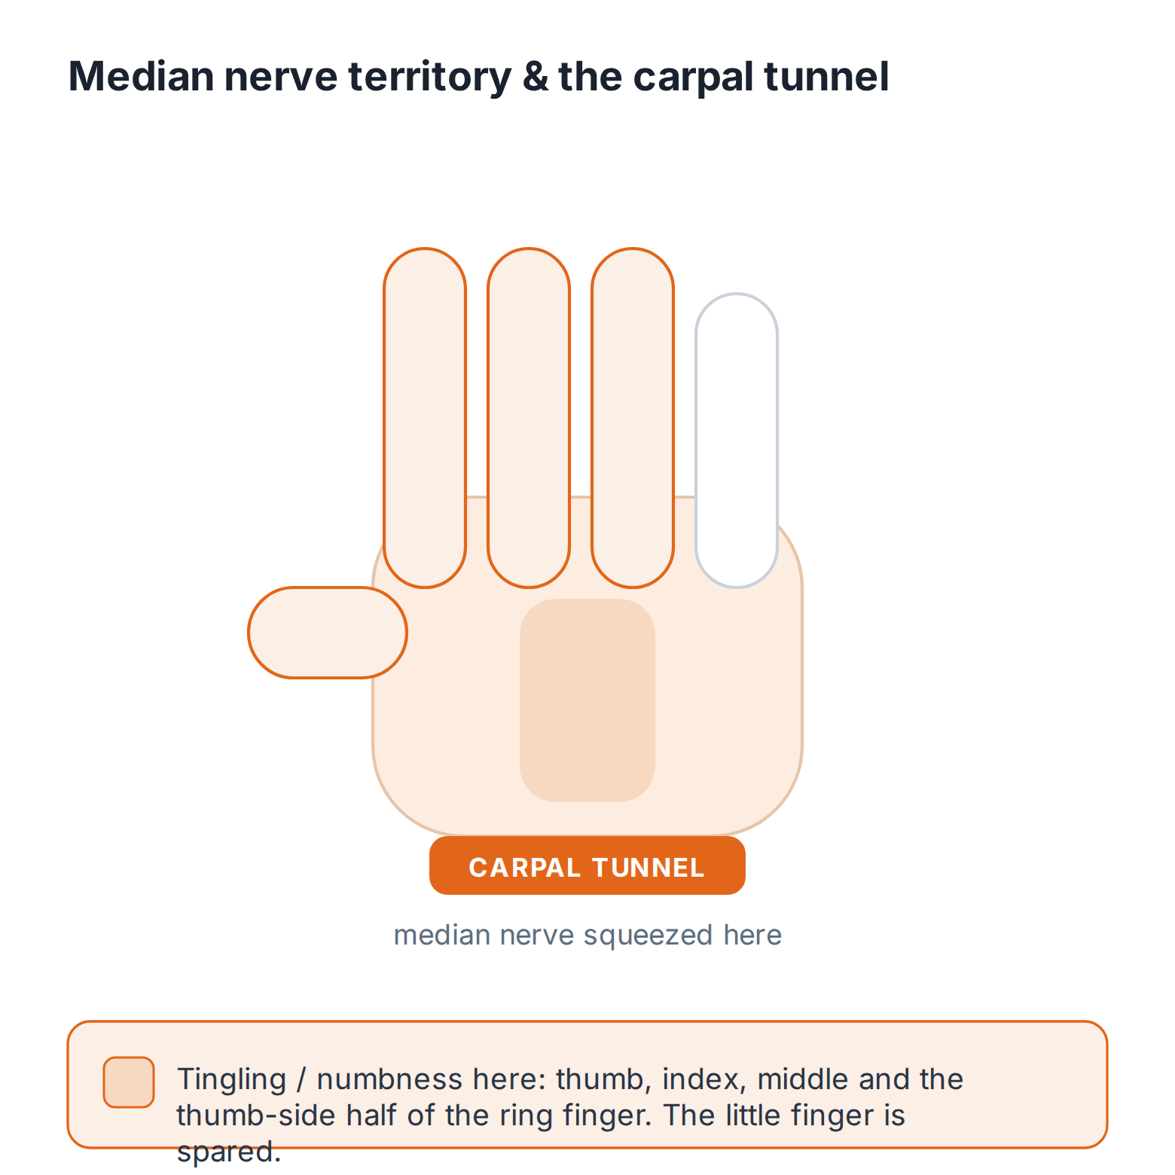

Clue | What the patient describes
Where | Tingling, numbness or pain in the THUMB, INDEX, MIDDLE and the thumb-side of the RING finger. The little finger is spared.
When | Worse at NIGHT — it wakes them from sleep.
The flick sign | They shake or “flick” the wrist to relieve it — a strongly suggestive clue.
Later | Weakness, clumsiness, dropping things, and wasting of the thumb (thenar) muscles.
ℹ WHO GETS IT
Often there is no cause (idiopathic). Look for the treatable associations: pregnancy, hypothyroidism, diabetes, rheumatoid arthritis and obesity. Occupation and hobbies matter too — sustained gripping, vibration, or leaning on the wrist (for example, cycling).

Assess it
Examine
- Look: wasting of the thenar (thumb-base) muscles — a sign of more advanced disease.
- Test power: thumb abduction (the median-supplied abductor pollicis brevis) and opposition.
- Test sensation over the median territory.
- Provocation tests: Tinel’s (tapping over the tunnel) and Phalen’s (holding the wrist flexed) may reproduce the symptoms.
⚠ A KEY EXAM TRAP
Tinel’s and Phalen’s tests have low sensitivity — a NEGATIVE test does NOT rule out carpal tunnel syndrome. A positive test supports the diagnosis, but a good history carries far more weight than either sign.
Investigate — only when it changes your plan
- Most cases need no test. A typical history and examination are enough to diagnose and to start treatment.
- Nerve conduction studies are useful when the picture is atypical or uncertain, when another diagnosis is possible, or when surgery is being planned.
- Check for an associated cause where the history suggests one (for example, thyroid function).
Manage it — a stepped approach
Match the treatment to the severity. Start conservatively in mild cases; escalate if symptoms are severe, persistent, or there are signs of nerve damage.
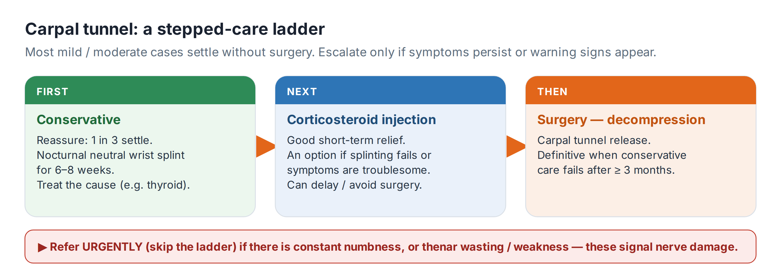

✓ FOR MILD TO MODERATE SYMPTOMS
• Reassure: explain that up to a third of cases settle on their own, and pregnancy-related cases usually resolve after delivery.
• Treat any underlying cause.
• Night splint: a wrist splint worn at night holds the wrist neutral and is a reasonable first step for several weeks.
• Corticosteroid injection into the carpal tunnel can give useful, if sometimes temporary, relief and may defer or avoid surgery. Check the agent, dose and technique against the BNF and your local guidance — do not work from memory.
⚠ REFER URGENTLY — THE NERVE IS AT RISK
Refer urgently for surgical assessment (carpal tunnel decompression) if there is:
• CONSTANT (not just intermittent) numbness
• Wasting or weakness of the thenar muscles
• Severe symptoms, or symptoms that fail conservative treatment
These signal nerve damage that can become permanent if decompression is delayed.
ℹ WHAT SURGERY INVOLVES
Carpal tunnel release divides the transverse carpal ligament to free the nerve. It is a common, effective day-case procedure — the definitive treatment for significant or persistent disease.
Recognise → Act → Refer
Recognise | Act | Refer
Intermittent night-time median tingling, no wasting | Reassure; treat any cause; night splint; consider injection | Only if not improving
Symptoms in pregnancy | Reassure; night splint; expect resolution after delivery | Rarely needed
Constant numbness OR thenar wasting / weakness | Do not delay conservative trials | URGENT — surgical assessment for decompression
Atypical or uncertain picture | Consider nerve conduction studies | Specialist opinion if diagnosis unclear

🔎 SOURCES & FURTHER READING
Verified against the following UK sources at the date of publication:
- NICE CKS — Carpal tunnel syndrome (diagnosis, conservative care, referral).
- BNF — for any corticosteroid injection agent, dose and technique.
- Refer to local hand-surgery / orthopaedic and physiotherapy pathways.

⚠ IMPORTANT — EDUCATIONAL DISCLAIMER
This document is provided exclusively for educational and training purposes as a Bradford VTS teaching aid. It does not constitute formal clinical guidance.
Clinicians must independently verify all medical information, prescribing guidance, procedural protocols, and legal requirements against current national guidance (NICE, NICE CKS, BNF, MHRA and relevant Royal Colleges), local policies, and regulatory bodies before applying any of it in practice. Information is correct to the best of our knowledge at the date of publication but guidance changes — the responsibility for safe, up-to-date practice rests with the individual clinician.

