BRADFORD VTS TEACHING AIDS

Joint Hypermobility — Scoring & Assessment

MSK Teaching Series · For GP Trainees & IMGs June 2026
✓ In a nutshell
The Beighton score (0–9) measures generalised joint hypermobility (GJH) — how bendy the joints are. It does not, by itself, make any diagnosis.
Hypermobility is common and often benign. It becomes relevant when it is symptomatic — and may underlie 30–40% of the MSK presentations you see.
The old 'Brighton / joint hypermobility syndrome' label is superseded. Symptomatic hypermobility is now framed as hypermobile EDS (hEDS) or hypermobility spectrum disorder (HSD).
The Beighton score · Five manoeuvres, nine points
One point is awarded for each side that performs a manoeuvre, plus one for the forward-bend — giving a maximum of 9.
 | Manoeuvre | Points
1 | Passive dorsiflexion of the little (5th) finger beyond 90° | 1 per hand (max 2)
2 | Passive apposition of the thumb to the flexor aspect of the forearm | 1 per thumb (max 2)
3 | Hyperextension of the elbow beyond 10° | 1 per elbow (max 2)
4 | Hyperextension of the knee beyond 10° | 1 per knee (max 2)
5 | Forward flexion of the trunk, knees straight, palms flat on the floor | 1 (max 1)
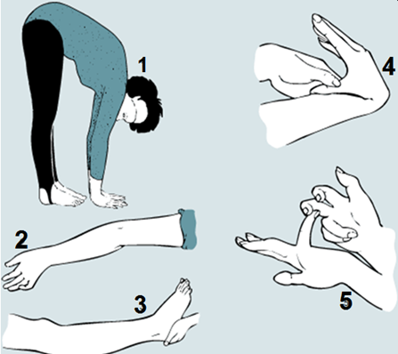
The five Beighton manoeuvres (maximum score 9).

Interpreting the score · Age- and sex-adjusted cut-offs
Generalised joint hypermobility (GJH) is defined by a Beighton score at or above an age-related threshold — because flexibility declines with age:
Group |  |  | Threshold for GJH
Pre-pubertal children & adolescents |  |  | ≥ 6 / 9
Adults (up to ~50 years) |  |  | ≥ 5 / 9
Adults over 50 years |  |  | ≥ 4 / 9
▸ Historical hypermobility — the 5-part questionnaire
If joints are now stiffer, the Beighton score may miss past hypermobility. A validated 5-part questionnaire captures it — a 'yes' to two or more suggests hypermobility:
- Can you now (or could you ever) place your hands flat on the floor without bending your knees?
- Can you now (or could you ever) bend your thumb to touch your forearm?
- As a child, did you amuse friends by contorting your body, or could you do the splits?
- As a child or teenager, did your kneecap or shoulder dislocate on more than one occasion?
- Do you consider yourself 'double-jointed'?
▲ A high Beighton score is NOT a diagnosis
Generalised hypermobility on its own is just a finding. It does not equal hEDS.
- hypermobile EDS (hEDS) requires the full 2017 international criteria — generalised hypermobility PLUS systemic features, a positive family history and/or musculoskeletal complications, AND exclusion of other connective-tissue disorders.
- Hypermobility spectrum disorder (HSD) describes symptomatic hypermobility that does not meet the full hEDS criteria.
- The older terms 'joint hypermobility syndrome' and the Brighton criteria are no longer used.
 |  | Why it matters in primary care
- Hypermobility may underlie 30–40% of MSK presentations — recurrent sprains, 'growing pains', non-specific joint and back pain, and clumsiness.
- It is a recognised risk factor for fibromyalgia and chronic widespread pain — worth screening for in that group.
- Associated features can include fatigue, autonomic symptoms, anxiety, and easy bruising — ask about them.
Managing symptomatic hypermobility
◎ Core management
- Reassure and explain — it is common, manageable, and not a sign of joint destruction.
- Graded, low-impact strengthening — swimming, cycling and Pilates build the muscle support that lax joints rely on.
- Proprioception and pacing work, often with physiotherapy, to improve joint control and reduce flares.
- Medial arch supports / orthotics help where there is foot pronation.
- Refer to physiotherapy for a tailored programme; involve specialist services for diagnostic uncertainty or significant systemic features.
◆ What's changed from older teaching
- 'Joint hypermobility syndrome' and the Brighton criteria are retired — replaced by hEDS and HSD (2017 international classification).
- GJH thresholds are age-adjusted (≥6 pre-puberty, ≥5 in adults, ≥4 over 50) — not a single '≥4 + arthralgia' rule.
- A high Beighton score alone no longer 'diagnoses' anything — symptoms and the full criteria matter.
■ Disclaimer & verification
Key sources used for this update: 2017 International Classification of the Ehlers–Danlos Syndromes (hEDS criteria) and hypermobility spectrum disorders; Beighton scoring & 5-part questionnaire (Hakim & Grahame); NICE CKS / Ehlers-Danlos Support UK educational resources.
This document is provided exclusively for educational and training purposes as a teaching aid. It does not constitute formal clinical guidance. Clinicians must independently verify all medical information, prescribing guidance, procedural protocols and legal requirements against current national guidance (e.g. NICE, NICE CKS, BNF), local policies and the relevant regulatory bodies before applying anything in practice.

