BRADFORD VTS TEACHING AIDS | June 2026
MUSCULOSKELETAL SKILLS · CLINICAL REFERENCE
The Acutely Injured Knee
Reading the history, examining safely, and knowing who to refer — for GP trainees and IMGs

★ THE BIG IDEA: THE STORY MAKES THE DIAGNOSIS
The knee is the most commonly injured joint in sport, and the history gives you 70–80% of the diagnosis — the examination adds only the remaining 10–20%. A normal knee between flare-ups, and even a normal X-ray, must NEVER reassure you out of a worrying history.
Why this matters
- The ACL is the most commonly injured knee ligament, and 70% of knee haemarthroses (blood in the joint) are due to an ACL tear.
- It is missed for far too long. On average it takes around two years from injury to diagnosis, and the first doctor to see the patient makes the diagnosis in only about 1 in 10 cases — usually because a normal examination between episodes was wrongly reassuring.
- Do not be that doctor. Let the history lead.
The history — the questions that matter
In the chaos of a match the exact mechanism is often forgotten, so ask about the things the patient WILL remember.
Ask about | Why it matters
A pop, crack or snap | A sudden audible or felt “pop” at the moment of injury strongly suggests an ACL rupture.
Could they carry on? | Having to stop and leave the field points to a significant injury.
How fast did it swell? | The single most useful question — see the timing rule below.
Did it lock or give way? | True locking suggests a loose body or meniscal tear; giving way on turning suggests instability (ACL).
Where is the pain? | Medial or lateral pain suggests ligament or meniscus; pain at the front suggests the patellofemoral joint.
The swelling clock — timing tells you the cause
When the knee swelled is one of the most powerful clues you have. Learn this pattern.
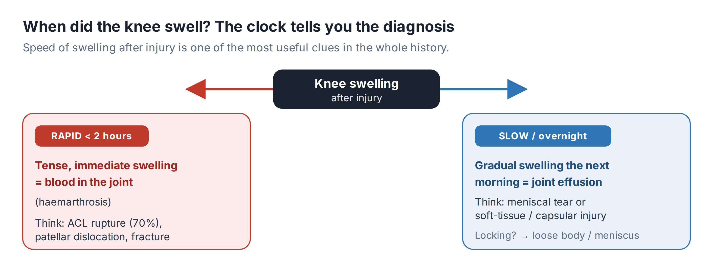
🕒 READ THE CLOCK
Immediate / rapid swelling (within the first hour or two) = blood in the joint (haemarthrosis). Think ACL tear (70%), an osteochondral fracture, or a patellar dislocation.
Slow swelling (over several hours, often overnight) = a reactive effusion. Think meniscal injury.

When to X-ray — the Ottawa Knee Rules
Not every injured knee needs an X-ray. The Ottawa Knee Rules safely identify who does, reducing unnecessary imaging.
ℹ X-RAY THE KNEE IF ANY ONE OF THESE IS PRESENT
• Age 55 years or older
• Tenderness over the head of the fibula
• Isolated tenderness of the patella
• Unable to flex the knee to 90°
• Unable to bear weight (4 steps) both immediately after injury AND at assessment
⚠ AN X-RAY ONLY EXCLUDES A FRACTURE
A normal X-ray does NOT exclude a serious soft-tissue injury. Ligament and meniscal tears are invisible on plain films — if the history is worrying, refer regardless of the X-ray.
Examining the knee
Examine in the familiar order — Look, Feel, Move — always comparing with the normal side.
Look
- Gait and limp as the patient walks in; muscle wasting (especially quadriceps, which wastes fast); swelling; bruising; alignment (varus / valgus).
Feel
- Warmth; an effusion (patellar tap or sweep test); joint-line tenderness (meniscus); tenderness over the collateral ligaments and their attachments.
Move
- Range: active, then passive flexion and extension.
- Collateral ligaments: apply valgus and varus stress in full extension and at 30° of flexion. Laxity in full extension implies major injury; laxity only at 30° isolates the collateral ligament.
- Cruciates: Lachman’s test, the anterior/posterior drawer, and the pivot-shift. Be honest — these are difficult and unreliable in non-expert hands and in a painful, guarded knee. Do not let normal tests overrule a clear history.
- Meniscus: joint-line tenderness is the most useful sign; McMurray’s test reproduces pain and a click.
ℹ DON’T FORGET
Always consider referred pain from the hip (especially in children and teenagers — think slipped upper femoral epiphysis) and the possibility of generalised joint disease.

The four ligaments at a glance
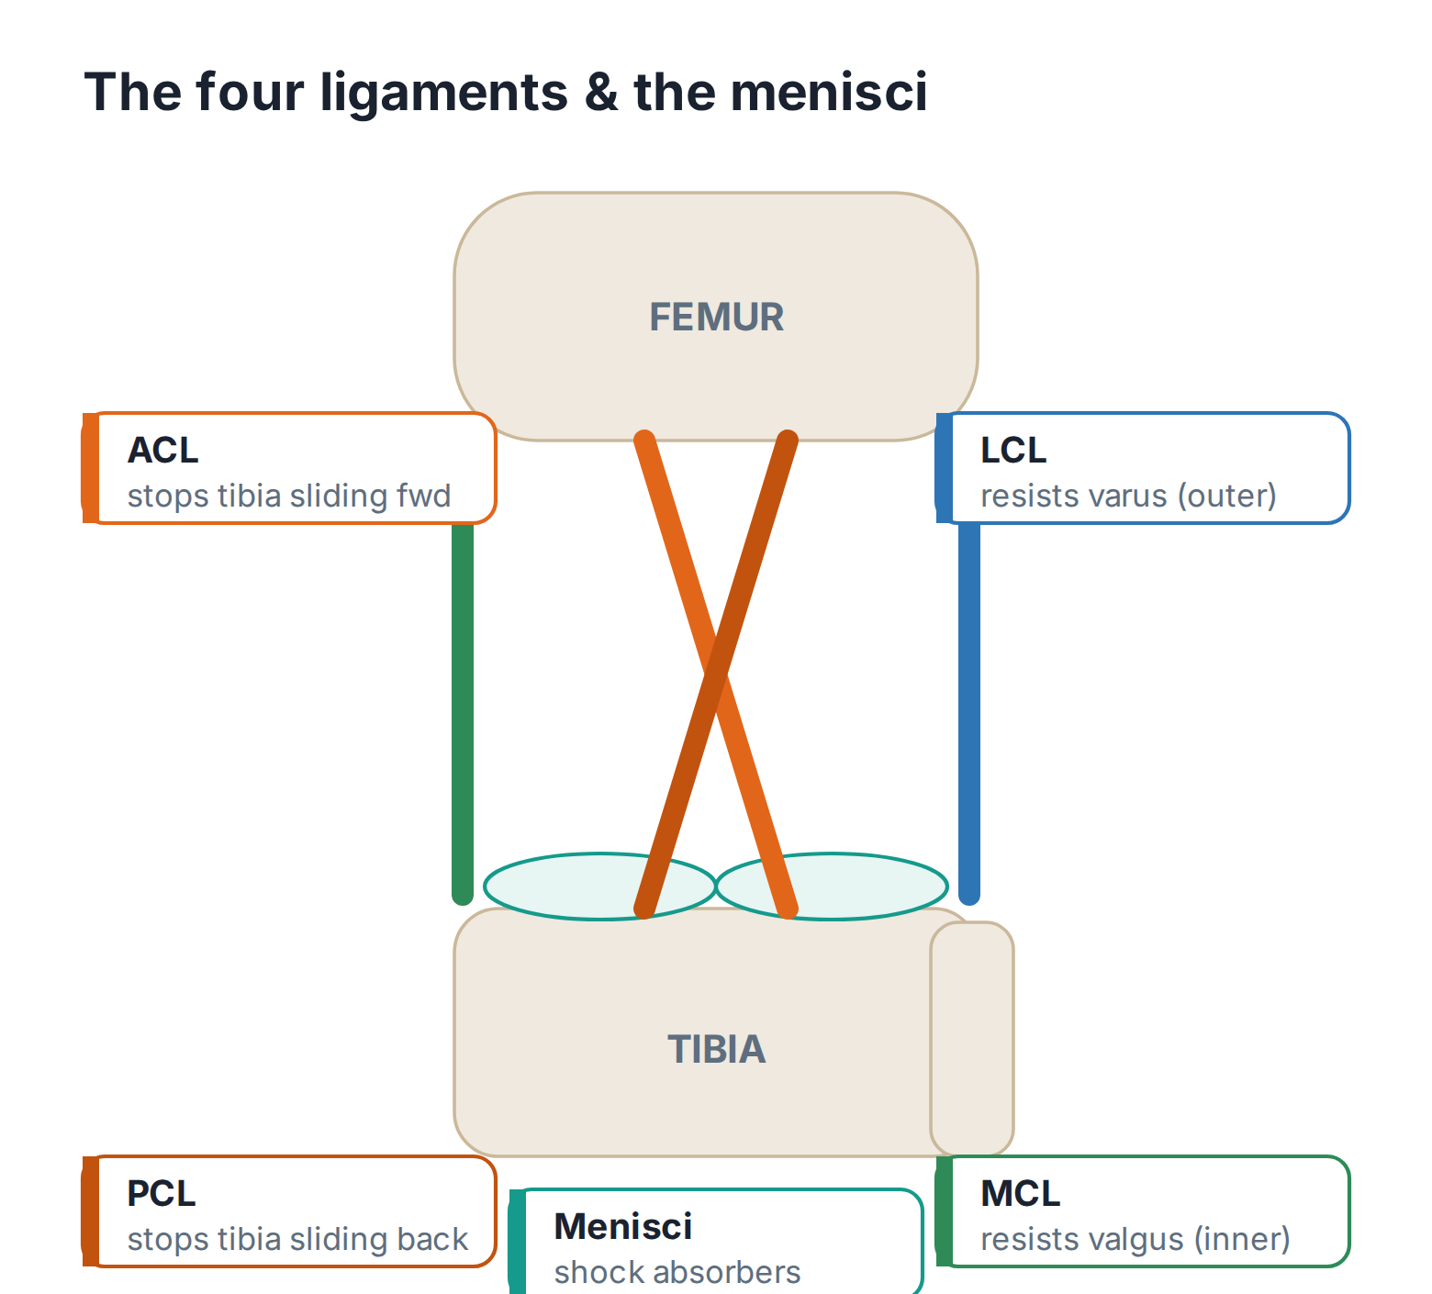

Ligament | Share | Typical injury | Outlook & management
ACL | ‘70% of haemarthroses | Twisting on a planted foot; a “pop”, rapid swelling, later giving way on turning | Refer all suspected cases to a knee specialist. Rehab focused on hamstrings ± reconstruction for high-demand patients.
PCL | ~4% | A blow to the front of the shin with the knee bent (dashboard, fall); often few symptoms | Usually managed conservatively, with strong quadriceps rehab.
MCL | ~29% | A valgus force to a partly bent knee; tender over the medial femoral condyle (not the joint line) | Excellent outlook. Early mobilisation and rehab; a brace for higher-grade tears.
LCL | ~2% | A varus force — less common | Graded and managed like the MCL.
💡 MCL TENDERNESS vs MENISCAL TENDERNESS
Tenderness over the medial femoral condyle points to the MCL; tenderness on the joint line itself points to the medial meniscus. This single distinction separates two common injuries.

Two cases worth remembering
🏒 CASE 1 — THE CLASSIC ACL
A 25-year-old hockey player is tackled at speed a month ago. She feels and hears a loud crack, cannot continue, and the knee swells within hours. An X-ray is normal; she is bandaged and rests. The swelling settles. Last night, at her first training session back, the knee gave way and swelled again overnight.
This is an ACL rupture until a knee specialist proves otherwise. The dynamic injury, the crack, the inability to continue, the rapid swelling, the normal X-ray, the lack of follow-up, and later giving way — it all fits. Refer.
🦵 CASE 2 — THE LOCKED KNEE
A 35-year-old man twists on a flexed knee playing football, feels severe medial pain, and collapses. The knee is stuck (locked) for a while, then frees. It swells slowly, overnight.
True locking suggests a loose body — most likely a torn medial meniscus. The slow (overnight) swelling is a reactive effusion. Refer to the acute knee clinic; an early meniscal repair can succeed where the tear is in the well-supplied outer rim.
Investigations and referral
- Plain X-ray (AP and lateral): use the Ottawa rules; add skyline and tunnel views if indicated. Remember it only excludes fracture.
- Aspiration: not routine in primary care. Blood in the aspirate (haemarthrosis) signals significant intra-articular injury needing specialist assessment.
- MRI: the test for soft-tissue (ligament and meniscus) injury — arranged through the specialist / acute knee pathway.
- Refer any suspected ACL rupture, locked knee, significant instability, or haemarthrosis to the acute knee / orthopaedic clinic.
Recognise → Act → Refer
Recognise | Act | Refer
“Pop” + rapid swelling + later giving way | Rest, analgesia; apply Ottawa rules | Knee specialist — suspected ACL until excluded
Twist + true locking + slow swelling | Analgesia; do not force the knee straight | Acute knee clinic — likely meniscal
Inability to weight-bear or fibular-head / patellar tenderness | X-ray per Ottawa rules | Per X-ray findings; refer fractures urgently
Hot, red, very painful knee ± fever | Treat as a possible septic joint | SAME-DAY emergency assessment

🔎 SOURCES & FURTHER READING
Verified against the following UK sources at the date of publication:
- NICE CKS — Knee pain – assessment.
- Stiell IG et al. — Ottawa Knee Rules (decision rule for knee X-ray).
- BMJ Best Practice — Assessment of acute knee injury.
- Refer to local orthopaedic / acute knee clinic pathways for onward management.

⚠ IMPORTANT — EDUCATIONAL DISCLAIMER
This document is provided exclusively for educational and training purposes as a Bradford VTS teaching aid. It does not constitute formal clinical guidance.
Clinicians must independently verify all medical information, prescribing guidance, procedural protocols, and legal requirements against current national guidance (NICE, NICE CKS, BNF, MHRA and relevant Royal Colleges), local policies, and regulatory bodies before applying any of it in practice. Information is correct to the best of our knowledge at the date of publication but guidance changes — the responsibility for safe, up-to-date practice rests with the individual clinician.

