BRADFORD VTS TEACHING AIDS | June 2026
MUSCULOSKELETAL SKILLS · CLINICAL REFERENCE
Examining the Lumbar Spine
A practical guide to technique, nerve-root signs and red flags for GP trainees and IMGs

★ THE ONE IDEA TO HOLD ONTO
Most back pain is mechanical and gets better on its own. Your real job at every visit is to actively screen for the few dangerous causes — above all, cauda equina syndrome. Examine in a fixed order, map the symptoms to a nerve root, and palpate last.
A safe, repeatable order
Use the same sequence every time so nothing is forgotten under pressure. Palpation comes LAST — once the history and tests have already told you where to look.
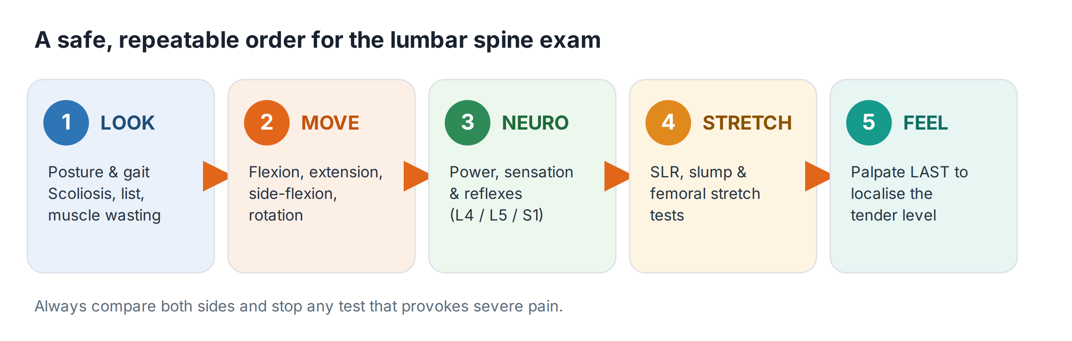
Look
- From behind: is the spine straight, or is there a scoliosis or a list to one side? Look for loss of the normal lumbar curve, and for muscle wasting or asymmetry.
- From the side: note an increased thoracic kyphosis or a flattened lumbar lordosis.
- Watch them walk: an antalgic (painful) gait, a limp, or guarding all give clues before you lay a hand on the patient.
ℹ WHERE THE PAIN COMES FROM
Sitting, lifting and stooping typically provoke mechanical lumbar pain. Pain on walking that eases on resting or bending forward points instead to the hip, spinal stenosis, or a circulatory (claudication) cause — think more widely.
Move
Test flexion, extension, lateral flexion and rotation. Watch the quality of movement, not just the range.
- Flexion: toe-touching mainly measures hip and hamstring flexibility. To judge true lumbar movement, watch how the segments unfurl and how the pelvis tilts.
- Side flexion: compare the two sides for symmetry — measure roughly how far the hand slides down each leg.
- Extension: often limited, but in some patients it actually relieves the symptoms.
- Rotation: assess seated, which fixes the pelvis and removes hip rotation.
Neuro — map the symptom to a nerve root
Leg symptoms in a single dermatome point to nerve-root irritation. Match the area to the root — but confirm with power and reflexes, because a higher lesion can affect lower roots.
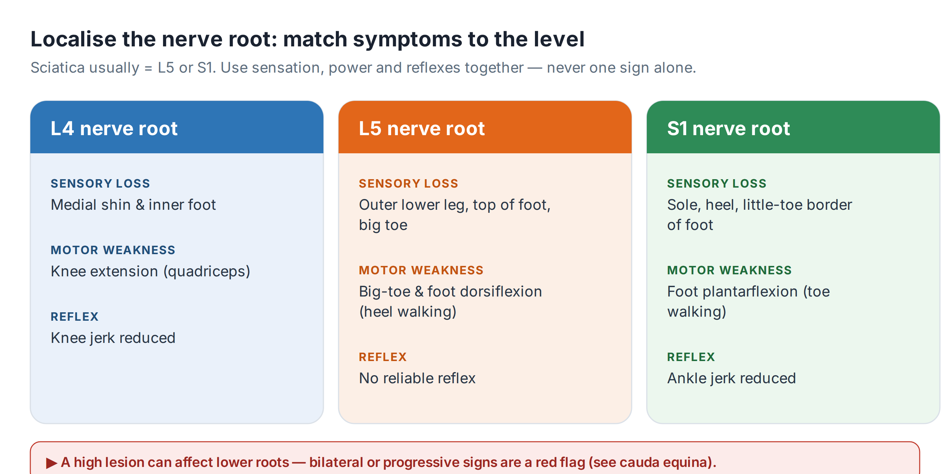
Stretch tests — confirming nerve-root tension
Test | How to do it and what it means
Straight-leg raise (SLR) | Lift the straightened leg with the patient lying flat. Pain felt BELOW the knee, reproducing their symptoms, suggests L5/S1 root irritation. Lowering slightly until the pain eases, then dorsiflexing the ankle to bring it back (Bragard’s), confirms a neural cause.
Slump test | Seated, the patient slumps, then extends the knee and dorsiflexes the ankle. More sensitive than SLR — it often reproduces the exact pain felt when driving. Be gentle: it can be very uncomfortable.
Crossed SLR | Raising the GOOD leg reproduces pain in the affected leg. Less common, but a stronger pointer to a disc prolapse.
Femoral nerve stretch | Prone, bend the knee to stretch the femoral nerve. Anterior thigh pain suggests a higher (L2–L4) root.
💡 COMPARE THE TESTS
Always test the good side first, and compare. A negative slump test with a positive SLR at 30° — or vice versa — still points to nerve-root tension. One normal test does not exclude the problem.
Feel — last of all
- Now that you know roughly where the problem is, palpate gently over the spinous processes, the gaps between them, and the paraspinal muscles to pinpoint the tender level and any muscle spasm.
- Begin light and increase pressure slowly — starting deep on an irritable back loses the patient’s trust and the rest of the examination with it.
Red flags — cauda equina is the emergency
⚠ SAME-DAY REFERRAL FOR URGENT MRI
Ask about and act on these at EVERY presentation of back pain or sciatica:
• Bilateral sciatica or new bilateral leg symptoms
• Saddle (perineal, perianal, genital) numbness or tingling
• Difficulty starting to pass urine, or reduced sensation of the urinary stream
• Loss of the sensation of a full bladder, or loss of the urge to open the bowels
• A lax anal sphincter or new faecal incontinence
Refer the same day for emergency assessment and urgent MRI. Do not arrange routine imaging and do not wait.
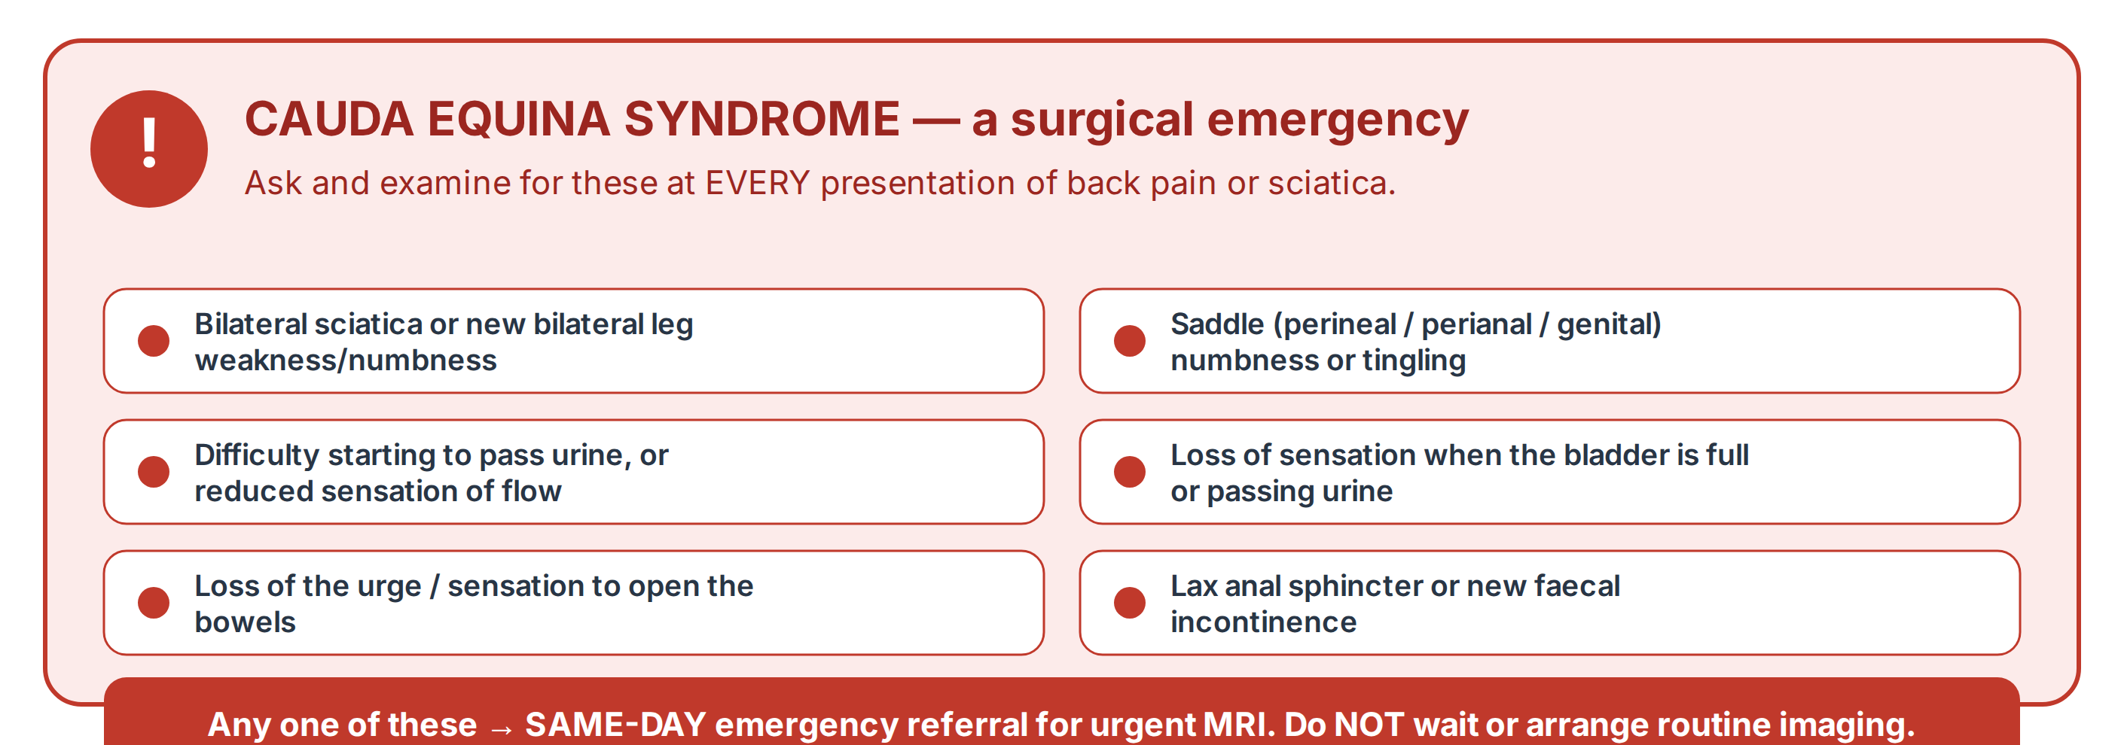

What NICE NG59 says about management
For mechanical low back pain and sciatica without red flags, the modern approach is to keep people active and avoid over-medicalising. This is a major change from older teaching.
✓ DO
• Reassure: explain that the outlook is good and that staying active aids recovery.
• Use a risk-stratification tool (such as STarT Back) to match the level of support to the person’s risk of persistent pain.
• Offer a group exercise programme as a first-line treatment.
• Consider a short course of an oral NSAID at the lowest effective dose for the shortest time — with a check on gastrointestinal, cardiac and renal risk, and gastroprotection where needed.
✗ DO NOT
• Do NOT offer paracetamol alone for low back pain.
• Do NOT routinely image people in the non-specialist setting.
• Do NOT offer opioids for chronic low back pain, and only consider a weak opioid (with NSAIDs contraindicated) for acute pain.
• Do NOT offer gabapentinoids, other antiepileptics, oral steroids or benzodiazepines for sciatica.
• Do NOT offer antidepressants (SSRI, SNRI or tricyclic) to treat low back pain.
⚠ A NOTE ON PRESCRIBING
This summary is about WHICH treatments are and are not recommended. Always check exact drug, dose and duration in the BNF and your local formulary before prescribing.
Recognise → Act → Refer
Recognise | Act | Refer
Mechanical low back pain, no red flags | Reassure, keep active, self-management; consider short NSAID course | Only if not settling, or for structured support
Sciatica, single nerve root, no red flags | Stay active, exercise, analgesia per NG59 | Specialist opinion / imaging if severe or persistent
Any cauda equina red flag | Do NOT delay or arrange routine imaging | SAME-DAY emergency referral, urgent MRI
Suspected cancer, infection or fracture | Arrange urgent investigation | Urgent / suspected-cancer pathway

🔎 SOURCES & FURTHER READING
Verified against the following UK sources at the date of publication:
- NICE NG59 — Low back pain and sciatica in over 16s: assessment and management.
- NICE CKS — Sciatica (lumbar radiculopathy): assessment, red flags, cauda equina syndrome.
- NICE CKS — Back pain – low (without radiculopathy).
- BNF — for all drug, dose and duration decisions.

🖼 A NOTE ON THE IMAGES IN THIS DOCUMENT
The original version of this resource used photographs of a model demonstrating the examination. These have been replaced with clean, custom-drawn diagrams — for consistent quality, clearer teaching, and to avoid using identifiable images of a person. The clinical content is unchanged.

⚠ IMPORTANT — EDUCATIONAL DISCLAIMER
This document is provided exclusively for educational and training purposes as a Bradford VTS teaching aid. It does not constitute formal clinical guidance.
Clinicians must independently verify all medical information, prescribing guidance, procedural protocols, and legal requirements against current national guidance (NICE, NICE CKS, BNF, MHRA and relevant Royal Colleges), local policies, and regulatory bodies before applying any of it in practice. Information is correct to the best of our knowledge at the date of publication but guidance changes — the responsibility for safe, up-to-date practice rests with the individual clinician.

