BRADFORD VTS TEACHING AIDS | June 2026
MUSCULOSKELETAL OSCE · FACILITATOR PACK
MSK OSCE Workshop
A run-sheet for facilitators delivering the musculoskeletal skills circuit

★ WHAT THIS WORKSHOP DELIVERS
A practical afternoon of musculoskeletal examination skills, run as a timed circuit of short OSCE-style stations. Each trainee rotates through every station, examines or reasons through a case, and receives structured feedback. The aim is fluent, safe examination and sound clinical reasoning — the everyday MSK skills of UK general practice.
The circuit at a glance
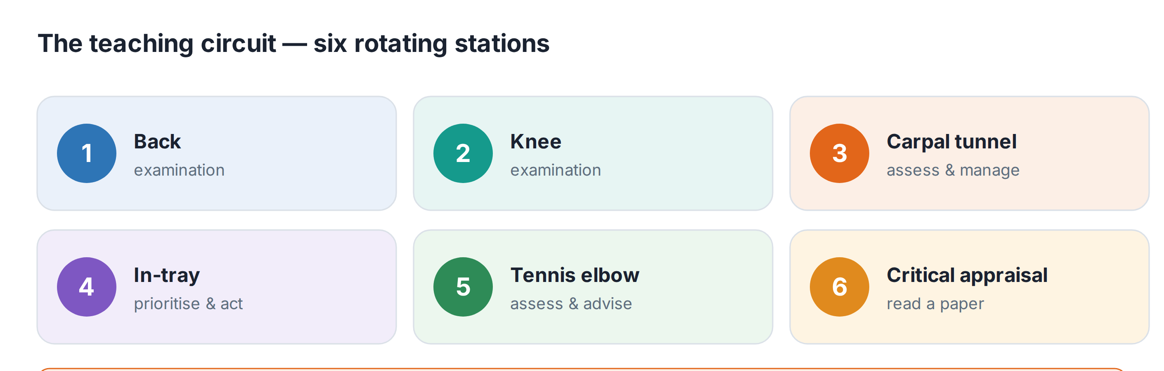
Suggested timetable
Time | Activity
2.00 – 2.15 | Welcome and briefing for facilitators and trainees
2.15 – 3.15 | Stations 1–3 (about 20 minutes each, including feedback)
3.15 – 3.30 | Tea break
3.30 – 4.30 | Stations 4–6 (about 20 minutes each, including feedback)
ℹ HOW EACH STATION RUNS
Allow roughly 7–10 minutes for the trainee to examine or work through the case, then 5–7 minutes for feedback and discussion using the station’s feedback sheet. Keep to time so every trainee completes the full circuit.

The six stations
# | Station | Equipment | Task
1 | Back examination | Couch, tape measure, pin/monofilament, tendon hammer, chair | Perform a competent lumbar spine examination and screen for red flags
2 | Knee examination | Couch, patella hammer | Examine the knee and reason from the findings (patellofemoral pain case)
3 | Carpal tunnel syndrome | None | Assess and discuss the management of carpal tunnel syndrome
4 | “In-tray” exercise | Sample letters and reports | Sort and prioritise correspondence, deciding on appropriate action for each
5 | Tennis elbow | None | Assess, then discuss management with a shared-decision focus (load management first)
6 | Critical appraisal | 6 copies of an RCT | Appraise the methodology and discuss its implications for practice
Roles and set-up
- Each clinical station needs: one assessor (briefed in advance), one volunteer “patient” where required, and the station’s briefing, patient and feedback sheets.
- Recruit and brief volunteer patients beforehand for the back and knee stations, and give them a chance to rehearse the findings with the assessor.
- Dignity and consent: on the back station, saddle (perineal) sensation is ASKED about, never tested on a volunteer. Always gain consent before any examination.
- The non-examination stations (in-tray and critical appraisal) need no patient — just the materials and a facilitator to lead the debrief.
Facilitator tips for good feedback
✓ MAKE THE FEEDBACK COUNT
• Start by asking the trainee how they felt it went.
• Give specific, behaviour-based feedback — what was done well, and one or two concrete things to change.
• Reinforce the safety points: the red flags and the “when to refer” for each condition.
• Note where current guidance has moved on — for example, load management (not injection) first for tennis elbow, and keeping people active in low back pain.
📚 COMPANION TEACHING AIDS
Each clinical station has a matching Bradford VTS teaching aid — shoulder, lumbar spine, acute knee, patellofemoral pain, carpal tunnel and tennis elbow — for trainees to read before or after the workshop.

🔎 SOURCES & FURTHER READING
Verified against the following UK sources at the date of publication:
- NICE CKS / NICE guidelines — for each station’s clinical content (see the individual teaching aids).
- RCGP curriculum — Musculoskeletal health.
- Use the companion Bradford VTS teaching aids for full, referenced clinical detail.

⚠ IMPORTANT — EDUCATIONAL DISCLAIMER
This document is provided exclusively for educational and training purposes as a Bradford VTS teaching aid. It does not constitute formal clinical guidance.
Clinicians must independently verify all medical information, prescribing guidance, procedural protocols, and legal requirements against current national guidance (NICE, NICE CKS, BNF, MHRA and relevant Royal Colleges), local policies, and regulatory bodies before applying any of it in practice. Information is correct to the best of our knowledge at the date of publication but guidance changes — the responsibility for safe, up-to-date practice rests with the individual clinician.

