What is Audit
Marinker (1990): the attempt to improve the quality of medical care by measuring the performance in relation to desired standards and by improving this performance.

So it seem that audit is all about
- taking note of what we do,
- examining any departures from ‘best practice’ in order to understand and act upon the causes,
- implementing changes
And by doing this we ultimately aim to improve care and hopefully learn something from it at the same time. That is why we believe all GP trainees should be doing audit.

The 5-point Audit Cycle

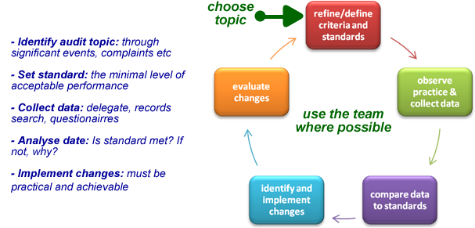

Why do Audit?
- To measure and improve the quality of care and service (clinical governance).
- It results in the improved care of patients (by identifying needs).
- It encourages teamwork and enhances motivation.
- It helps you learn (often in a collaborative way).
- It encourages the efficient use of resources .
- It helps in terms of accountability to those outside the profession.

helpful guidance and tips on the next page...
Prerequisites:
- The work submitted must be the personal work of the trainee. Data collection by others is acceptable; collaboration with others must be clearly identified with the whole audit project clearly overseen by the trainee.
- The audit should cover a complete cycle (one and a half times around the 5 point audit cycle on the previous page). What this means is that you need to re-audit to see if there was any change. Therefore, you ought to present TWO data collections with plans for change between these. If you still find this confusing, please talk to your trainer or programme director). Some areas/schemes accept a one cycle audit – i.e. no need to do a re-audit – check with your TPDs).

Structure of Your Audit Work
The audit itself should make specific reference to the following:
- The criteria used must be clearly and explicitly stated.
- The standards being assessed must be clearly defined (and how you set them).
- There should be clear relevance to general practice. A section on ‘reasons for choice of audit’ in your introduction will help you achieve this.
- There should be a section on “preparation and planning”. How did you go about your audit in practice? Who did you involve? Who did what? Throughout the audit there must be evidence that it has been discussed at appropriate points with the team, for example
- agreeing the standards
- discussion of proposed changes
- and conclusions)
- There should be references to appropriate literature (web references are accepted). These references should justify the choice of audit (in your intro), the choice of criteria and standards set.
- There should be clear proposals for changes. These should be specific, practical and achievable.
- There should be a conclusion which discusses issues like
- how successful the audit was in creating change; factors affecting the audit outcome
- the reasons for the level of progress achieved
- your reflections and what you learned from the process of doing the audit, the need for continuing change
- where should you, the department or practice go from here?

