Timelines – understanding your journey so far
This exercise is designed to help your trainer to get to know you. Knowing more about you helps your trainer to better design things like teaching sessions and educational activities around you. For it to work you need to be as honest and open as you can. Think about your life journey so far – ever since you were a child. We’d like you to try filling in the blank graph below - but before you do, please continue reading first.

- The X axis represents time, along which you will need to plot your educational journey so far – like primary school, secondary school, medical school, FY, other work posts and so on. You can change the detail on the time axis if you want to. There are also a couple of blanks in case you need extra ‘slots’.
- The Y axis has a positive and negative side; it represents your feelings or experience in each section of your educational journey (the X axis).

The aim is to draw a wavy line representing your experiences in the different educational phases in your life. An example is given below. You may or may not dip below the X-axis in some places – that’s okay.

- After you’ve mapped out your graph, chose two or three adjectives or phrases to describe why you have chosen the position on the Y axis. Write these words on the graph in the relevant places. Examples include: good team work, supportive, fun, relevant, boring, stressful, bullied, horrible nurses, unsupported.

Notes for the Trainer – Consider doing one yourself – to compare and encourage dialogue. Explore the ups and downs. Some trainers ask the trainee to focus on the experience of the post and not what was going on in the ‘outside’ work life. Others leave it open so that they can find out more about the trainee in general.

Example

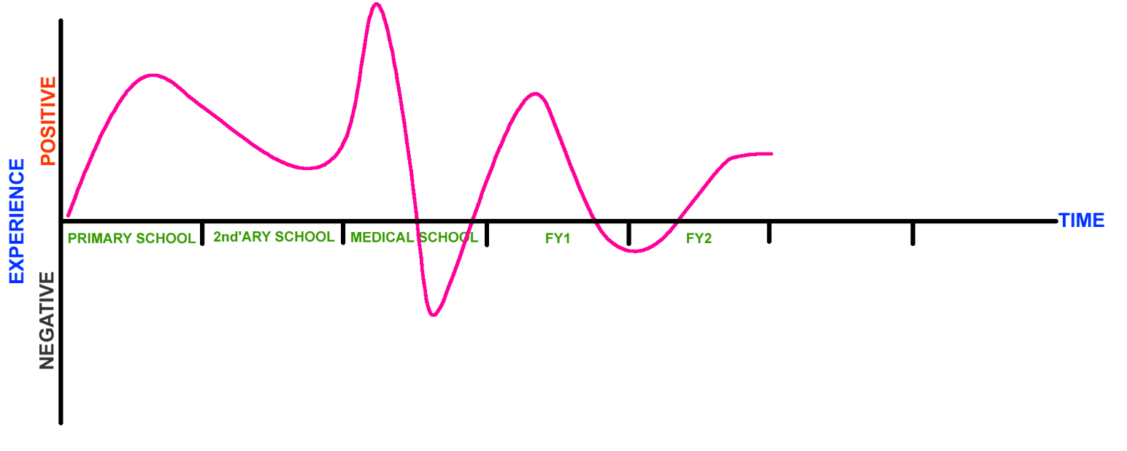

Map your journey so far…

