Encouraging, Motivating and Inspiring your Trainee



& a Small Workshop on Reslience

Dr Ramesh Mehay
Former Training Programme Director (Bradford)
www.bradfordvts.co.uk
www.essentialgptrainingbook.com

EXERCISE 1 – Personal Shields
In medieval Europe, and many other parts of the world, people used pictures and symbols on their shields to identify who they were and tell others about themselves. In this exercise, we (you and your trainer) will each construct our own “personal shield” and share its meaning with each other.

- In each quadrant, use any combination of drawings, pictures, or words to say something about yourself
- For example, you could have:
- One quadrant for the county/city/town that you come from
- One quadrant for a hobby or interest you have
- One quadrant for the greatest achievement of your life to date
- One quadrant for your personal aspiration for the future.
- After completing our shields, we will see if we can work out each other’s shield first.
- Then, we will each take a turn explaining our shield to each other - what the pictures, symbols, or words we have chosen for the four quadrants of our shield mean to us.

EXERCISE 2 – Timelines

This exercise is designed to help your trainer to get to know you. Knowing more about you helps your trainer to better design things like teaching sessions and educational activities around you. For it to work you need to be as honest and open as you can. Think about your life journey so far – ever since you were a child. We’d like you to try filling in the blank graph below - but before you do, please continue reading first.

The X axis represents time, along which you will need to plot your educational journey so far – like primary school, secondary school, medical school, FY, other work posts and so on. You can change the detail on the time axis if you want to. There are also a couple of blanks in case you need extra ‘slots’.

The Y axis has a positive and negative side; it represents your feelings or experience in each section of your educational journey (the X axis).

The aim is to draw a wavy line representing your experiences in the different educational phases in your life. An example is given below. You may or may not dip below the X-axis in some places – that’s okay.

After you’ve mapped out your graph, chose two or three adjectives or phrases to describe why you have chosen the position on the Y axis. Write these words on the graph in the relevant places. Examples include: good team work, supportive, fun, relevant, boring, stressful, bullied, horrible nurses, unsupported.

Notes for the Trainer – Consider doing one yourself – to compare and encourage dialogue. Explore the ups and downs. Some trainers ask the trainee to focus on the experience of the post and not what was going on in the ‘outside’ work life. Others leave it open so that they can find out more about the trainee in general.

Example
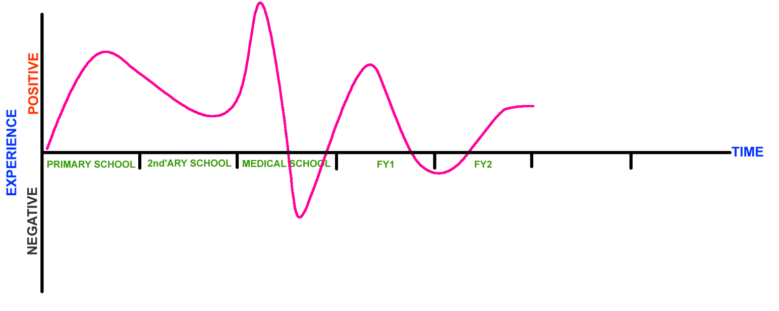

Your journey so far…

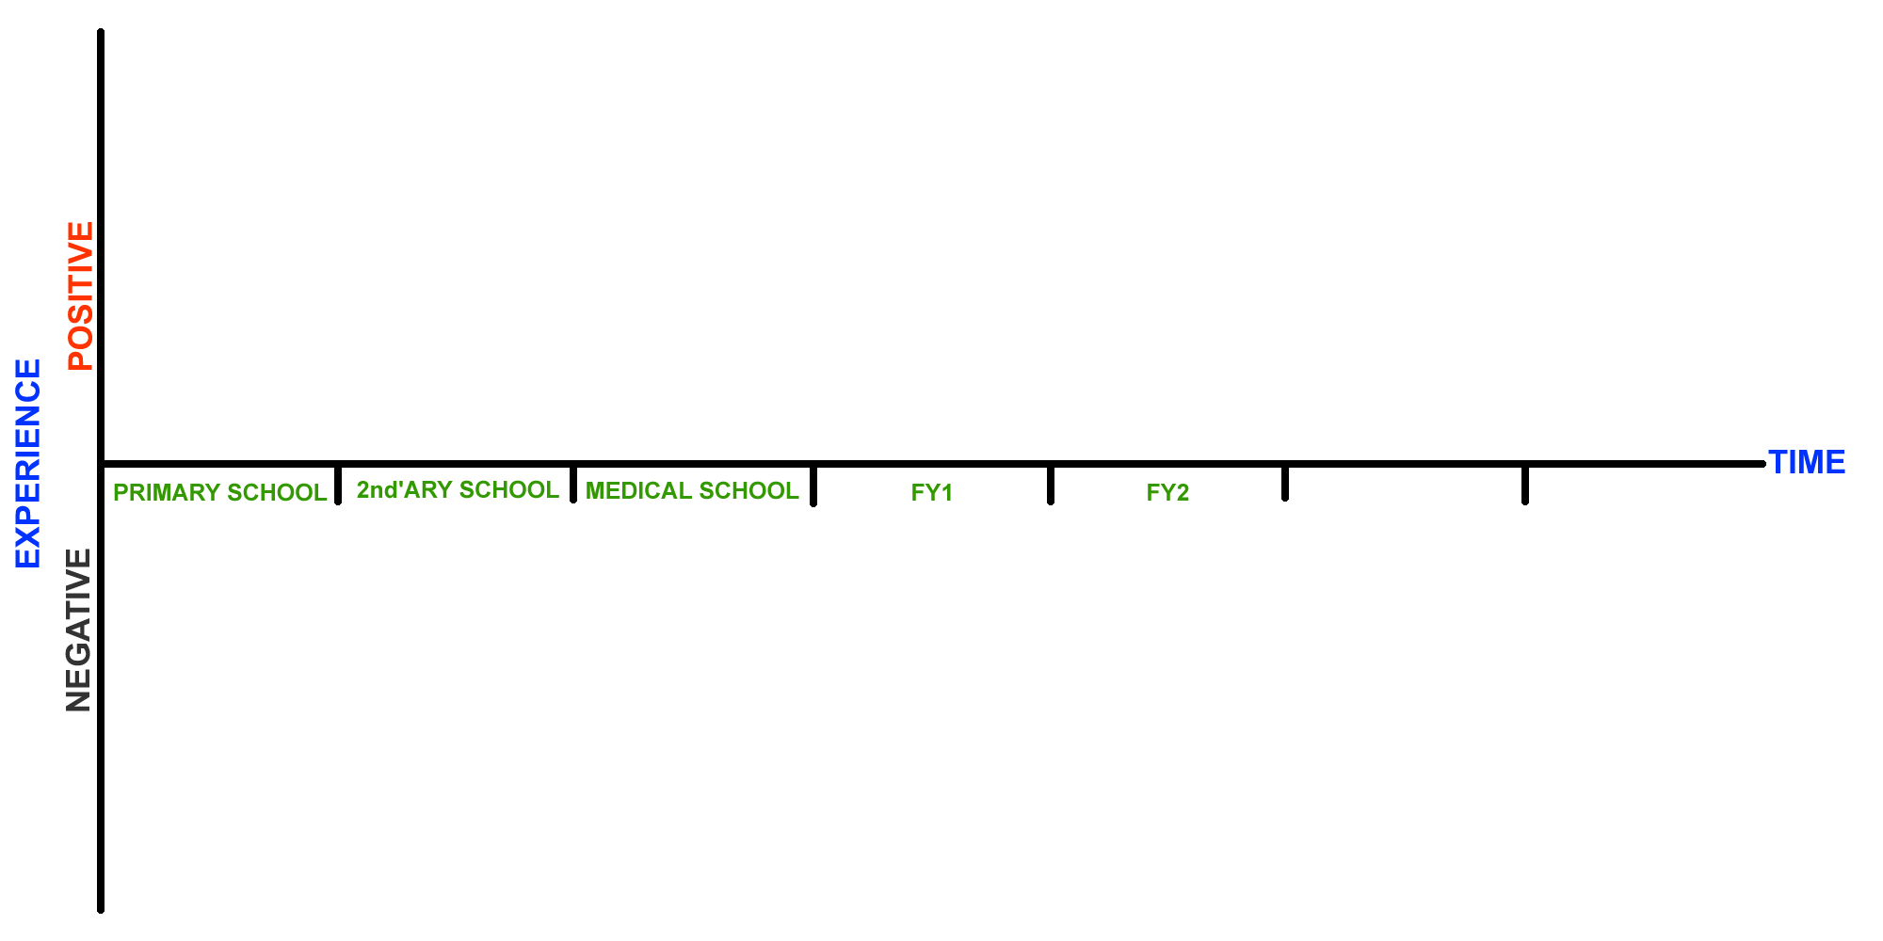

EXERCISE 3 – The Attitudinal Grid
Please take a moment to do the rating scales exercise below. When marking your position, please be honest about how you feel. Your trainer can only help you if you answer as honestly as you can. Read the question and pay attention to your first initial gut reaction – this is often your most honest internal stance. (Rating Scale: adapted by Dr Ramesh Mehay from original work by Roger Neighbour & Penny Trafford)
The physical aspects of minor illness should be the GP’s chief concern | ------------------------------------------------------------------------------- | Psycho-social aspects of minor illness should be the GP’s chief concern
I like to consult in a methodical linear manner (History, HPC, PMH, FH, SH) | ------------------------------------------------------------------------------- | I like to consult in a variety of ways – (depends on patient & their needs)
It’s better to be over-cautious than over confident | ------------------------------------------------------------------------------- | To grow in confidence you have to be prepared to take some risks
A doctor should try to keep his/her own feelings out of the consultation process | ------------------------------------------------------------------------------- | A doctor’s own feelings have a significant contribution to make to the consultation process
There needs to be clear boundaries between a doctor’s on and off duty life | ------------------------------------------------------------------------------- | A doctor can’t expect always to leave his/her work behind at the end of the day
A problem unsolved is a problem insufficiently investigated | ------------------------------------------------------------------------------- | Not all problems have an explanation or a solution
I generally like to deal with one problem at a time | ------------------------------------------------------------------------------- | It’s not really a big deal if a patient comes in with 2 or 3 problems
I like to try out new ideas for myself to see if they might be of value | ------------------------------------------------------------------------------- | I like to wait until new ideas have been tried out and tested by others before trying them
A learner should always feel free to constructively criticise his/her trainer | ------------------------------------------------------------------------------- | It is not a learner’s place to constructively criticise his/her trainer
By the end of training, a learner should have definite plans for his/her future career | ------------------------------------------------------------------------------- | It doesn’t matter if a learner has no definite plans by the end of his training
I prefer to understand how a disease affects a patient’s life & his/her family | ------------------------------------------------------------------------------- | I prefer to understand the patho physiology of disease and its Mx
A management plan often depends on complex negotiation with the patient | ------------------------------------------------------------------------------- | There’s management plans for most conditions which patients should be on
I’m looking forward to seeing patients over time and see how their lives change | ------------------------------------------------------------------------------- | I’m interested in sorting out as many patients as I can
I don’t mind the nurses or admin staff questioning me or my actions. | ------------------------------------------------------------------------------- | Nurses and admin shouldn’t really quiz the doctors.
Awareness of the relationship between trainer and learner generates useful educational insight | ------------------------------------------------------------------------------- | The relationship between trainer/learner is best kept on a purely professional footing
It the training has been good, the transition from learner to qualified GP holds few surprises | ------------------------------------------------------------------------------- | No matter how good one’s training, things are very different as a qualified GP
I believe it is possible for education to change people’s personality | ------------------------------------------------------------------------------- | I don’t think education can really change people’s personality

This questionnaire below ((Jones & Crandall 1986) is one of the few alternative reliable and valid tests of Self-Actualisation – alternative to the POI (on which it is based). POI is considered the most reliable and valid – the one most used in research around Self-Actualisation. (Personal Orientation Inventory by Shostrom). Another interesting one is this one (although I am not sure how reliable and valid it is): http://www.allthetests.com/quiz01/dasquiztd.php3?testid=1022641069
EXERCISE 4 – Short Index of Self-Actualisation

Please rate yourself on the following scales. Be honest. This questionnaire is not about what you would like to do or be, but what you actually do or are (or where you are currently in your life).
 | DISAGREE |  |  | AGREE
 | 1 | 2 | 3 | 4 | 5 | 6
- I do not feel ashamed of any of my emotions | □ | □ | □ | □ | □ | □
- I believe that people are essentially good and can be trusted | □ | □ | □ | □ | □ | □
- I feel free to be angry at those I love | □ | □ | □ | □ | □ | □
- I can like people without having to approve of them | □ | □ | □ | □ | □ | □
- It is better to be yourself then to be popular (even if it means becoming unpopular) | □ | □ | □ | □ | □ | □
- I can express my feelings even when they may result in undesirable consequences | □ | □ | □ | □ | □ | □
- I am loved because I give love | □ | □ | □ | □ | □ | □
PLEASE NOTE DIFFERENT RATING SCALE: | AGREE |  |  | DISAGREE
 | 1 | 2 | 3 | 4 | 5 | 6
- I feel I must do what others expect me to do | □ | □ | □ | □ | □ | □
- It is always necessary that others approve of what I do | □ | □ | □ | □ | □ | □
- I don’t accept my own weaknesses | □ | □ | □ | □ | □ | □
- I fear failure | □ | □ | □ | □ | □ | □
- I avoid attempts to analyse and simplify complex domains | □ | □ | □ | □ | □ | □
- I have no mission in life to which I feel especially dedicated | □ | □ | □ | □ | □ | □
- I do not feel responsible to help anybody | □ | □ | □ | □ | □ | □
- I am bothered by fears of being inadequate | □ | □ | □ | □ | □ | □
Interpretation (Alvin & Rick 1986)
Total your scores across the 15 items. The higher the score, the more self-actualised you are at this time. The following table will show you how your score compares to those of other college students.
SCORE PERCENTILE
77 99
76 95
75 90
73 80
71 70
69 60
67 50
65 40
60 30
55 20
53 10
52 5
51 1

Do you have enough ENERGY for what you want to do? Have you discovered your REAL SELF? The purpose of Self-Actualisation is to experience the vitality (energy, passion) in everyday life in every aspect of living. Self-actualizing people are alive and awake to the wonder of life and relationships and challenges. The so-called “motivation problems” that people struggle with is never about “motivation”; It is about needs. Use the scale below to recognize where you are and how effective you are in meeting your basic needs. It will release you from being stuck in the lower levels & allow you to move to the next level of being your authentic self.
EXERCISE 5 – The Pyramid of Needs
Please be honest. Some items are very personal – you don’t have to disclose these if you don’t want to.
SELF ACTUALISATION
Cognitive needs: to know, understand, learn
Contribution needs: To make a difference
Conative needs: to choose your unique way of life
Love needs: to care & extend yourself to others
Truth Needs: to know what is true, real, authentic
Aesthetic needs: to see, enjoy, and create beauty
Expressive needs: to be and express your best self
EGO (Self Value)
Importance of your voice and opinion
Honour and dignity from colleagues
Sense of respect for achievements
Sense of human dignity/ Value as a person
SOCIAL
Group acceptance/connection
Bonding with partner / Lover
Bonding with significant people
Love/Affection
Social Connection: Friends / Companions
SAFETY
Sense of control, Personal Power, Efficacy
Sense of order/structure
Stability on life
Career/Job safety
Health Safety
Physical/Personal Safety
SURVIVAL
Money
Sex (optional)
Exercise
Vitality
Weight Management
Food
Sleep
Drink
Dysfunctional  Neurotic  Psychotic | Extremes  Too much  Too little | Not getting by  Cravings  Dissatisfaction | Doing okay | Feeling good | Thriving | Optimistic  Super thriving | Maximising

Hall & Goodenough: www.coachingunity.co.za/Maslow%20Self%20Actualising%20Needs%20Analysis.pdf

The Wheel of Life is an NLP tool to help provide an overall summary of your life and to highlight important areas in your life that you may be neglecting. The wheel activates the reticular activating system which then heightens your awareness about the issue.
EXERCISE 6 – The Wheel of Life

Instructions
- If there are important parts of your life not catered for by the labels already on the circle – replace them. There is one blank space already provided for this purpose.
- Now mark each segment with an arc (parallel to the outer arc) to indicate how satisfied you are in your present state (where the outer limit of the circle represents a 10 – complete satisfaction).
- Go through each segment again and check you’re comfortable with the score you have awarded.
- For each arc, now mark a second arc - perhaps with a dotted line or different colour pen)]. This arc represents where you want to be for that segment to make your life better. The wheel is not about achieving a score of 10 in everything but about whether you are happy with the value of the score you have given. Some people might have given something like a 7 for work and that is a happy enough state. Usually a score less than 5 means more focus work needed.

YOUR CHOICE:_____________
Love/
Romance
Work

END OF DOCUMENT

