Encouraging, Motivating and Inspiring your Trainee



and getting to know them better too.

Dr Ramesh Mehay
Training Programme Director (Bradford)
www.bradfordvts.co.uk
www.essentialgptrainingbook.com

EXERCISE 1 – Timelines

This exercise is designed to help your trainer to get to know you. Knowing more about you helps your trainer to better design things like teaching sessions and educational activities around you. For it to work you need to be as honest and open as you can. Think about your life journey so far – ever since you were a child. We’d like you to try filling in the blank graph below - but before you do, please continue reading first.

The X axis represents time, along which you will need to plot your educational journey so far – like primary school, secondary school, medical school, FY, other work posts and so on. You can change the detail on the time axis if you want to. There are also a couple of blanks in case you need extra ‘slots’.

The Y axis has a positive and negative side; it represents your feelings or experience in each section of your educational journey (the X axis).

The aim is to draw a wavy line representing your experiences in the different educational phases in your life. An example is given below. You may or may not dip below the X-axis in some places – that’s okay.

After you’ve mapped out your graph, chose two or three adjectives or phrases to describe why you have chosen the position on the Y axis. Write these words on the graph in the relevant places. Examples include: good team work, supportive, fun, relevant, boring, stressful, bullied, horrible nurses, unsupported.

Notes for the Trainer – Consider doing one yourself – to compare and encourage dialogue. Explore the ups and downs. Some trainers ask the trainee to focus on the experience of the post and not what was going on in the ‘outside’ work life. Others leave it open so that they can find out more about the trainee in general.

Example
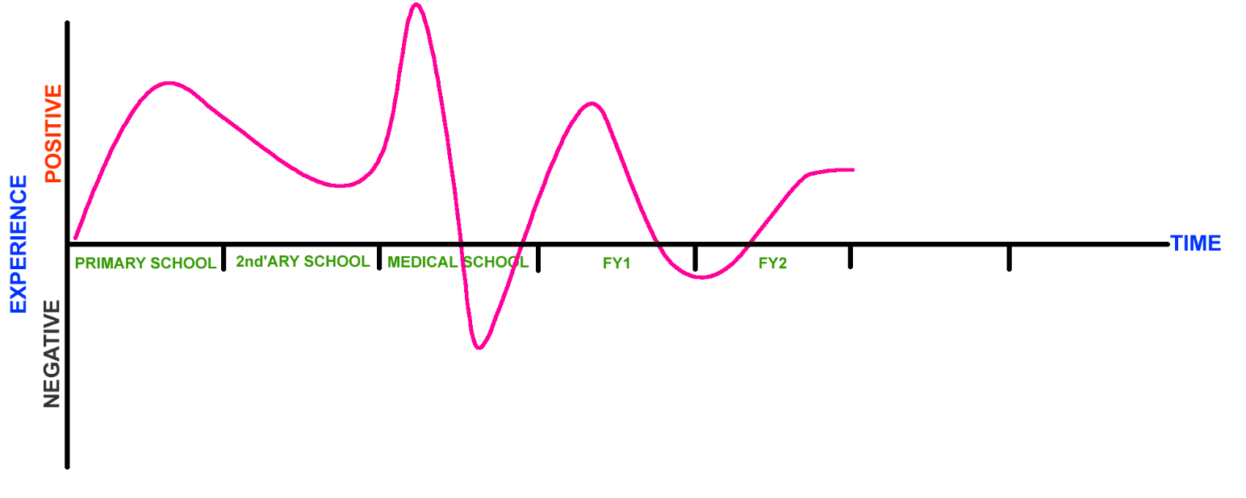

Your journey so far…

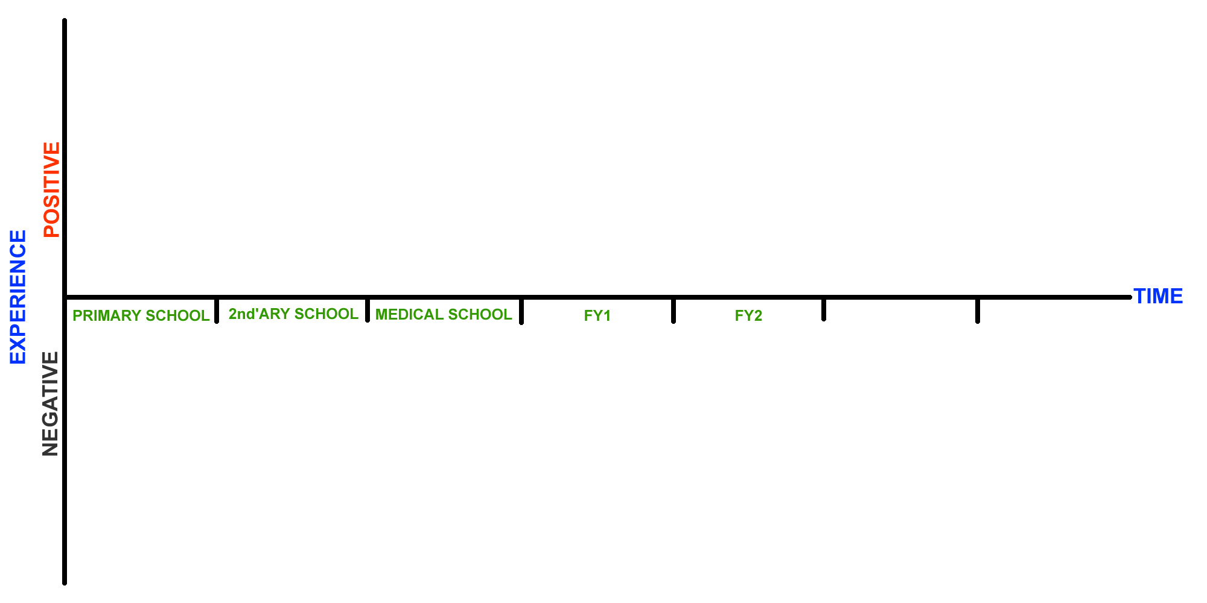

EXERCISE 2 – Personal Shields
In medieval Europe, and many other parts of the world, people used pictures and symbols on their shields to identify who they were and tell others about themselves. In this exercise, we (you and your trainer) will each construct our own “personal shield” and share its meaning with each other.

- In each quadrant, use any combination of drawings, pictures, or words to say something about yourself
- For example, you could have:
- One quadrant for the county/city/town that you come from
- One quadrant for a hobby or interest you have
- One quadrant for the greatest achievement of your life to date
- One quadrant for your personal aspiration for the future.
- After completing our shields, we will see if we can work out each other’s shield first.
- Then, we will each take a turn explaining our shield to each other - what the pictures, symbols, or words we have chosen for the four quadrants of our shield mean to us.

Please take a moment to do the rating scales exercise below. When marking your position, please be honest about how you feel. Your trainer can only help you if you answer as honestly as you can. Read the question and pay attention to your first initial gut reaction – this is often your most honest internal stance. (Rating Scale: adapted by Dr Ramesh Mehay from original work by Roger Neighbour & Penny Trafford)
EXERCISE 3 – The Attitudinal Grid
The physical aspects of minor illness should be the GP’s chief concern | ------------------------------------------------------------------------------- | Psycho-social aspects of minor illness should be the GP’s chief concern
I like to consult in a methodical linear manner (History, HPC, PMH, FH, SH) | ------------------------------------------------------------------------------- | I like to consult in a variety of ways – (depends on patient & their needs)
It’s better to be over-cautious than over confident | ------------------------------------------------------------------------------- | To grow in confidence you have to be prepared to take some risks
A doctor should try to keep his/her own feelings out of the consultation process | ------------------------------------------------------------------------------- | A doctor’s own feelings have a significant contribution to make to the consultation process
There needs to be clear boundaries between a doctor’s on and off duty life | ------------------------------------------------------------------------------- | A doctor can’t expect always to leave his/her work behind at the end of the day
A problem unsolved is a problem insufficiently investigated | ------------------------------------------------------------------------------- | Not all problems have an explanation or a solution
I generally like to deal with one problem at a time | ------------------------------------------------------------------------------- | It’s not really a big deal if a patient comes in with 2 or 3 problems
I like to try out new ideas for myself to see if they might be of value | ------------------------------------------------------------------------------- | I like to wait until new ideas have been tried out and tested by others before trying them
A learner should always feel free to constructively criticise his/her trainer | ------------------------------------------------------------------------------- | It is not a learner’s place to constructively criticise his/her trainer
By the end of training, a learner should have definite plans for his/her future career | ------------------------------------------------------------------------------- | It doesn’t matter if a learner has no definite plans by the end of his training
I prefer to understand how a disease affects a patient’s life & his/her family | ------------------------------------------------------------------------------- | I prefer to understand the patho physiology of disease and its Mx
A management plan often depends on complex negotiation with the patient | ------------------------------------------------------------------------------- | There’s management plans for most conditions which patients should be on
I’m looking forward to seeing patients over time and see how their lives change | ------------------------------------------------------------------------------- | I’m interested in sorting out as many patients as I can
I don’t mind the nurses or admin staff questioning me or my actions. | ------------------------------------------------------------------------------- | Nurses and admin shouldn’t really quiz the doctors.
Awareness of the relationship between trainer and learner generates useful educational insight | ------------------------------------------------------------------------------- | The relationship between trainer/learner is best kept on a purely professional footing
It the training has been good, the transition from learner to qualified GP holds few surprises | ------------------------------------------------------------------------------- | No matter how good one’s training, things are very different as a qualified GP
I believe it is possible for education to change people’s personality | ------------------------------------------------------------------------------- | I don’t think education can really change people’s personality

This questionnaire below ((Jones & Crandall 1986) is one of the few alternative reliable and valid tests of Self-Actualisation – alternative to the POI (on which it is based). POI is considered the most reliable and valid – the one most used in research around Self-Actualisation. (Personal Orientation Inventory by Shostrom). Another interesting one is this one (although I am not sure how reliable and valid it is): http://www.allthetests.com/quiz01/dasquiztd.php3?testid=1022641069
EXERCISE 4 – Short Index of Self-Actualisation

Please rate yourself on the following scales. Be honest. This questionnaire is not about what you would like to do or be, but what you actually do or are (or where you are currently in your life).
 | DISAGREE |  |  | AGREE
 | 1 | 2 | 3 | 4 | 5 | 6
- I do not feel ashamed of any of my emotions | □ | □ | □ | □ | □ | □
- I believe that people are essentially good and can be trusted | □ | □ | □ | □ | □ | □
- I feel free to be angry at those I love | □ | □ | □ | □ | □ | □
- I can like people without having to approve of them | □ | □ | □ | □ | □ | □
- It is better to be yourself then to be popular (even if it means becoming unpopular) | □ | □ | □ | □ | □ | □
- I can express my feelings even when they may result in undesirable consequences | □ | □ | □ | □ | □ | □
- I am loved because I give love | □ | □ | □ | □ | □ | □
PLEASE NOTE DIFFERENT RATING SCALE: | AGREE |  |  | DISAGREE
 | 1 | 2 | 3 | 4 | 5 | 6
- I feel I must do what others expect me to do | □ | □ | □ | □ | □ | □
- It is always necessary that others approve of what I do | □ | □ | □ | □ | □ | □
- I don’t accept my own weaknesses | □ | □ | □ | □ | □ | □
- I fear failure | □ | □ | □ | □ | □ | □
- I avoid attempts to analyse and simplify complex domains | □ | □ | □ | □ | □ | □
- I have no mission in life to which I feel especially dedicated | □ | □ | □ | □ | □ | □
- I do not feel responsible to help anybody | □ | □ | □ | □ | □ | □
- I am bothered by fears of being inadequate | □ | □ | □ | □ | □ | □
Interpretation (Alvin & Rick 1986)
Total your scores across the 15 items. The higher the score, the more self-actualised you are at this time. The following table will show you how your score compares to those of other college students.
SCORE PERCENTILE
77 99
76 95
75 90
73 80
71 70
69 60
67 50
65 40
60 30
55 20
53 10
52 5
51 1

Do you have enough ENERGY for what you want to do? Have you discovered your REAL SELF? The purpose of Self-Actualisation is to experience the vitality (energy, passion) in everyday life in every aspect of living. Self-actualizing people are alive and awake to the wonder of life and relationships and challenges. The so-called “motivation problems” that people struggle with is never about “motivation”; It is about needs. Use the scale below to recognize where you are and how effective you are in meeting your basic needs. It will release you from being stuck in the lower levels & allow you to move to the next level of being your authentic self.
EXERCISE 4 – The Pyramid of Needs
Please be honest. Some items are very personal – you don’t have to disclose these if you don’t want to.
SELF ACTUALISATION
Cognitive needs: to know, understand, learn
Contribution needs: To make a difference
Conative needs: to choose your unique way of life
Love needs: to care & extend yourself to others
Truth Needs: to know what is true, real, authentic
Aesthetic needs: to see, enjoy, and create beauty
Expressive needs: to be and express your best self
EGO (Self Value)
Importance of your voice and opinion
Honour and dignity from colleagues
Sense of respect for achievements
Sense of human dignity/ Value as a person
SOCIAL
Group acceptance/connection
Bonding with partner / Lover
Bonding with significant people
Love/Affection
Social Connection: Friends / Companions
SAFETY
Sense of control, Personal Power, Efficacy
Sense of order/structure
Stability on life
Career/Job safety
Health Safety
Physical/Personal Safety
SURVIVAL
Money
Sex (optional)
Exercise
Vitality
Weight Management
Food
Sleep
Drink
Dysfunctional  Neurotic  Psychotic | Extremes  Too much  Too little | Not getting by  Cravings  Dissatisfaction | Doing okay | Feeling good | Thriving | Optimistic  Super thriving | Maximising

Hall & Goodenough: www.coachingunity.co.za/Maslow%20Self%20Actualising%20Needs%20Analysis.pdf

The Wheel of Life is an NLP tool to help provide an overall summary of your life and to highlight important areas in your life that you may be neglecting. The wheel activates the reticular activating system which then heightens your awareness about the issue.
EXERCISE 6 – The Wheel of Life

Instructions
- If there are important parts of your life not catered for by the labels already on the circle – replace them. There is one blank space already provided for this purpose.
- Now mark each segment with an arc (parallel to the outer arc) to indicate how satisfied you are in your present state (where the outer limit of the circle represents a 10 – complete satisfaction).
- Go through each segment again and check you’re comfortable with the score you have awarded.
- For each arc, now mark a second arc - perhaps with a dotted line or different colour pen)]. This arc represents where you want to be for that segment to make your life better. The wheel is not about achieving a score of 10 in everything but about whether you are happy with the value of the score you have given. Some people might have given something like a 7 for work and that is a happy enough state. Usually a score less than 5 means more focus work needed.

YOUR CHOICE:_____________
Love/
Romance
Work

This exercise is best done in pairs because the other person will help to retain objectivity. (Acknowledgements to Dr. Natheera Indrasenan – who first taught me about core values and the wheel of life on an NLP course in London back in 2004)
EXERCISE 7 – Core Values (i)

- List three things YOU WOULD REALLY LIKE TO HAVE or
YOU VALUE ALREADY HAVING
For instance, it might be to have spare time to chill, to have a great love in your life, or value having some really close friends.
1.

2.

3.
- List three things YOU WANT TO BE
For example, you might want to be at peace with God, a well-known DJ artist, to be slimmer.
1.

2.

3.
- List three things YOU WANT TO DO
For example, you might want to swim with dolphins, do more for world poverty, travel the world.
1.

2.

3.

- Now talk about each of these to your colleague. The sheet overleaf tells your colleague what they need to do.
- Variations: Did you know that the more items you list, the more reliable set of core values you get. So you might want to list 18 items instead of 9.

Instructions for the facilitating colleague
EXERCISE 7 – Core Values (ii)
Read the whole of this document carefully before your proceed. Encourage the person you are helping to read it too – but only after they have completed the exercise.

First, some information about core values
Your core values DRIVE you. Your set of values are special and unique to you. They are the moral principles that define the essence of you and your accepted standards. Often a lot of dissatisfaction in one’s life and the difficulties in decision-making comes from:
- Not having identified our unique values and/or
- Not living by them.

To successfully achieve what we want in life and be happy and motivated we need to identify our highest values and commit to living in congruence with these. Some of the most respected and successful people in society are those who had a firm grasp on their highest values and consistently live by them. It makes the difference between drifting along in your life and agonising over difficult decisions and becoming focused about doing the right thing. You will feel more in control of your life and confident and find decisions easier to make as you always keep your values in mind. When you are congruent, you not only live your best life but also have a powerful influence on others – patient, colleagues and partners for instance.

Some people are unclear about their core values

Achievement | Independence | Spirituality
Respect | Control – see note 1 | Honesty
Challenge | Discipline | Courage
Creativity | Security –see note 2 | Love
Adventure | Power | Contribution- see note 3
Recognition – see note 4 | Loyalty | Connecting – see note 5
Commitment | Examples of core values

Note 1 – Control is not a bad core value to have. For example, having control in terms of where your life is heading.
Note 2 – Security might be the core value underlying some people’s desire to have a family or find love.
Note 3 – Contribution is about making a difference to people or the world.
Note 4 – Recognition is being well-known in your field.
Note 5 – Connecting might be connecting with nature or with God, with other people, with family or even the self (e.g. where there are issues about self-confidence).

Some people are not clear about their core values because they don’t interpret themselves deeply enough. For example, wanting to go to the third world to help people in need might be about a) spirituality b) contribution (making a difference to the world) or c) connecting (with others). Only the person can decide which of these is most relevant.

You might have looked at the core values list and said to yourself: ‘I value all of the core values listed there’. I’m sure that is probably true, but what is also true is that you will (if you think deeply enough about it) value some higher than others. For one person creativity may be a top value, for another it may be independence. It’s important to clarify this hierarchy if you want to be true to sorting your own life.

Finally, it’s interesting to note that some people live by other people’s values. This might be their parents or their peers. Are you one of those? In that case, what is so unique about your life? There will be something. What is it?

Your task for this exercise
EXERCISE 7 – Core Values (iii)
You need to tease out the core value(s) underpinning the 9 statements made. BUT you can only do that by trying to understand the motivation behind the desire. Therefore engage in dialogue about each statement.

- For each statement, start by asking something like….
- ‘What would you be doing?’
- ‘Imagine yourself being/doing that know. What can you see & hear?’
- ‘How does it make you feel? What’s so good about it? What would having or doing or being this give you?

Clarify where necessary:
- ‘Do you think the core value is curiosity or is it challenge? What sort of curiosity/challenge?’
Examples
- I wanted to become a doctor because I know I wouldn’t have to worry about a job’ (core value = security [job security])
- ‘I wanted to become a doctor because I wanted to prove to myself that I could do it.’ (core value = achievement)
- ‘I wanted to become a doctor because of knowing that I am helping people in the world’ (core value = contribution)
- ‘Once I make a decision, I make a decision. Someone made me think about being a doctor and then I decided that was it. Doctoring was going to be part of my life’ (core value = control)

- Tease out and write down the PRIMARY CORE VALUE
As the person talks about the listed item, they may mention an actual word from the core value set above. The very first core value word they come up with is the PRIMARY core value that relates to that item. Any others that come after that are secondary core values (and you can ignore them). Get the person talking to write down the primary core values next to the item in their list. Don’t spend too much time mulling around in thought. You need to be ruthless with time: Get the person to talk about his/her item fairly quickly and as soon as the core value is identified, stop them and tell them what to write down and move onto the next item: ‘Right, it sounds like the core value is freedom. Write that down and let’s move on’.

- After you have talked about all the items, review the primary core value list. Are there any recurring core value themes? Group recurring ones together – these are your TRUE CORE VALUE SET (usually 3-4 items).

- Now get the other person score each core value item on a scale of 1-10 based on how much they are living by this value at the moment (1 being the least score). This will tell you if you need to focus on it (usually scores less than 7 need more work). These will form the basis of your future goals and help align their life closer to what you want it to be (their values). That in turn will give them more fulfilment and happiness in life (self-actualisation).

More Examples of Core Values
- A person who wants a large house – for some the core value will be about comfort, for others security and possibly even achievement (‘At last, I’ve got my own house’).
- People often want money – depends on reason e.g. comfort, security and/or freedom (if they say they want to go out more, have more holidays, shop til they drop).
- Some people want to become a GP trainer to prove to themselves they are good enough (a sense of achievement), prove their worth or show off to others (self-confidence = connecting with self), belong to an elite group (connecting with others), to give something back (contribution) or to see young doctors develop (contribution).
- To have more spare time = FREEDOM; to have a great love in my life = ROMANCE; to have close friends = SECURITY
- To be at peace with God = SECURITY; to have more connection with God = connection/spirituality; to be a well-known DJ artist = achievement or recognition; swimming with dolphins = CONNECTING with nature or sense of ADVENTURE.
- Warning: You’ll sometimes look at an item and think ‘Oh, I know straight away what the core value is here’ but I urge you to carry on through the process and talk about it. When you explore reasons for the statement, the first core value that is spoken, is the one that you need to make a note of – and it might not be what you anticipated.
Ask your colleague an area from their Wheel of Life that they would like to explore (a low score which they’re not too happy about). Your aim is to try and get them to move them forwards in this domain of their life. But remember – only if it is the right time for them (if it is not, back off and perhaps pick something else).
EXERCISE 8 – Motivational Interviewing (i)

Here are some of the things I would like you to practice (take a moment to read).

Building Rapport
- Mirror them
- Pace, pace, lead
- Match their dominant VAK style

MI microskills
- Affirm
- Listen (& Empathise)
- Open Questions (ask)
- Summarise (to show understanding)
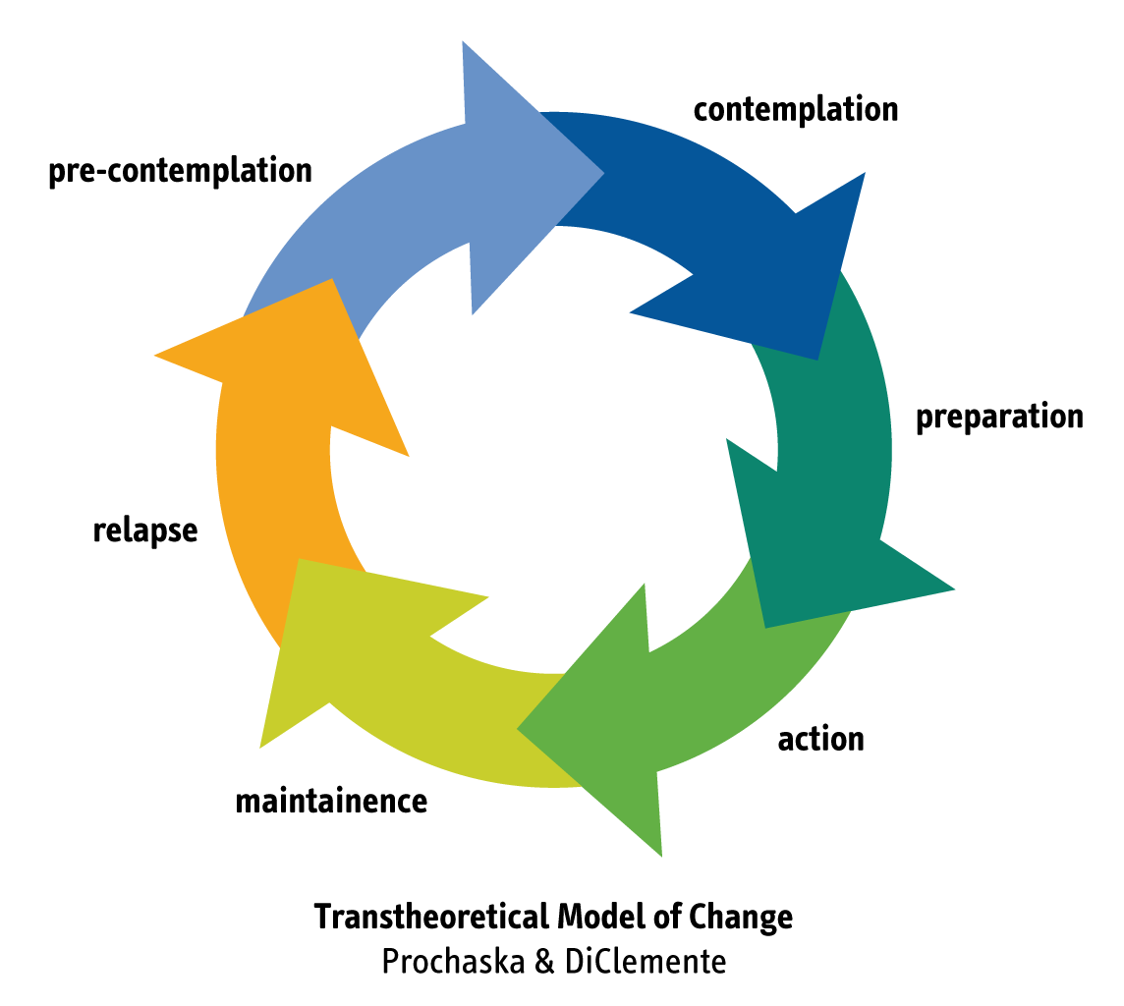
- Self-motivating statements (support)

Work out where in the Change Cycle they are
For all of them, explore THOUGHTS and FEELINGS and BEHAVIOURS

Precontemplation (not keen on changing)
- Create rapport, dialogue (empathise, listen, reflect, summarise)
- Explore long term goals
- Then create discrepancy or dissonance

Contemplation (unsure whether to change or not, pull and push factors for both)
- Enhance ambivalence by help problem solve what to do by exploring pros and cons of BOTH changing and not changing.
- Use a motivational balance sheet (see next page)

Preparation (keen to change but doesn’t know where to start)
- Review discrepancy
- Set goals to be achieved (gently)
- Determine the next step (however small). Go slow. Don’t rush. Small steps are okay.

PreContemplation stage
EXERCISE 8 – Motivational Interviewing (ii)
Your Aim: raise doubt; recognise the problem

Things to do
They are not keen on changing, therefore…
- Spend time creating rapport, engage in dialogue (empathise, listen, reflect, summarise)
- Explore long term goals and values & Explore thoughts, feelings and behaviours
- If it is possible (and gently) - create discrepancy – either through knowledge to correct crooked thinking or inconsistencies between current behavior and long term goals and values.
- If rebellious – listen to resistance, emphasise choice. If giving reasons not to change – listen. Explore reasons not to change in detail, and then the same for reasons to change (see sheet (iii)). Back off if still not engaging.

Things NOT to do
- DON’T: argue them into discomfort, talk them into change, make judgments, use authority, provide advice (esp if they are rebellious). Don’t rush them!

Possible Questions | Any of these apply?
- Why do you want to carry on doing what you do?  - I feel .......................  - I want to carry on mostly because…… | - Others believe I need to change.  - I do not see it as a problem.  - I’ve not thought about changing the behaviour before.  - I feel annoyed/angry that others want to change me.  - I think/feel that change is hopeless.  - I can see more reasons to stay the same than change.

Tools
An example of a GP trainee not engaging with his ePortfolio
‘I can but I don’t want to’ | ‘I want to, I can, I will’
- Write in the ePortfolio | - Ignore the ePortfolio
‘I can’t and I don’t want to | ‘I want to, but I can’t’
- End up in front of an ARCP panel  - End up with no CCT  - Not be prepared for Appraisal & Revalidation  - Be seen as a lazy GP trainee  - Destroy my social life because of the eP | - Find the time

Blank template
Use this to explore the current state of one’s mind and life with the thing that one is unsure of changing.
‘I can but I don’t want to’ | ‘I want to, I can, I will’
‘I can’t and I don’t want to | ‘I want to, but I can’t’

Contemplation stage
EXERCISE 8 – Motivational Interviewing (iii)
Your Aim: help them to see concern with current behavior, enhance desire to change, realise their confidence to make a start
Things to do
They are ambivalent (unsure) about changing. On the one hand they want to and on the other they don’t. Therefore…
- Explore ambivalence – Explore reasons NOT to change AND reasons TO change.
- Explore ambivalence using NLP: ‘What do you SEE around you in a year’s time. What do you HEAR others saying to you. What are you THINKING about yourself? What are you FEELING? How much do you really want this goal?’
- Use Motivational Balance Sheet below. Step back. What does the table say? What are the most important things in their lives?
- Explore long term goals and values & Explore thoughts, feelings and behaviours
- Reflect back the discrepancy between core values/long term goals and present behavior
- If situation is right: confidence to change, barriers to change (and how to overcome), reflect statements of desire and confidence to start.

Things NOT to do
- DON’T: give advice, problem-solve for them, bring in your own experience, work with only the positives and ignore the negatives, try to make plans before the desire to change. Don’t rush it!

Possible Questions | Any of these apply?
- On the one hand I want to change because ...  - but on the other hand I don’t want to change because …  - And I feel… | - I have doubts about my lifestyle  - I am weighing up the pros and cons of change  - I want to change but am unsure if I can  - I want to but I don’t know if I can  - I would like to change, but now is not the right time

Tools
MOTIVATIONAL BALANCE SHEET
Weighting | Reasons I want to stay as I am | Reasons I want to change | Weighting
 | SHORT TERM | SHORT TERM
 | LONG TERM | LONG TERM
Not all the factors that are explore will have the same weight. Therefore, indicate weighting via a number of +++’s or - - -‘s

Preparation stage
EXERCISE 8 – Motivational Interviewing (iv)
Your Aim: enhance optimism about change, develop an early action plan (the next small step)

Things to do
They have made the decision to change but don’t know where to start. Therefore…
- Revisit reasons for change (the discrepancy). Explore THOUGHTS and FEELINGS and BEHAVIOURS
- Check verbal and non-verbal behavior is consistent with desire to change
- Explore commitment & confidence (use tool below). Especially as them why their confidence rating IS NOT a ZERO.
- Clarify joint goals – explore options to achieve goals – explore consequences of each option – select an option.
- Identify the next small step, barriers & how to overcome, who will help, monitoring success
- Visualize success.

Things NOT to do
- DON’T: assume ambivalence is gone, work towards solutions too early, accept their first decision as the final decision, problem-solve for them, talk about your own experience, assume their goals are the same as yours. Don’t rush it!

Possible Questions | Any of these apply?
- I want to change because...  - I can change because...  - I will start…  - And I feel… | - I am ready to make choices to change  - Change fits with my long-term goals and values  - I believe I can make a start  - I believe I will change  - Now is the right time to start

Tools
COMMITMENT & CONFIDENCE TOOL
Commitment: How much do I want to change?
1 (not at all) |  | 10 (v. much)
Confidence: How confident am I that I will change?
1 (not at all) |  | 10 (v. much)
Why is the confidence score NOT a ZERO*:

GOAL
By........................................................................................ I will have …

*The reasons they give will help boost confidence further and make them realise that they can do it.

END OF DOCUMENT

